PRESS RELEASE

Würth Elektronik expands its MagI³C series with variable step-down modules featuring high current outputs
Power Modules for Higher Current
Waldenburg (Germany), July 30, 2025 – Würth Elektronik has expanded its successful MagI³C-VDLM power module series with two new models. With output currents of 4 A and 5 A respectively, they further enhance the performance of the existing portfolio of compact DC/DC power supply modules.
The new modules are designed for input voltages from 4 to 36 V and come in a space-saving LGA-26 package (11 × 6 × 3 mm). They provide an output voltage from 1 to 6 V and, like all power modules in the MagI³C-VDLM series, integrate the essential components for a DC/DC power supply in a compact package: switching regulator with integrated MOSFETs, controller, compensation circuitry, and a shielded inductor.
The power modules maintain high efficiency across the entire output current range by automatically switching between operating modes based on load requirements. So they ensure minimal output ripple – ideal for precise and interference-sensitive applications. Typical applications include point-of-load DC/DC converters, industrial, medical, test and measurement equipment, or for supplying power to DSPs, FPGAs, MCUs, MPUs, and interfaces.
Excellent efficiency
The MagI³C-VDLM modules achieve peak efficiencies of up to 96 percent and impress with their excellent EMC performance in accordance with EN55032 Class B / CISPR-32. Additional features include selectable switching frequencies, automatic PFM/PWM transition, and a sync function for synchronizing to individual clock frequencies.
The new MagI³C-VDLM modules are now available from stock without a minimum order quantity. All customers are offered design and layout reviews as well as EMI filter design support as a service.

Available images
The following images can be downloaded from the Internet in printable quality: https://kk.htcm.de/press-releases/wuerth/
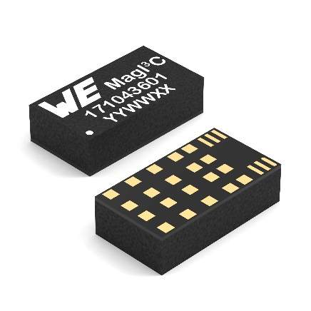
Image source: Würth Elektronik
The MagI³C-VDLM power module family has been expanded with two LGA-26 SMDs offering output currents of 4 A and 5 A, respectively.

About the Würth Elektronik eiSos Group
Würth Elektronik eiSos Group is a manufacturer of electronic and electromechanical components for the electronics industry and a technology company that spearheads pioneering electronic solutions. Würth Elektronik eiSos is one of the largest European manufacturers of passive components and is active in 50 countries. Production sites in Europe, Asia and North America supply a growing number of customers worldwide.
The product range includes passive components, power modules, digital isolators, optoelectronics, electromechanical components, thermal management solutions, sensors and wireless modules. The portfolio is rounded off by customer-specific solutions.
The unrivaled service orientation of the company is characterized by the availability of all catalog components from stock without minimum order quantity, free samples and extensive support through technical sales staff and selection tools.
Würth Elektronik is part of the Würth Group, the global market leader in the development, production, and sale of fastening and assembly materials, and employs around 7,500 people. In 2024, the Würth Elektronik Group generated sales of 1.02 Billion Euro.
Würth Elektronik: more than you expect!
Further information at www.we-online.com

Further information:  Würth Elektronik eiSos GmbH & Co. KG  Sarah Hurst  Clarita-Bernhard-Strasse 9  81249 Munich  Germany  Phone: +49 7942 945-5186  E-mail: sarah.hurst@we-online.de  www.we-online.com | Press contact:  HighTech communications GmbH  Brigitte Basilio  Brunhamstrasse 21  81249 Munich  Germany  Phone: +49 89 500778-20  E-mail: b.basilio@htcm.de  www.htcm.de

