PRESS RELEASE
New Würth Elektronik location in South Africa
A Growth Market with Good Infrastructure
Waldenburg (Germany), July 24, 2025 – On June 1, 2025, a new Würth Elektronik branch opened in Brackenfell, Western Cape, South Africa. The location operates under the name Wurth Electronics South Africa (Pty.) Ltd and will serve local customers, but will also be responsible for the markets of Botswana, Mauritius, Namibia, Tanzania and Zambia.
Ahmet Çakır, who also heads the branch in Turkey, will take over the management of the new location, under the leadership of Rob Sperring, Vice President for Southern Europe, Middle East and Africa. “South Africa was chosen for the new office primarily because of its strategic importance as a gateway to sub-Saharan Africa,” explains Çakır "The new location offers excellent logistical advantages, thanks to a well-developed infrastructure and connectivity. The growing economic potential, a diverse industrial base and increasing customer demand in the region were also key factors in the decision."
The Wurth Electronics South Africa (Pty.) Ltd team currently consists of six employees. However, it will soon be expanded to ensure the best possible service for customers in the region's emerging markets.
“Great engineering deserves great support!”
The official opening ceremony for the new location will take place in early 2026. Four EMC seminars held by Würth Elektronik in South Africa's two largest cities, Cape Town and Johannesburg, have already been completed. “This once again underlines our commitment and our contribution to the region,” emphasizes Ahmet Çakır. "We also support our customers here in South Africa through targeted knowledge transfer, just as Würth Elektronik does in many other regions around the globe. Great engineering deserves great support! And we are happy to provide this support, because we are much more than just a component supplier."

Wurth Electronics South Africa (Pty.) Ltd
Unit 3, Reserve 1
Corner Kruispad and Capricorn Way
7560 Brackenfell, Western Cape
South Africa

Available images
The following images can be downloaded from the Internet in printable quality: https://kk.htcm.de/press-releases/wuerth/
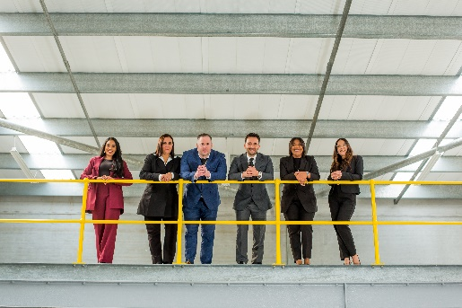  Image source: Würth Elektronik  Start with six employees: The team in South Africa under the leadership of Ahmet Çakir (4th from left) will soon be expanded - for optimum service in an up-and-coming market. |   Image source: Würth Elektronik  The Team of Wurth Electronics South Africa (Pty.) Ltd (from left): Lauren Kemp, Finance Manager, Khandre Geswindt, Internal Sales & Logistics, Lailah Dustay, Sales Area Manager responsible for the Cape Town area, Ahmet Çakir, Branch Manager, Shonelle Govindasamy, Technical Sales Engineer for Durban, and Michael Crampton, Technical Sales Engineer for the Johannesburg area.

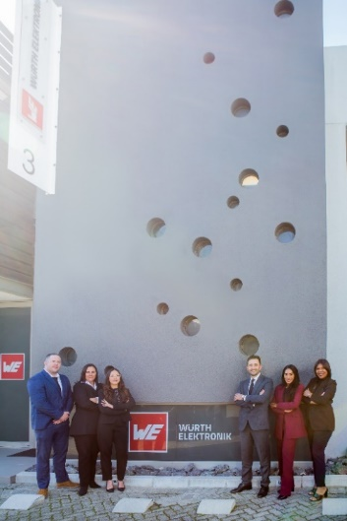
Image source: Würth Elektronik
The sky's the limit: The team at Wurth Electronics South Africa (Pty.) Ltd, here in front of the new office building, is looking forward to a new beginning at the “Gateway to Sub-Saharan Africa”.

About the Würth Elektronik eiSos Group
Würth Elektronik eiSos Group is a manufacturer of electronic and electromechanical components for the electronics industry and a technology company that spearheads pioneering electronic solutions. Würth Elektronik eiSos is one of the largest European manufacturers of passive components and is active in 50 countries. Production sites in Europe, Asia and North America supply a growing number of customers worldwide.
The product range includes passive components, power modules, digital isolators, optoelectronics, electromechanical components, thermal management solutions, sensors and wireless modules. The portfolio is rounded off by customer-specific solutions.
The unrivaled service orientation of the company is characterized by the availability of all catalog components from stock without minimum order quantity, free samples and extensive support through technical sales staff and selection tools.
Würth Elektronik is part of the Würth Group, the global market leader in the development, production, and sale of fastening and assembly materials, and employs around 7,500 people. In 2024, the Würth Elektronik Group generated sales of 1.02 Billion Euro.
Würth Elektronik: more than you expect!
Further information at www.we-online.com

Further information:  Würth Elektronik eiSos GmbH & Co. KG  Sarah Hurst  Clarita-Bernhard-Strasse 9  81249 Munich  Germany  Phone: +49 7942 945-5186  E-mail: sarah.hurst@we-online.de  www.we-online.com | Press contact:  HighTech communications GmbH  Brigitte Basilio  Brunhamstrasse 21  81249 Munich  Germany  Phone: +49 89 500778-20  E-mail: b.basilio@htcm.de  www.htcm.de

