FOR THE MEDIA
ASMPT presents software duo for seamlessly automated material flow optimization
Maximum uptime with 100-percent transparency
Atlanta (USA), July 15, 2025 – ASMPT, the world’s leading provider of hardware and software for semiconductor and electronics manufacturing, presents its powerful software duo for comprehensively automated material flow optimization in the Intelligent Factory. It is only with the integrated Factory Material Manager and WORKS Logistics applications that ASMPT’s highly developed manufacturing hardware can unfold its full potential.
To optimize the utilization of your production equipment, avoid excess material stocks and reduce scrap, you need total transparency of inventories, storage locations and the current material requirements of the SMT line. A data-driven connection between real-time material stock and requirement data enables precise control of manufacturing processes, ultimately maximizing your return on investment.
“In order for our cutting-edge manufacturing equipment to churn out products efficiently and without interruptions, it must be continuously replenished with material,” explains Thomas Bliem, Vice President R&D at ASMPT SMT Solutions. “This raises two fundamental questions. First, the where – i.e., where exactly is which material located in what package or container? Second, the where to – i.e., where exactly is the material needed and in what quantity? ASMPT provides answers to both questions with its seamlessly integrated Factory Material Manager and WORKS Logistics applications for automated material flow optimization.”
FACTORY Material Manager: Up-to-date inventory data in real time
As soon as new material is received, Factory Material Manager assigns to each package or container a unique ID (UID) that is linked to information about quantity, material number, manufacturer, batch number, delivery date, and special properties such as moisture sensitivity or its expiration date. Whenever the material changes its location, the UID on its label gets scanned, and the material consumption on the line is reported to Factory Material Manager via standardized interfaces. This permanent real-time inventory forms a digital twin of the physical material flow and thus provides the basis for all further optimization steps. The program uses this information to generate path-optimized pick lists and communicate with automatic storage systems. Factory Material Manager also ensures that materials are always taken from storage in accordance with the first-in-first-out (FIFO) principle and that exposure times are taken into account for moisture-sensitive devices (MSDs).
WORKS Logistics: Material flow according to the 4R principle
Factory Material Manager receives the information on the line’s material consumption from WORKS Logistics, which takes data from the rough production schedule (for example, from WORKS Planning) and reconciles it with the existing production resources, thus balancing material supply and consumption.
For smaller production runs, it is often sufficient to provide the material needed for the initial setup along with any refills that cover the entire order. For larger runs, WORKS Logistics forecasts the material requirements based on time slices and reports them to Factory Material Manager, which uses the data to generate supply requests to central and intermediate storage locations along with precisely timed transport orders. Working together, the two programs create an automated just-in-time in-house logistics system that consistently implements the 4R principle: the right material in the right place at the right time and in the right quantity.
After the completion of each production job, WORKS Logistics also analyzes how much material is still on each machine. If a feeder will be needed again in the coming days, the system instructs the staff to move it to the Active Feeder Rack located in the setup preparation area. Operators receive color-coded instructions from the software: a blinking red LED on the feeder means that it should be torn down and the material returned to storage, while a steady green LED means that the feeder should be kept ready in the Active Feeder Rack for an upcoming setup.

Illustrations for downloading
The following print-ready artwork is available on the internet for downloading:
https://kk.htcm.de/press-releases/asmpt/

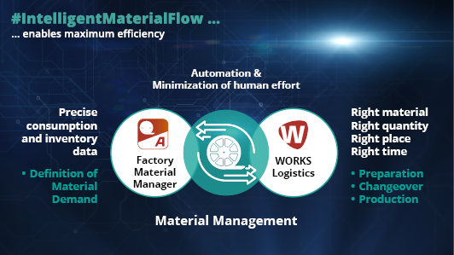 | 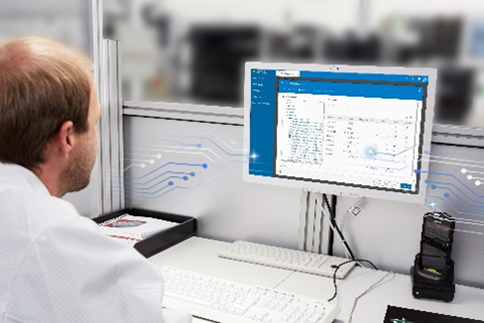
A strong pair: Factory Material Manager and WORKS Logistics ensure the seamlessly automated flow of materials in the entire factory.  Image credit: ASMPT | Permanent automatic inventory: With Factory Material Manager, operators have access to real-time inventory data at all times.  Image credit: ASMPT
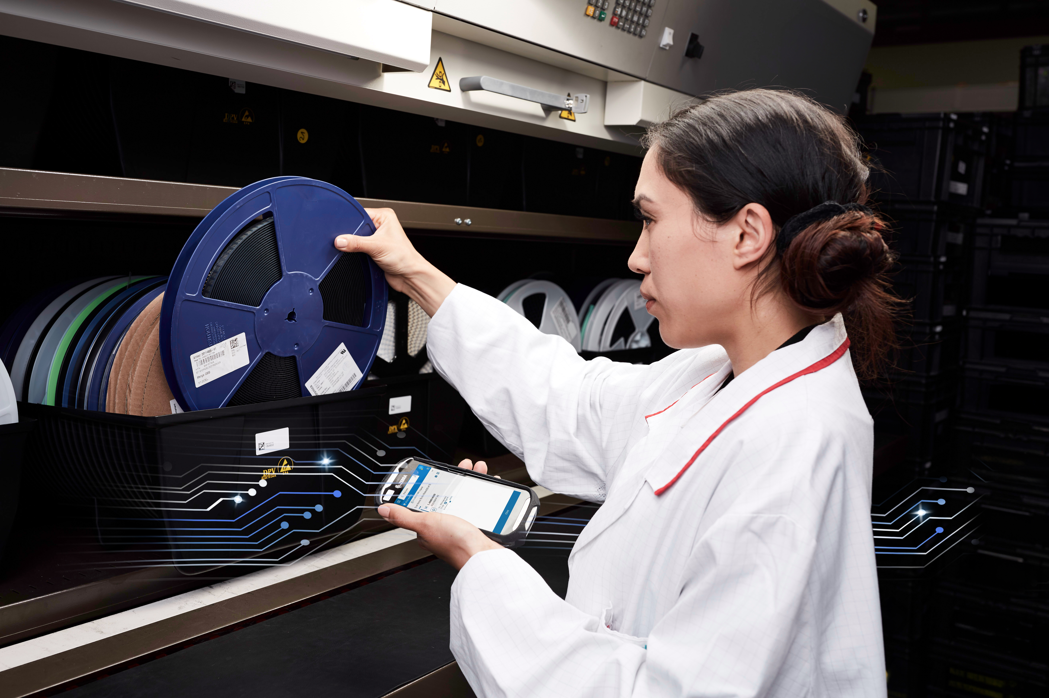 | 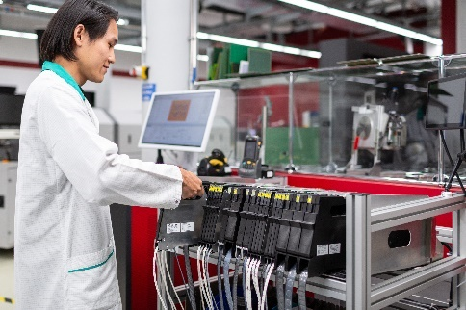
Employees receive pick lists optimized by Factory Material Manager to their handheld devices and confirm the removal by scanning the UID.  Image credit: ASMPT | WORKS Logistics organizes and optimizes the intermediate storage of material in an Active Feeder Rack in the setup preparation area.  Image credit: ASMPT

About ASMPT Limited (“ASMPT”)
ASMPT Limited is a leading global supplier of hardware and software solutions for the manufacture of semiconductors and electronics. Headquartered in Singapore, ASMPT’s offerings encompass the semiconductor assembly & packaging, and SMT (surface mount technology) industries, ranging from wafer deposition to the various solutions that organize, assemble and package delicate electronic components into a vast range of end-user devices, which include electronics, mobile communications, computing, automotive, industrial and LED (displays). ASMPT partners with customers very closely, with continuous investments in R&D helping to provide cost-effective, industry-shaping solutions that achieve higher productivity, greater reliability, and enhanced quality. ASMPT is a founding member of the Semiconductor Climate Consortium.
To learn more about ASMPT, please visit www.asmpt.com.

The ASMPT SMT Solutions segment
The mission of the SMT Solutions segment within ASMPT is to implement and support the Intelligent Factory at electronics manufacturers worldwide.
ASMPT solutions support the networking, automation, and optimization of central workflows with hardware, software and services that enable electronics manufacturers to transition to the Intelligent Factory in stages and enjoy dramatic improvements in productivity, flexibility, and quality. With its integrated open automation concept, ASMPT opens the door for its customers to economically feasible automation, entirely in accordance with their individual requirements – modular, flexible, and vendor-independent.
The product range includes hardware and software such as SIPLACE placement solutions, DEK printing solutions, inspection and storage solutions, and the WORKS Software Suite. With WORKS, ASMPT offers electronics manufacturers high-quality software for planning, controlling, analyzing and optimizing all processes on the shop floor. Maintaining close relationships with customers and technology partners is a central component of ASMPT’s strategy.
For more information about ASMPT SMT Solutions, visit smt.asmpt.com.

Media contacts:
AMCAS ASMPT Press Office
SMT Solutions
Mark Ogden
Phone: +1 (770) 797 3189
E-mail: ogden.mark@asmpt.com
Website: smt.asmpt.com

Global ASMPT Press Office
ASMPT Ltd.
Susanne Oswald
Rupert-Mayer-Strasse 48
81379 Munich
Germany
Phone: +49 89 20800-26439
E-Mail: susanne.oswald@asmpt.com
Website: asmpt.com

