PRESS RELEASE
ASMPT at NEPCON Thailand
The Intelligent Factory Showcase
Singapore, July 11, 2025 – The presence of ASMPT SMT Solutions at the NEPCON Thailand trade fair attracted a great deal of interest from trade visitors. In addition to the latest hardware and software for SMT production, the focus at the ASMPT stand was on the integrative concept of the ASMPT Intelligent Factory. It combines data, processes and people with the aim of maximizing performance and minimizing errors.
Visitors to the trade fair were able to find out first-hand about DEK TQ solder paste printers, the Process Lens SPI system and pick-and-place machines from the SIPLACE SX and SIPLACE TX series, as well as other pioneering automation options such as automatic program change, automatic material feed and automatic waste disposal.
Another focus was ASMPT's industry-leading software portfolio, for example WORKS Operations for employee scheduling in an expert pool, Virtual Assist the personal assistant on the smartphone, or the ASMPT Academy training courses. The market and technology leader also presented powerful tools for data analysis and process optimization: SMT Analytics, WORKS Monitoring and WORKS Optimization.
The entire hardware and software portfolio is fully networked. Productivity-relevant information is continuously collected via standardized interfaces and then used in planning, material flow and personnel deployment in order to optimize processes, reduce error rates and increase overall efficiency.
“We greatly appreciated the positive feedback on our presence at the trade fair, which confirms that we are recognized worldwide as a reliable partner for modern, forward-thinking electronics manufacturers thanks to our innovative hardware and software solutions”, emphasizes Sopchock Yuttawong, General Manager for Thailand since January 2025.

Illustrations for downloading
The following print-ready artwork is available on the internet for downloading:
https://kk.htcm.de/press-releases/asmpt/

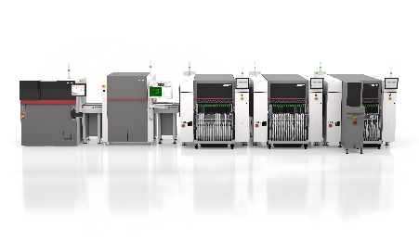 | 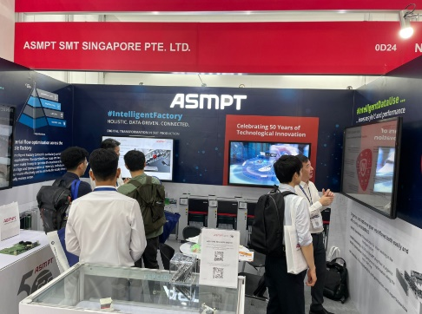
SMT line from ASMPT: DEK TQ L printer, Process Lens SPI system and SIPLACE SX placement solutions with a waffle pack changer at the end-of-line machine.  Image credit: ASMPT | Well attended: ASMPT's stand at NEPCON Thailand presented the integrative concept of the Intelligent Factory, among many other things.  Image credit: ASMPT

About ASMPT Limited (“ASMPT”)
ASMPT Limited is a leading global supplier of hardware and software solutions for the manufacture of semiconductors and electronics. Headquartered in Singapore, ASMPT’s offerings encompass the semiconductor assembly & packaging, and SMT (surface mount technology) industries, ranging from wafer deposition to the various solutions that organize, assemble and package delicate electronic components into a vast range of end-user devices, which include electronics, mobile communications, computing, automotive, industrial and LED (displays). ASMPT partners with customers very closely, with continuous investments in R&D helping to provide cost-effective, industry-shaping solutions that achieve higher productivity, greater reliability, and enhanced quality. ASMPT is a founding member of the Semiconductor Climate Consortium.
To learn more about ASMPT, please visit www.asmpt.com.

The ASMPT SMT Solutions segment
The mission of the SMT Solutions segment within ASMPT is to implement and support the Intelligent Factory at electronics manufacturers worldwide.
ASMPT solutions support the networking, automation, and optimization of central workflows with hardware, software and services that enable electronics manufacturers to transition to the Intelligent Factory in stages and enjoy dramatic improvements in productivity, flexibility, and quality. With its integrated open automation concept, ASMPT opens the door for its customers to economically feasible automation, entirely in accordance with their individual requirements – modular, flexible, and vendor-independent.
The product range includes hardware and software such as SIPLACE placement solutions, DEK printing solutions, inspection and storage solutions, and the WORKS Software Suite. With WORKS, ASMPT offers electronics manufacturers high-quality software for planning, controlling, analyzing and optimizing all processes on the shop floor. Maintaining close relationships with customers and technology partners is a central component of ASMPT’s strategy.
For more information about ASMPT SMT Solutions, visit smt.asmpt.com.

Media contacts:
ASMPT ROA Press Office
SMT Solutions
ASMPT SMT Singapore Pte. Ltd.
Janet Loh
Phone: +65 6877 3948
E-mail: Janet.loh@asmpt.com
Website: smt.asmpt.com

Global ASMPT Press Office
ASMPT Ltd.
Susanne Oswald
Rupert-Mayer-Strasse 48
81379 Munich
Germany
Phone: +49 89 20800-26439
E-Mail: susanne.oswald@asmpt.com
Website: asmpt.com

