PRESS RELEASE
Würth Elektronik and Nexperia present motor driver evaluation kit
Faster Development of Efficient Motor Controllers
Waldenburg (Germany), July 3, 2025 – Würth Elektronik and Nexperia have developed the NEVB-MTR1-KIT1 modular motor driver evaluation kit. The kit, created in collaboration, can be configured for use in under two minutes and is conveniently powered via USB-C. Thanks to the open architecture, microcontrollers and components can be easily exchanged. Open-source firmware enables rapid adaptation and development of motor controllers under real-world conditions. A particular highlight of the kit is the high-current connectors integrated by Würth Elektronik, which enable evaluations up to 1 kW at 48 V. The kit includes a 3-phase inverter board, a motor controller board, a microcontroller development board, pre-wired motor connections, and a BLDC (brushless DC) motor.
The demands on dynamics, fault tolerance, and energy efficiency in modern drive systems are rising steadily. The development of motor control systems has therefore become increasingly complex – a multidimensional technical task in which hardware and software must interact seamlessly. Selecting the right switches (MOSFETs, IGBTs), gate drivers, and protection elements is crucial. Only an optimally matched driver-switch combination enables high efficiency and reliability. Inadequate selection, on the other hand, can lead to increased switching losses, critical thermal behavior, or unstable dynamics. The behavior of the components must be carefully validated under real-world conditions, taking into account factors such as parasitic elements, switching transients, and EMI.
This is where the modular kit makes things much easier for developers: it is designed so that different motors and control concepts can be operated - even using sensors.
Playground for engineers
"Our collaboration with Würth Elektronik brings together the strengths of both companies to support engineers in pushing the boundaries of what’s possible,” said Oleg Krapivner, Marketing Senior Director at Nexperia. “By combining passive components and power semiconductors on a single board, we’re providing a practical platform that helps accelerate innovation at the heart of designs. We’re offering more than just an evaluation tool - it’s a playground for engineers to experiment, iterate, and bring new ideas to life."
“The NEVB-MTR1-KIT1 marks a paradigm shift in our evaluation boards, says Alexander Gerfer, CTO at the Würth Elektronik eiSos Group. “Rather than forcing engineers to adopt a fixed reference design, the board becomes a modular, developer-friendly platform that can be adapted to a wide range of motors, control algorithms, and test setups. This flexibility not only speeds up motor controller development but also enables faster iterations, testing, and optimization – exactly what modern development projects need.”

Available images
The following images can be downloaded from the Internet in printable quality: https://kk.htcm.de/press-releases/wuerth/
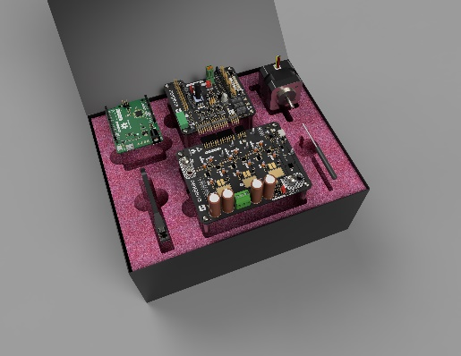Image source: Nexperia
The Nexperia NEVB-MTR1-KIT1 motor driver evaluation kit is the result of collaboration between Nexperia and Würth Elektronik.

Available videos
You can find videos on this topic on our YouTube channel:
https://www.youtube.com/watch?v=PfDqjth2_tk
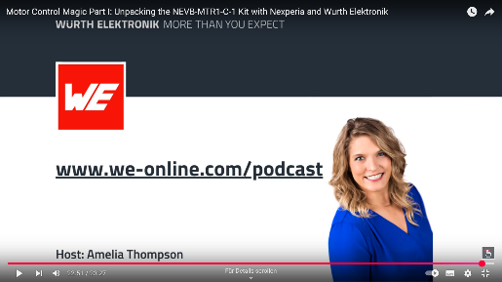Source: Würth Elektronik
A podcast provides insights into the origin of this motor driver kit.

About Nexperia
Headquartered in the Netherlands, Nexperia is a global semiconductor company with a rich European history and over 12,500 employees across Europe, Asia, and the United States. As a leading expert in the development and production of essential semiconductors, Nexperia’s components enable the basic functionality of virtually every commercial electronic design in the world – from automotive and industrial to mobile and consumer applications.
The company serves a global customer base, shipping more than 100 billion products annually. These products are recognized as benchmarks in efficiency – in process, size, power, and performance. Nexperia's commitment to innovation, efficiency, sustainability, and stringent industry requirements is evident in its extensive IP portfolio, its expanding product range, and its certification to IATF 16949, ISO 9001, ISO 14001 and ISO 45001 standards.
Press contact:  Nexperia  Anne Proch  Phone: +49 160 916 884 18  E-mail: anne.proch@nexperia.com | Publitek  Lucy Sorton  Phone: +44 07966 301949  E-mail: lucy.sorton@publitek.com

About the Würth Elektronik eiSos Group
Würth Elektronik eiSos Group is a manufacturer of electronic and electromechanical components for the electronics industry and a technology company that spearheads pioneering electronic solutions. Würth Elektronik eiSos is one of the largest European manufacturers of passive components and is active in 50 countries. Production sites in Europe, Asia and North America supply a growing number of customers worldwide.
The product range includes passive components, power modules, digital isolators, optoelectronics, electromechanical components, thermal management solutions, sensors and wireless modules. The portfolio is rounded off by customer-specific solutions.
The unrivaled service orientation of the company is characterized by the availability of all catalog components from stock without minimum order quantity, free samples and extensive support through technical sales staff and selection tools.
Würth Elektronik is part of the Würth Group, the global market leader in the development, production, and sale of fastening and assembly materials, and employs around 7,500 people. In 2024, the Würth Elektronik Group generated sales of 1.02 Billion Euro.
Würth Elektronik: more than you expect!
Further information at www.we-online.com

Further information:  Würth Elektronik eiSos GmbH & Co. KG  Sarah Hurst  Clarita-Bernhard-Strasse 9  81249 Munich  Germany  Phone: +49 7942 945-5186  E-mail: sarah.hurst@we-online.de  www.we-online.com | Press contact:  HighTech communications GmbH  Brigitte Basilio  Brunhamstrasse 21  81249 Munich  Germany  Phone: +49 89 500778-20  E-mail: b.basilio@htcm.de  www.htcm.de

