FOR THE MEDIA
Toni Patzner becomes Global Head of Supply Chain Management at ASMPT SMT Solutions
Focused on lean structures
Munich (Germany), July 1, 2025 – On June 1, 2025, Toni Patzner assumed the position of Global Head of Supply Chain Management. The experienced manager succeeded Jörg Cwojdzinski, who retired after decades of service. The appointment is another example of ASMPT’s focus on continuity, technological excellence and lean management in a field that has won several international awards.
ASMPT operates a global network of state-of-the-art production facilities, suppliers and logistics centers. The global player has won the “Factory of the Year” award several times, both internationally and locally. Its factories in Germany, Great Britain, Hungary, Singapore and Malaysia are among the most innovative in the industry and set standards in automation and Industry 4.0.
An experienced successor with a focus on lean structures
On June 1, 2025, Toni Patzner took over as Global Head of Supply Chain Management, succeeding Jörg Cwojdzinski after his retirement. Patzner is an experienced manager who has been with the company for over 30 years and stands for strategic vision and operational excellence. In various management positions, most recently as Senior Director Global SCM Operations, he was responsible for the successful integration of DEK solder paste printers into the ASMPT production as well as for facility expansions in Malaysia and Hungary, to name just a few.
Patzner, who holds a degree in automation technology from the University of Applied Sciences in Munich, is regarded as an assertive advocate for customer-oriented processes and lean structures.
“Excellence does not come from complexity, but from clarity and consistency. Leanness is our path to global success,” said Toni Patzner. “I stand for an open feedback culture, clear communication, and continuous improvement. For me, leadership means providing orientation and working with strong teams to achieve measurable results for a sustainable production network.”

Illustrations for downloading
The following print-ready artwork is available on the internet for downloading:
https://kk.htcm.de/press-releases/asmpt/

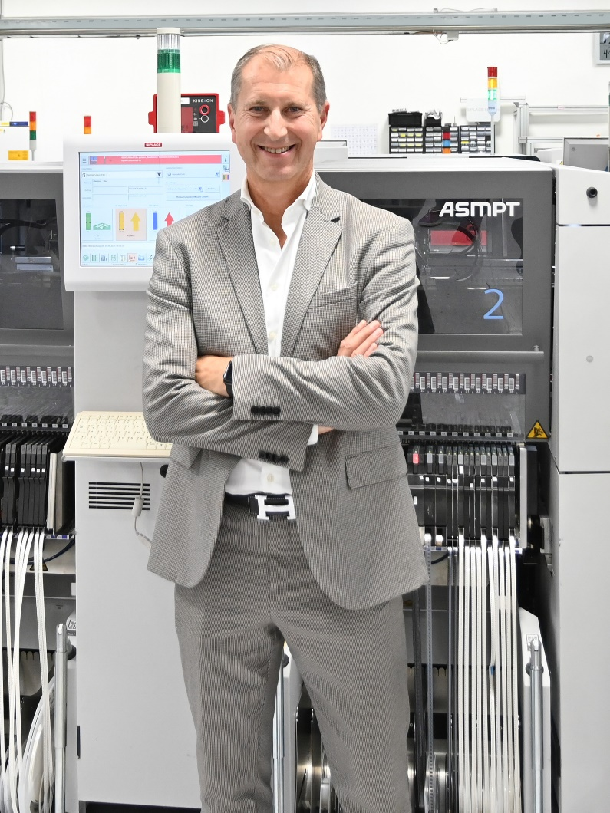

Toni Patzner Head of Supply Change Management at ASMPT SMT Solutions

Image credit: ASMPT

About ASMPT Limited (“ASMPT”)
ASMPT Limited is a leading global supplier of hardware and software solutions for the manufacture of semiconductors and electronics. Headquartered in Singapore, ASMPT’s offerings encompass the semiconductor assembly & packaging, and SMT (surface mount technology) industries, ranging from wafer deposition to the various solutions that organize, assemble and package delicate electronic components into a vast range of end-user devices, which include electronics, mobile communications, computing, automotive, industrial and LED (displays). ASMPT partners with customers very closely, with continuous investments in R&D helping to provide cost-effective, industry-shaping solutions that achieve higher productivity, greater reliability, and enhanced quality. ASMPT is a founding member of the Semiconductor Climate Consortium.
To learn more about ASMPT, please visit www.asmpt.com.

The ASMPT SMT Solutions segment
The mission of the SMT Solutions segment within ASMPT is to implement and support the Intelligent Factory at electronics manufacturers worldwide.
ASMPT solutions support the networking, automation, and optimization of central workflows with hardware, software and services that enable electronics manufacturers to transition to the Intelligent Factory in stages and enjoy dramatic improvements in productivity, flexibility, and quality. With its integrated open automation concept, ASMPT opens the door for its customers to economically feasible automation, entirely in accordance with their individual requirements – modular, flexible, and vendor-independent.
The product range includes hardware and software such as SIPLACE placement solutions, DEK printing solutions, inspection and storage solutions, and the WORKS Software Suite. With WORKS, ASMPT offers electronics manufacturers high-quality software for planning, controlling, analyzing and optimizing all processes on the shop floor. Maintaining close relationships with customers and technology partners is a central component of ASMPT’s strategy.
For more information about ASMPT SMT Solutions, visit smt.asmpt.com.

Media contacts:
Global ASMPT Press Office
ASMPT Ltd
Susanne Oswald
Rupert-Mayer-Strasse 48
81379 Munich
Germany
Tel: +49 89 20800-26439
E-mail: susanne.oswald@asmpt.com
Website: asmpt.com

HighTech communications GmbH
Barbara Ostermeier
Brunhamstrasse 21
81249 Munich
Germany
Tel.: +49-89 500778-10|
E-mail: b.ostermeier@htcm.de
Website: www.htcm.de

