PRESS RELEASE
ASMPT at NEPCON Thailand
Hardware and software perfectly integrated in the Intelligent Factory
Singapore, May 28, 2025 – Market and technology leader ASMPT SMT Solutions will present its latest machines, software solutions and integrated concepts for efficient, connected and future-proof electronics production at NEPCON Thailand, one of Southeast Asia’s leading trade fairs for the electronics manufacturing industry, from June 18 to 21, 2025, at booth D24 in hall 100 (Singapore Pavilion). The main focus will be ASMPT’s integrative concept of the Intelligent Factory, a comprehensive approach that connects data, processes and people with each other in a highly automated environment.
“Unlike most other manufacturers, ASMPT covers almost all production steps with its own hardware and software,” explained Mr DaeSung Kim, Managing Director of Customer Relationship Management in the Asia region (excluding China) at ASMPT. “At our booth, trade visitors can see how our machines and our software work together as an integrative whole under the Intelligent Factory concept for maximum productivity, quality and efficiency. We are very much looking forward to meeting and talking with visitors in person.”
Printing, SPI and assembly from a single source
Trade visitors will receive comprehensive information on DEK TQ solder paste printers, the Process Lens SPI system and placement machines from the SIPLACE SX and SIPLACE TX series. Additional pioneering automation options such as Automated Program Change, automatic material supply capabilities and automated waste removal will be presented virtually.
Software for maximum ROI
Another central focus area will be ASMPT’s industry-leading software portfolio with applications that support training, knowledge transfer, and the targeted assignment of specialists. WORKS Operations, for example, enables the deployment of specialists across multiple lines from a central pool of experts, while Virtual Assist brings AI-based support directly to the smartphone as a personal database in daily operations. And the ASMPT Academy features modern and practice-oriented training formats – virtually and on-site.
ASMPT will also present powerful tools for data analysis and process optimization: SMT Analytics for deep insights into production processes, WORKS Monitoring for real-time KPI visualization and reporting, and WORKS Optimization for intelligent process control along the entire SMT line.
Seamlessly networked for maximum efficiency
All hardware solutions and the comprehensive software pool from ASMPT are fully networked with each other via standardized interfaces. Numerous sensors and data sources continuously collect productivity-relevant information in real time. This data is then used in planning, material flow and staff deployment operations to optimize processes, reduce fault rates, and raise the factory’s overall efficiency in a sustainable manner.
50 years of partnership in electronics production
For 50 years now, ASMPT has been a preferred partner for the electronics manufacturing industry – in Thailand as well as at countless production sites all over the world. With innovative technologies, deep process expertise and a holistic solution approach, ASMPT reliably supports its customers on the road to the Intelligent Factory.

Illustrations for downloading
The following print-ready artwork is available on the internet for downloading:
https://kk.htcm.de/press-releases/asmpt/

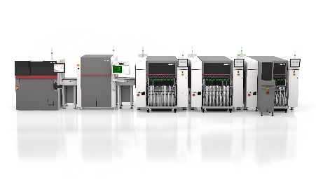 | 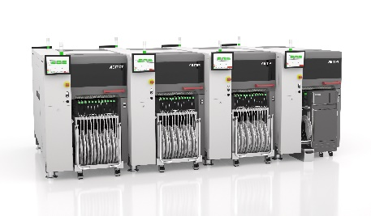
SMT line from ASMPT: DEK TQ L printer, Process Lens SPI system and SIPLACE SX placement solutions with a waffle pack changer at the end-of-line machine.  Image credit: ASMPT | SIPLACE TX micron units with a tray unit in the end-of-line machine.  Image credit: ASMPT
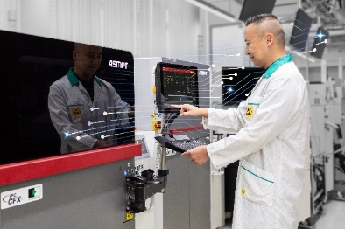 | 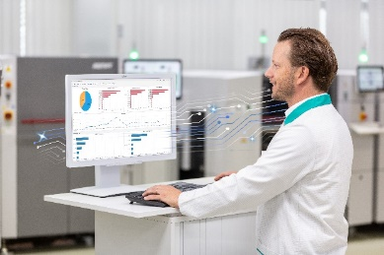
At NEPCON Thailand, ASMPT will present its software-oriented approach to integrating existing hardware and software systems.  Image credit: ASMPT | SMT Analytics: AI and NLP assistance systems provide support for line operators and maintenance technicians.  Image credit: ASMPT
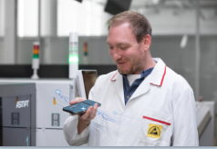 | 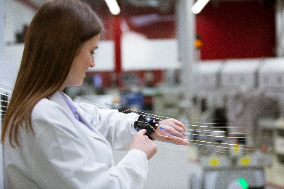
Thanks to NLP technology, operators can ask Virtual Assist questions just like a human colleague.  Image credit: ASMPT | Operators receive their work assignments on their portable digital devices via WOKRS Operations – prioritized according to their qualifications and with sufficient lead time.  Image credit: ASMPT

About ASMPT Limited (“ASMPT”)
ASMPT Limited is a leading global supplier of hardware and software solutions for the manufacture of semiconductors and electronics. Headquartered in Singapore, ASMPT’s offerings encompass the semiconductor assembly & packaging, and SMT (surface mount technology) industries, ranging from wafer deposition to the various solutions that organize, assemble and package delicate electronic components into a vast range of end-user devices, which include electronics, mobile communications, computing, automotive, industrial and LED (displays). ASMPT partners with customers very closely, with continuous investments in R&D helping to provide cost-effective, industry-shaping solutions that achieve higher productivity, greater reliability, and enhanced quality. ASMPT is a founding member of the Semiconductor Climate Consortium.
To learn more about ASMPT, please visit www.asmpt.com.

The ASMPT SMT Solutions segment
The mission of the SMT Solutions segment within ASMPT is to implement and support the Intelligent Factory at electronics manufacturers worldwide.
ASMPT solutions support the networking, automation, and optimization of central workflows with hardware, software and services that enable electronics manufacturers to transition to the Intelligent Factory in stages and enjoy dramatic improvements in productivity, flexibility, and quality. With its integrated open automation concept, ASMPT opens the door for its customers to economically feasible automation, entirely in accordance with their individual requirements – modular, flexible, and vendor-independent.
The product range includes hardware and software such as SIPLACE placement solutions, DEK printing solutions, inspection and storage solutions, and the WORKS Software Suite. With WORKS, ASMPT offers electronics manufacturers high-quality software for planning, controlling, analyzing and optimizing all processes on the shop floor. Maintaining close relationships with customers and technology partners is a central component of ASMPT’s strategy.
For more information about ASMPT SMT Solutions, visit smt.asmpt.com.

Media contacts:
ASMPT ROA Press Office
SMT Solutions
ASMPT SMT Singapore Pte. Ltd.
Janet Loh
Phone: +65 6877 3948
E-mail: Janet.loh@asmpt.com
Website: smt.asmpt.com

Global ASMPT Press Office
ASMPT Ltd.
Susanne Oswald
Rupert-Mayer-Strasse 48
81379 Munich
Germany
Phone: +49 89 20800-26439
E-Mail: susanne.oswald@asmpt.com
Website: asmpt.com

