PRESS RELEASE
ASMPT presents central platform for data exchange in electronics manufacturing
WORKS Integration – the data center for intelligent manufacturing
Atlanta (USA), May 22, 2025 – With WORKS Integration, ASMPT SMT Solutions, the market and technology leader in SMT, provides a central integration platform through which all its hardware and software solutions can communicate with each other. By also integrating third-party and customer-specific systems, the platform serves as the foundation for ASMPT’s holistic concept of intelligent electronics manufacturing.
“WORKS Integration ensures that all production data is available exactly where it is needed for things like production planning and setup preparation, material flow and process optimization, and quality control,” said Thomas Bliem, Vice President R&D at ASMPT SMT Solutions. “By creating a centrally networked database with high connectivity across all systems, the platform makes fully digitized and highly automated intelligent production possible.”
A central data hub for all systems
Extending across all protocols and versions, WORKS Integration establishes an IIoT communication base to which the sensors on the production hardware as well as all software applications send their data. In addition to connecting the entire hardware and software portfolio of ASMPT SMT Solutions, WORKS Integration makes it possible to integrate third-party machines and programs via industry-standard interfaces. Even complex customer-specific applications can be easily linked via proprietary interfaces.
All connected systems obtain the information they need exclusively via WORKS Integration. Operating in the background, the application enables the continuous exchange of data between different hardware and software entities irrespective of their format or manufacturer.
WORKS Integration supports proven internal machine interfaces as well as industry standards such as IPC-2591, CFX, and SECS/GEM. Adapters convert all incoming information into a shared public data structure.
Centralized, standardized, resilient
This unified system offers numerous advantages for users. Since the various instances do not communicate with each other directly but exclusively through WORKS Integration, the number of interfaces and data channels is reduced considerably, as are potential interdependencies and sources of errors.
Machines and/or programs can be easily replaced, updated and scaled up or down without creating version conflicts or redundant data streams while encrypted communication reliably protects the system from unauthorized access. In addition, a central health monitoring system provides valuable information for technical support and fault analysis.

Illustrations for downloading
The following print-ready artwork is available on the internet for downloading:
https://kk.htcm.de/press-releases/asmpt/

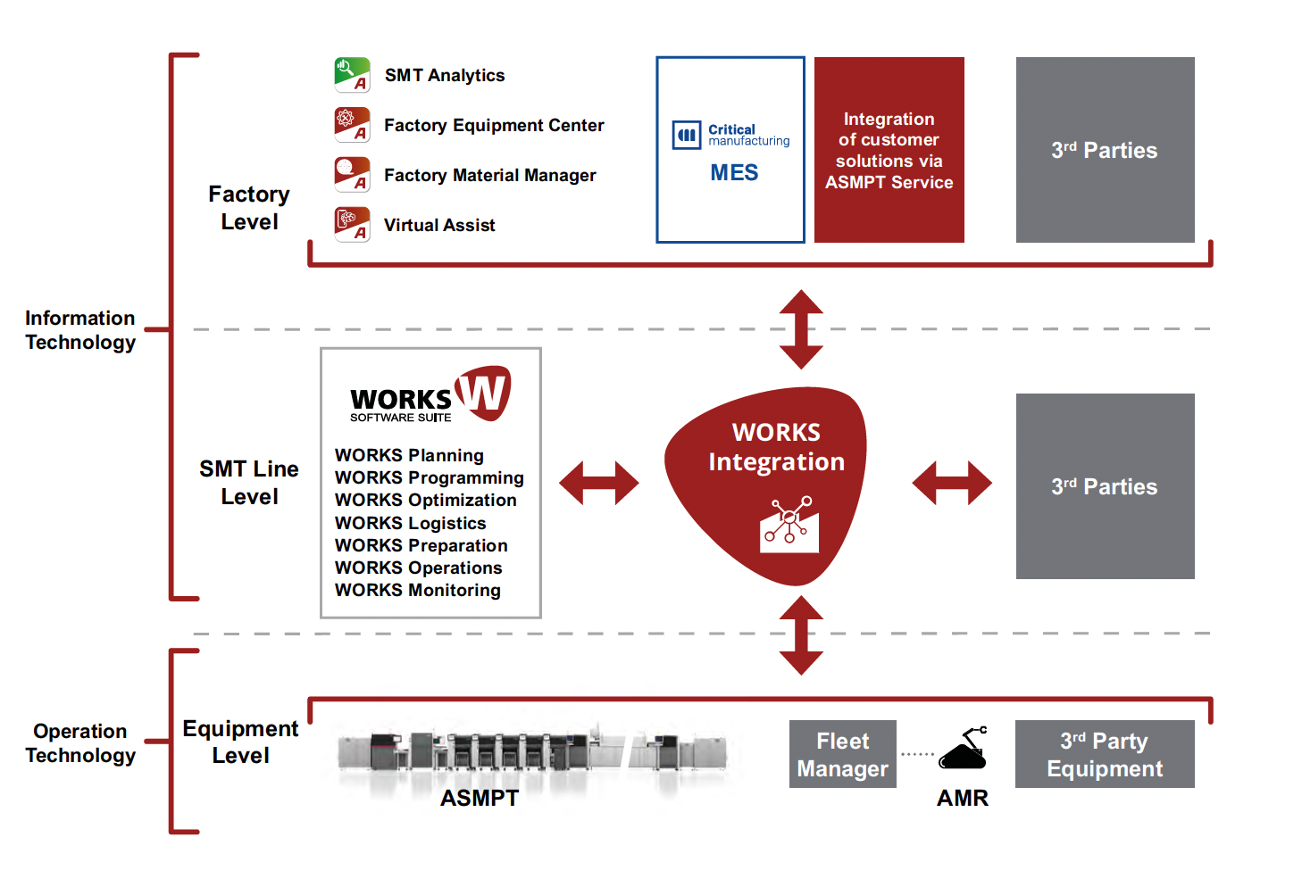

WORKS Integration seamlessly integrates all hardware and software solutions from ASMPT and makes it easy to connect third-party systems.

Image credit: ASMPT

About ASMPT Limited (“ASMPT”)
ASMPT Limited is a leading global supplier of hardware and software solutions for the manufacture of semiconductors and electronics. Headquartered in Singapore, ASMPT’s offerings encompass the semiconductor assembly & packaging, and SMT (surface mount technology) industries, ranging from wafer deposition to the various solutions that organize, assemble and package delicate electronic components into a vast range of end-user devices, which include electronics, mobile communications, computing, automotive, industrial and LED (displays). ASMPT partners with customers very closely, with continuous investments in R&D helping to provide cost-effective, industry-shaping solutions that achieve higher productivity, greater reliability, and enhanced quality. ASMPT is a founding member of the Semiconductor Climate Consortium.
To learn more about ASMPT, please visit www.asmpt.com.

The ASMPT SMT Solutions segment
The mission of the SMT Solutions segment within ASMPT is to implement and support the Intelligent Factory at electronics manufacturers worldwide.
ASMPT solutions support the networking, automation, and optimization of central workflows with hardware, software and services that enable electronics manufacturers to transition to the Intelligent Factory in stages and enjoy dramatic improvements in productivity, flexibility, and quality. With its integrated open automation concept, ASMPT opens the door for its customers to economically feasible automation, entirely in accordance with their individual requirements – modular, flexible, and vendor-independent.
The product range includes hardware and software such as SIPLACE placement solutions, DEK printing solutions, inspection and storage solutions, and the WORKS Software Suite. With WORKS, ASMPT offers electronics manufacturers high-quality software for planning, controlling, analyzing and optimizing all processes on the shop floor. Maintaining close relationships with customers and technology partners is a central component of ASMPT’s strategy.
For more information about ASMPT SMT Solutions, visit smt.asmpt.com.

Media contacts:
AMCAS ASMPT Press Office
SMT Solutions
Mark Ogden
Phone: +1 (770) 797 3189
E-mail: ogden.mark@asmpt.com
Website: smt.asmpt.com

Global ASMPT Press Office
ASMPT Ltd.
Susanne Oswald
Rupert-Mayer-Strasse 48
81379 Munich
Germany
Phone: +49 89 20800-26439
E-Mail: susanne.oswald@asmpt.com
Website: asmpt.com

