PRESS RELEASE

Hufschmied and HEDS Dental cooperate
For perfect machining in dental laboratories
Bobingen (Germany), May 20, 2025 – Hufschmied Zerspanungssysteme GmbH and HEDS Group GmbH are working together on a complete solution for HSC milling in dental laboratories. The HEDS (“High End Digital Smile”) joint venture, founded by eight dental laboratories, has developed its own HSC milling machine for dental laboratories and consulted Hufschmied on the tools. Their special tools for machining zirconium dioxide, plastics, titanium, and cobalt-chromium will be part of the overall solution for the upcoming HEDmill One milling machine. With this milling machine, developed by dental technicians for dental technicians, HEDS Dental aims to set new standards in terms of performance, service life, efficiency, operation, and process reliability.
The joint purchase of materials was the origin of the laboratory partnership. However, the need to procure spare parts and perform maintenance on the milling machines already in the laboratories' inventory provided the resources to build an internal development and production team. This made it possible to develop their own HSC milling machine with industrial technology standards that is optimally adapted to the needs of dental laboratories.
“We entered into a technology partnership with Hufschmied because we realize that tools are one of the decisive factors in achieving maximum performance with our HEDmill One milling machine,” says Leon Felzmann, Managing Director at HEDS Dental. “The close partnership on equal terms results in an efficient development cooperation with short coordination channels. Our joint development team offers a new perspective to dental technicians who want to optimize performance and process reliability in their laboratories.”
Insights into the technology partnership between HEDS and Hufschmied
The close cooperation between HEDS Dental and Hufschmied Zerspanungssysteme has already led to initial technological successes. A milestone was the introduction of the “Zirkonator,” a specially developed tool for high-performance machining of zirconium oxide. This tool was specifically developed for the manufacture of crowns and bridges in dental laboratories and has been further optimized. Thanks to the Zirkonator, dental technicians can make their work processes significantly more efficient, as machining is carried out with increased precision, longer tool life, and reduced material loss.
Another advance is the successful implementation of HPC milling tools for machining plastics, including aligners and flexible prostheses. These specially designed tools enable a significant improvement in surface quality and a reduction in machining times, allowing dental laboratories to increase their productivity.
Looking ahead
The technology partnership between HEDS Dental and Hufschmied Zerspanungssysteme is being further expanded to open new technological possibilities for dental laboratories. One forward-looking project is the development of milling tools for machining glass ceramics such as lithium disilicate (LiSi). Until now, such materials have mainly been ground – a costly and time-consuming process. The ability to mill glass ceramics in the future would not only offer greater process reliability thanks to geometrically defined milling tools but also enable more precise results and more economical production.
“Our goal is to work with HEDS Dental to develop groundbreaking solutions for dental laboratories. Smooth machining processes are possible when the tool, machining strategy, and machine are perfectly matched to the workpiece and material. The results so far show that we are on the right track with this partnership,” says Christel Hufschmied, Managing Director of Hufschmied Zerspanungssysteme GmbH.

Available images
The following images can be downloaded from the Internet in printable quality:
https://kk.htcm.de/press-releases/hufschmied/
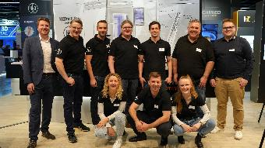  Image source:  Hufschmied Zerspanungssysteme  Hufschmied and HEDS Group together at IDS 2025: Thomas Niefenecker, Head of International Sales, Hufschmied Zerspanungssysteme GmbH, Maximilian-C. v. Schön-Angerer, Managing Director, Martin Buchholz, Partner, Ole Junge, Authorized Signatory, Phillipp Meier, Partner, Stefan Gibisch, Partner (all HEDS Group GmbH), Michael Mödinger, Application Engineer (Hufschmied) (from left to right), Sophie Ecker, Finance, Leon Felzmann, Managing Director, Nike Dingeldein, Authorized Signatory (kneeling from left to right, all HEDS) | 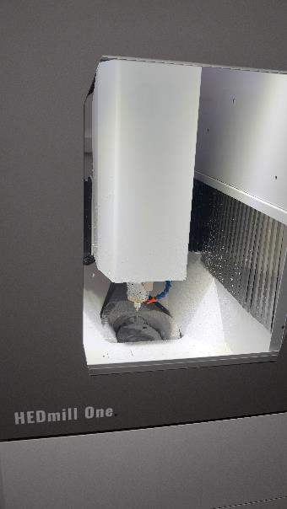  Image source: Hufschmied Zerspanungssysteme  On display for the first time at IDS 2025: the prototype of the HEDmill One milling machine developed by the HEDS Group.

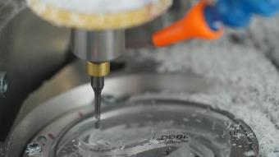  Image source:  Hufschmied Zerspanungssysteme  Trade fair demonstration: HEDliners, the almost invisible aligners developed by HEDS Group for correcting misaligned teeth, were manufactured on the HEDmill One. | 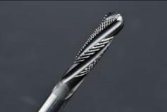  Image source:  Hufschmied Zerspanungssysteme  The Zirkonator impresses with its superior performance and service life when processing zirconia.

About HEDS Dental
HEDS - High End Digital Smile - is a joint venture of dental laboratory owners from all over Germany. The aim is to make everyday work in dental laboratories easier and more efficient. As an industry-independent company, HEDS focuses on transparent prices and customer relationships based on partnership. The products are developed by dental technicians for dental technicians, precisely tailored to the day-to-day needs of the industry.
For more information: https://heds.dental/

About Hufschmied Zerspanungssysteme GmbH
Established in 1991 and headquartered in Bobingen near Augsburg, Hufschmied Zerspanungssysteme GmbH is a manufacturer of high-quality tools for machinable production and friction stir welding. By specializing at an early stage in the machining of plastics, fiberglass materials and carbon fiber, Hufschmied has become a leader in Europe in the development of solutions for new materials. The company is an established system supplier to renowned machine tool manufacturers. Tools and manufacturing process consulting from Hufschmied are particularly valued in the automotive and aerospace industries as well as in medical technology. The company is involved in numerous organizations, including Composites United Deutschland e. V. Hufschmied's manufacturing operations are located in Bobingen, Winterlingen and Sigmaringen on the Swabian Alb. Hufschmied is certified according to ISO 9001:2015 (quality management) and ISO 14001:2015 (environmental management).

Hufschmied Zerspanungssysteme GmbH – One Cut Ahead
For more information: www.hufschmied.net

Additional information:  Hufschmied Zerspanungssysteme GmbH  Marco Beigl  Edisonstrasse 11d  86399 Bobingen  Germany  Phone: +49 8234 9664-0  Telefax: +49 8234 9664-99  E-Mail: info@hufschmied.net  www.hufschmied.net | Press contact:  HighTech communications GmbH  Brigitte Basilio  Brunhamstrasse 21  81249 Munich  Germany  Phone: +49 89 500778-20  E-Mail: b.basilio@htcm.de  www.htcm.de

