FOR THE MEDIA
ASMPT presents die bonder with intelligent features
INFINITE pushes the boundaries of miniaturization
Regensburg (Germany), May 14, 2025 – ASMPT, the leading supplier of production equipment for advanced packaging and semiconductor assembly, introduces its flagship INFINITE bonder, which achieves top performance in throughput and quality. With its intelligent features, especially in the areas of adhesive application and placement, the machine meets even the most challenging requirements in the areas of miniaturization and material properties.
“Miniaturization to the near-atomic level is pushing Moore’s Law, which states that the number of transistors per chip area doubles every two years, to its physical and economic limits,” said Dr. Gary Widdowson, Chief Technology Officer at ASMPT Semiconductor Solutions. “As a result, further steps in miniaturization are shifting more and more toward making advances in of component packaging. With our highly innovative INFINITE bonder, manufacturers will be optimally prepared for this challenge.”
The INFINITE bonder achieves a throughput rate of up to 18,500 UPH with a placement accuracy of ±20 μm @ 3 σ in standard mode and ±12.5 μm @ 3 σ in high-precision mode. In its standard version, the machine can process dies with areas ranging from 0.2 × 0.2 mm to 9 × 9 mm and thicknesses ranging from 0.075 to 1 mm with a bonding force ranging from 0.196 to 29.43 N. The maximum substrate size is 300 × 100 mm.
Intelligent features save time and maximize quality
To create the best possible conditions for the application of adhesives, the INFINITE bonder first uses its iSense function to inspect each placement area for bumps and warps. All the user needs to do during the setup phase is to specify the epoxy resin’s parameters, the desired bond line thickness, and the fillet height to be achieved. All other parameters such as the processing speed, pattern and application height, are automatically determined by the ASMPT AI. The machine optimizes the application of the adhesive over the course of a few test steps with touchless measurements and feedback. Most setups are completed within 30 minutes.
With the intelligent iTouch feature, the INFINITE bonder can maintain the programmed bonding forces with exceptional accuracy. This enables the reliable processing of even very thin dies made of highly sensitive materials such as silicon carbide (SiC) and gallium nitride (GaN). The precisely defined and monitored bonding force is ideal for silver-sintering paste and keeps the fillet height within the defined window despite varying process parameters.
The INFINITE bonder supports various packaging types, such as BGA, LGA, SiP, MEMS, or QFN. The high-precision machine can be deployed in many demanding production areas for products like 5G components, high-performance AI chips, safety-critical components for the automobile industry or the medical sector, and last but not least for high-quality and highly miniaturized consumer products.

Illustrations for downloading
The following print-ready artwork is available on the internet for downloading:
https://kk.htcm.de/press-releases/asmpt/

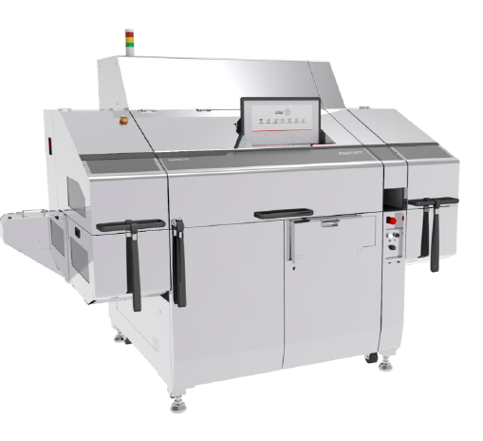

INFINITE high-speed die bonder: Reliable packaging for the next advances in miniaturization.

Image credit: ASMPT

About ASMPT Limited (“ASMPT”)
ASMPT Limited is a leading global supplier of hardware and software solutions for the manufacture of semiconductors and electronics. Headquartered in Singapore, ASMPT’s offerings encompass the semiconductor assembly & packaging, and SMT (surface mount technology) industries, ranging from wafer deposition to the various solutions that organize, assemble and package delicate electronic components into a vast range of end-user devices, which include electronics, mobile communications, computing, automotive, industrial and LED (displays). ASMPT partners with customers very closely, with continuous investments in R&D helping to provide cost-effective, industry-shaping solutions that achieve higher productivity, greater reliability, and enhanced quality. ASMPT is a founding member of the Semiconductor Climate Consortium.
To learn more about ASMPT, please visit www.asmpt.com.

About ASMPT Semiconductor Solutions (“ASMPT SEMI”)
ASMPT SEMI is the leading provider of forward-looking solutions for advanced packaging and semiconductor assembly. With its commitment to innovation and customer satisfaction, ASMPT SEMI offers a comprehensive range of products and services that meet the evolving needs of the microelectronics industry. Expert knowledge covers areas such as flip-chip and wafer-level packaging, advanced interconnect technologies, and more. ASMPT SEMI’s state-of-the-art solutions enable customers to achieve higher performance, greater reliability, and improved cost-efficiency in the manufacturing of their semiconductor devices.
For more information about ASMPT SEMI, visit semi.asmpt.com.

Media contacts:
Global ASMPT Press Office
ASMPT Ltd
Susanne Oswald
Rupert-Mayer-Strasse 48
81379 Munich
Germany
Tel: +49 89 20800-26439
E-mail: susanne.oswald@asmpt.com
Website: asmpt.com

HighTech communications GmbH
Barbara Ostermeier
Brunhamstrasse 21
81249 Munich
Germany
Tel.: +49-89 500778-10|
E-mail: b.ostermeier@htcm.de
Website: www.htcm.de

