PRESS RELEASE

Hufschmied and CMS form technical partnership
Together for more efficient machining
Bobingen (Germany), Zogno (Italy), May 13, 2025 – Hufschmied Zerspanungssysteme GmbH and CMS S.p.A. have entered a groundbreaking technical partnership. The manufacturer of material- and process-specific cutting tools and the CNC machine tool manufacturer are joining forces to fundamentally improve the machining strategies for advanced materials. The expertise and resources of both companies will be used to develop comprehensive process engineering solutions for current customer needs. The cooperation includes the expansion of existing customer projects, joint trade show appearances and the development of new machining concepts. The advantages of integrated machining solutions will be demonstrated to a broad audience in Europe and beyond at joint workshops, webinars and open house days.
The partnership focuses on the development of advanced machining strategies for high-performance materials such as composite materials and engineering plastics. By combining their joint strengths, Hufschmied and CMS are able to offer integrated solutions that combine machine design, cutting tool technology and optimized machining. With the CMS ARES machine, which has been specially adapted to the specifications of Hufschmied and is available at the Bobingen site, the companies are creating a platform for optimizing machining parameters and strategies. This state-of-the-art machine makes it possible to carry out tests, to refine machining strategies and to gain valuable insights for the further development of the digital manufacturing solution. These insights are incorporated not only into the design of tools and machines, but also into customized solutions for customers.
Innovative process optimization
A central aspect of the collaboration is joint commitment to process optimization. The precision tool manufacturer's expertise in analyzing machining processes is leveraged in the partnership to maximize precision, shorten cycle times, extend tool life and develop cost-effective solutions for customers. Thanks to the comprehensive expertise of both partners, each phase of the value chain – from material preparation to final processing – is seamlessly integrated. The result: higher efficiency, reduced scrap rates and superior machining quality. “This partnership represents a significant advance in machining technology. Combining Hufschmied's state-of-the-art tool technology with CMS' expertise in CNC machines, the collaboration opens up new possibilities for efficiency, quality and sustainability in the machining of advanced materials,” agree Christel Hufschmied, Managing Director of Hufschmied Zerspanungssysteme GmbH, and Matteo Radicioni, CEO of CMS S.p.A.

Available images
The following images can be downloaded from the Internet in printable quality:
https://kk.htcm.de/press-releases/hufschmied/
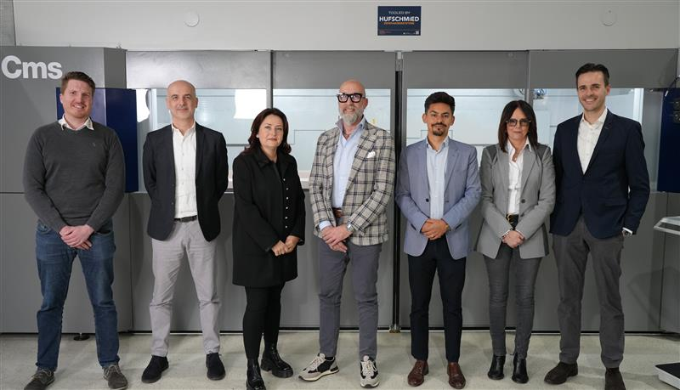Image source: Hufschmied Zerspanungssysteme
Christel Hufschmied, Managing Director of Hufschmied Zerspanungssysteme GmbH, and Matteo Radicioni, CEO of CMS S.p.A., (center) have decided to work together. (from left to right: Thomas Niefenecker, Roberto Milesi, Christel Hufschmied, Matteo Radicioni, Patrick Pulendran, Mirella Locatelli and Stefano Locher)

About CMS
CMS S.p.A. manufactures CNC machines and systems for composite materials, carbon fiber, aluminum, light alloys, plastic, glass, stone, and metals processing. Its offer has expanded with a complete range of solutions for Large Format Additive Manufacturing. The Company was established in 1969 by Mr Pietro Aceti with a vision of offering customized and state-of-the-art solutions, based on the in-depth understanding of the customer’s production needs. Significant technological innovations, originating from substantial investments in research and development and take-overs of premium companies, have enabled constant growth in the various sectors of reference. CMS is part of SCM Group, a technological world leader in processing a wide range of materials: wood, plastic, glass, stone, metal, and composites. The Group companies, operating throughout the world, are reliable partners of leading manufacturing industries in various market sectors, including the furniture, construction, automotive, aerospace, ship-building, and plastic processing industries.

SCM Group coordinates, supports, and develops a system of industrial excellence with highly specialized and integrated plants in Italy and other sites in Germany, the United States and Brazil with production dedicated to local markets.
SCM Group has a turnover of 900 million euro, more than 4,000 employees and a direct presence on five continents.
CMS S.p.A.: your technology partner
For further information: www.cms.it/en
Additional information:  CMS S.p.A.  Via A. Locatelli 123  24019 Zogno (Bg)  Italy  Phone: +39 0345 64111  E-Mail: info@cms.it  www.cms.it/en | Press contact:  Elena Turba  Phone: +39 342 5419082  E-Mail: elena.turba@cms.it

About Hufschmied Zerspanungssysteme GmbH
Established in 1991 and headquartered in Bobingen near Augsburg, Hufschmied Zerspanungssysteme GmbH is a manufacturer of high-quality tools for machinable production and friction stir welding. By specializing at an early stage in the machining of plastics, fiberglass materials and carbon fiber, Hufschmied has become a leader in Europe in the development of solutions for new materials. The company is an established system supplier to renowned machine tool manufacturers. Tools and manufacturing process consulting from Hufschmied are particularly valued in the automotive and aerospace industries as well as in medical technology. The company is involved in numerous organizations, including Composites United Deutschland e. V. Hufschmied's manufacturing operations are located in Bobingen, Winterlingen and Sigmaringen on the Swabian Alb. Hufschmied is certified according to ISO 9001:2015 (quality management) and ISO 14001:2015 (environmental management).
Hufschmied Zerspanungssysteme GmbH – One Cut Ahead
For more information: www.hufschmied.net

Additional information:  Hufschmied Zerspanungssysteme GmbH  Marco Beigl  Edisonstrasse 11d  86399 Bobingen  Germany  Phone: +49 8234 9664-0  Telefax: +49 8234 9664-99  E-Mail: info@hufschmied.net  www.hufschmied.net | Press contact:  HighTech communications GmbH  Brigitte Basilio  Brunhamstrasse 21  81249 Munich  Germany  Phone: +49 89 500778-20  E-Mail: b.basilio@htcm.de  www.htcm.de

