PRESS RELEASE

Würth Elektronik extends its RGB LED product series
Compact LEDs for Pleasant, Even Lighting
Waldenburg (Germany), May 8, 2025 – Würth Elektronik expands its RGB LED series WL-SFTD SMT Full-color Top LED with the 2828 package, featuring a dome lens and a 70-degree emission angle. This ensures targeted and even light distribution, minimizing glare and maximizing brightness. The durable LEDs are suitable for demanding lighting and signaling applications – and thanks to their IPx8 water protection, they are also suitable for exposed outdoor conditions.
By combining a footprint of just 2.8 × 2.8 mm, a dome lens with an optimal 70-degree emission angle, efficient RGB color control, and an elegant matte black housing, an innovative solution is offered for flexible, energy-efficient lighting. Thanks to their high contrast and premium dynamic color display, the LEDs are ideal as pixels for video walls. With their matte black housing, they achieve up to 25 percent higher contrast than white PLCC LED housings.
The 70-degree emission angle of the dome lens improves light directionality, resulting in up to 20 percent more even light distribution compared to conventional LEDs with a lower emission angle. Besides video walls and displays, the LEDs are also suitable for architectural lighting as well as pathway and street lighting. Their IPx8 water protection also makes them ideal for use in harsh environments and weatherproof installations, audio and DJ equipment, as well as smart home and electronic products.
The new 2828 package, as well as all other packages from the WL-SFTD series, are now available from stock without a minimum order quantity. As a service for developers, Würth Elektronik provides free samples.

Available images
The following images can be downloaded from the Internet in printable quality: https://kk.htcm.de/press-releases/wuerth/

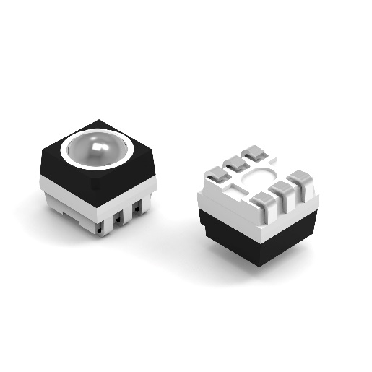
Image source: Würth Elektronik
Even light from a miniaturized LED:
WL-SFTD SMT Full-color Top LED with dome lens in the 2828 package

About the Würth Elektronik eiSos Group
Würth Elektronik eiSos Group is a manufacturer of electronic and electromechanical components for the electronics industry and a technology company that spearheads pioneering electronic solutions. Würth Elektronik eiSos is one of the largest European manufacturers of passive components and is active in 50 countries. Production sites in Europe, Asia and North America supply a growing number of customers worldwide.
The product range includes passive components, power modules, digital isolators, optoelectronics, electromechanical components, thermal management solutions, sensors and wireless modules. The portfolio is rounded off by customer-specific solutions.
The unrivaled service orientation of the company is characterized by the availability of all catalog components from stock without minimum order quantity, free samples and extensive support through technical sales staff and selection tools.
Würth Elektronik is part of the Würth Group, the global market leader in the development, production, and sale of fastening and assembly materials, and employs around 7,500 people. The Würth Elektronik Group generated sales of 1 Billion Euro (all figures according to preliminary results for 2024).
Würth Elektronik: more than you expect!
Further information at www.we-online.com

Further information:  Würth Elektronik eiSos GmbH & Co. KG  Sarah Hurst  Clarita-Bernhard-Strasse 9  81249 Munich  Germany  Phone: +49 7942 945-5186  E-mail: sarah.hurst@we-online.de  www.we-online.com | Press contact:  HighTech communications GmbH  Brigitte Basilio  Brunhamstrasse 21  81249 Munich  Germany  Phone: +49 89 500778-20  E-mail: b.basilio@htcm.de  www.htcm.de

