FOR THE MEDIA
ASMPT at SEMICON SEA showcases comprehensive advanced packaging expertise
Empower the Intelligence Revolution
Singapore, May 8, 2025 – ASMPT, a leading global supplier of hardware and software solutions for the manufacture of semiconductors and electronics, in particular advanced packaging (AP) solutions, will be exhibiting at SEMICON Southeast Asia (SEA) from 20 to 22 May 2025 at the Sands Expo and Convention Centre, Singapore (Booth L1613). ASMPT has consistently focused on innovation and technology leadership, emphasising its position as a trusted partner of the global semiconductor industry – especially in challenging times that require stable partnerships and technologically superior solutions. In line with this commitment, Dr Gary Widdowson, Chief Technology Officer at ASMPT Semiconductor Solutions, will present ‘ASMPT AP Technology for HI’ at the ‘Advanced Packaging & Heterogeneous Integration Summit’ on 21 May 2025.
The demand for more sophisticated packaging technologies is growing swiftly, driven by key applications such as high-performance computing, 5G and 6G telecommunications, modern automotive systems, and the rapidly increasing adoption of artificial intelligence. High-performance packaging capabilities are crucial to realise higher integration densities, increased energy efficiency, and reliable system performance.
Comprehensive portfolio for the entire AP spectrum
ASMPT's broad-based AP solutions portfolio covers all key technologies crucial for current and future requirements in AP. These include fan-out wafer level packaging (FOWLP), flip-chip interconnection, thermo-compression bonding (TCB), hybrid bonding, system-in-package (SiP), die attach for power devices and solutions for heterogeneous integration.
In addition to AP, ASMPT’s mainstream solutions portfolio includes high-end wire bonding technologies for high-frequency and automotive applications, highly automated packaging and material handling systems, as well as technologies for photonics and optical interconnect packaging, which are becoming increasingly important, particularly in meeting future high-speed and high-density requirements.
ASMPT’s solutions make it possible for customers to reliably fulfil demanding requirements for miniaturisation, signal and power integrity as well as thermal management, even at the highest power densities.
Singapore as a strategic innovation centre for advanced packaging
As part of a global development and production network, ASMPT’s state-of-the-art facility in Singapore plays a central role as an innovation and competence centre for AP. In addition to working closely with customers and partners in the global network, ASMPT continues to make strategic investments to expand its technological expertise and develop a strong talent pool of highly qualified engineers and technology specialists in Singapore. The combination of global expertise, global networking and knowledge sharing, and direct local market access creates ideal conditions for the fast implementation of new packaging concepts and for successfully meeting the growing requirements in the key markets for advanced packaging.
Strong partner in a dynamic environment
“Customers worldwide rely on trustworthy partnerships, especially in times of great global challenges and increasing demands on supply chain resilience”, explains Dr Gary Widdowson, Chief Technology Officer at ASMPT Semiconductor Solutions. “ASMPT is clearly positioning itself in Singapore as a reliable and stable technology partner whose solutions contribute to technological resilience with its solutions, especially in Asia and Europe.”
As part of the ‘Advanced Packaging & Heterogeneous Integration Summit’, Dr Widdowson will give a presentation entitled ‘ASMPT AP Technology for HI’ on 21 May 2025.
By taking part in SEMICON SEA, the region’s leading platform for the semiconductor and microelectronics industry, ASMPT underlines its key role in the field of AP – as a driver of innovation, a trusted partner and an enabler for the next generation of electronic systems.

Illustrations for downloading
The following print-ready artwork is available on the internet for downloading:
https://kk.htcm.de/press-releases/asmpt/

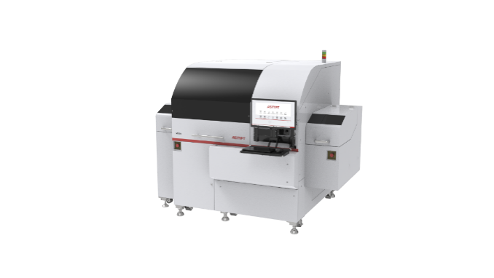 | 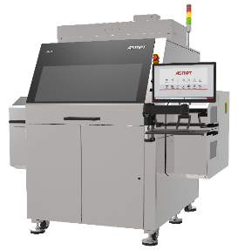
MEGA – Revolutionizing multi-chip packaging with precision and efficiency  Image credit: ASMPT | DALA – universal Pick & Place system for all camera module components  Image credit: ASMPT
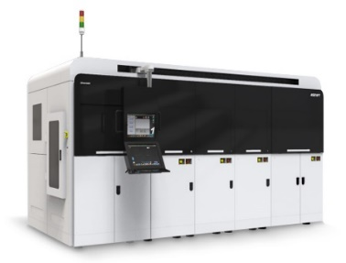 | 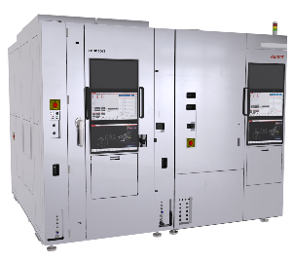
SilverSAMTM – sintering platform with an oxidation-free, copper-friendly environment for high-throughput of power modules  Image credit: ASMPT | LITHOBOLT® – ultra-high precision die bonder for die to wafer (D2W) hybrid bonding  Image credit: ASMPT
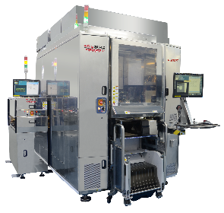 | 
FIREBIRD Series – enable advanced tech node semiconductor device for HPC data centre  Image credit: ASMPT | Dr Gary Widdowson, Chief Technology Officer at ASMPT Semiconductor Solutions  Image credit: ASMPT

About ASMPT Limited (“ASMPT”)
ASMPT Limited is a leading global supplier of hardware and software solutions for the manufacture of semiconductors and electronics. Headquartered in Singapore, ASMPT’s offerings encompass the semiconductor assembly & packaging, and SMT (surface mount technology) industries, ranging from wafer deposition to the various solutions that organise, assemble and package delicate electronic components into a vast range of end-user devices, which include electronics, mobile communications, computing, automotive, industrial and LED (displays). ASMPT partners with customers very closely, with continuous investment in R&D helping to provide cost-effective, industry-shaping solutions that achieve higher productivity, greater reliability, and enhanced quality. ASMPT is also a founding member of the Semiconductor Climate Consortium.
To learn more about ASMPT, please visit us at asmpt.com.

About ASMPT Semiconductor Solutions (“ASMPT SEMI”)
ASMPT SEMI is the leading supplier in advanced packaging and semiconductor assembly solutions. With a commitment to innovation and customer satisfaction, ASMPT SEMI provides a comprehensive range of products and services that cater to the evolving needs of the microelectronics industry. Their expertise spans across areas such as flip-chip and wafer-level packaging, advanced interconnect technologies, and more. ASMPT SEMI's cutting-edge solutions enable customers to achieve higher performance, increased reliability, and improved cost-efficiency when producing their semiconductor devices.
For more information about ASMPT SEMI, visit semi.asmpt.com.
Media contacts:
Global ASMPT Semiconductor Solutions Press Office
ASMPT Limited Hong Kong
Jessica Ho
Semiconductor Solutions
E-Mail: semi_stratmkt@asmpt.com
Website: semi.asmpt.com

Global ASMPT Press Office
ASMPT Ltd.
Susanne Oswald
Rupert-Mayer-Strasse 48
81379 Munich
Germany
Phone: +49 89 20800-26439
E-Mail: susanne.oswald@asmpt.com
Website: asmpt.com

