Media information
S+P Samson supplies dummies for setting up
GROB’s battery production plants.
Label manufacturer in demand as a technical films expert
Kissing, 29 April 2025 – GROB-WERKE GmbH & Co. KG relies on pre-cut special films from S+P Samson when setting up its high-precision battery stack production systems. The films serve as dummies for the expensive graphite anodes and cathodes. They ensure that the machines are calibrated without dust contamination and waste. The use of dummies has proven itself as a resource-saving process step and is expected to become standard practice among battery manufacturers.
"As we have been using indestructible industrial labels for many years, we know S+P Samson as specialists in the processing of technical films. The labelling materials gave us the idea of discussing our challenges in battery production with S+P. This led to an ingenious solution," recalls Stefan Weizmann, application engineer for special machines for the series production of battery cells at GROB-WERKE GmbH & Co. KG.
Batteries like those used in electric vehicles, consist of layers of electrodes and a separator film with a ceramic coating. To produce the stacks, the materials are fed from rolls, cut, stacked and measured electronically to an accuracy of 1/100 mm. Sheets that do not fit perfectly are ejected and correct sheets are stacked. To ensure that no electrode material is wasted during machine set-up, S+P Samson supplies a replacement material – a PET film with a precisely matched coating that behaves exactly like the electrode films. S+P Samson punches the contour of the dummies with an accuracy of 1/100 mm using a solid-state punch. The dummies are then supplied as coils with a length of approximately 1 km. During calibration, two coils, one as an anode dummy and one as a cathode dummy, run through the machine in 45 minutes.
A new business unit is established
“The delivery of the electrode dummies for GROB's battery production is a fascinating project for us, which has shown us that thanks to our capabilities and expertise as the market leader for heavy-duty labels, we are now also very much in demand as a partner for the processing and customisation of technical films,” explains Karl Tochtermann, CEO of S+P Samson GmbH. “We are looking forward to applying our know-how to other contexts and applications.”

Available images
The following printable images are available for download:
http://www.htcm.de/kk/spsamson/

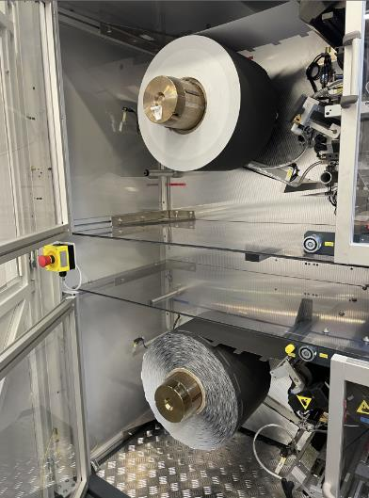  Image source: S+P Samson  Equipment for the series production of battery cells at GROB-WERKE GmbH & Co. KG. The material for the anode and cathode is not to be wasted during the machine set-up, hence the dummy material provided by S+P Samson is used here. | 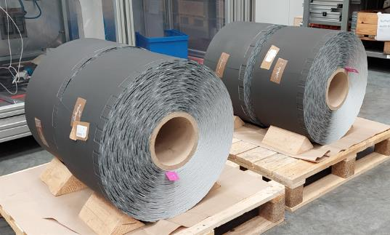  Image source: S+P Samson  Looks and behaves like the electrode material: S+P Samson dummy material for machine set-up.
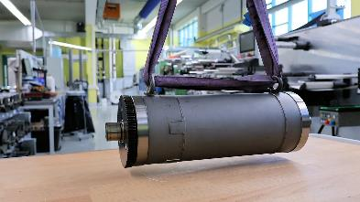  Image source: S+P Samson  S+P Samson uses this solid-state punch to punch the contours of the dummies with an accuracy of 1/100 mm. | 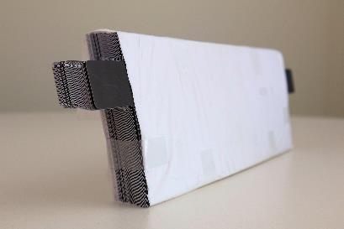  Image source: S+P Samson  When the perfectly fitting dummies of the electrode stacks leave the machine, the GROB system can start battery cell production.

S+P Samson GmbH
Founded in 1978, S+P Samson GmbH is a global manufacturer of labelling systems for extreme industrial requirements. The company develops and distributes labels that enable reliable identification of goods even under conditions of extreme temperatures, chemical or mechanical stress. S+P Samson is the market leader with its GRAPHIPLAST® plastic labels. S+P Samson advises on individual identification concepts that are characterised by the best interaction of label and printing system. As a system supplier, S+P Samson offers labelling, printing and identification solutions based on barcodes and RFID.
For further information visit www.sp-samson.com

Press contact:
S+P Samson GmbH
Nadja Hörmann
Marketing Manager
Industriestraße 32
86438 Kissing, Germany
Phone: +49 8233 846-187
Email: nadja.hoermann@sp-samson.com

HighTech communications GmbH
Marcus Planckh
Brunhamstraße 21
81249 München, Germany
Phone: +49 89 500778-22
Email: m.planckh@htcm.de
www.htcm.de

