PRESS RELEASE

Würth Elektronik Launches new Development Kit
Evaluation of SN6507 IC
Watertown (USA), April 29, 2025 – Würth Elektronik is excited to announce the launch of the SN6507 Development Kit [756507], featuring the Texas Instruments (TI) SN6507EVM. This comprehensive solution is designed to help engineers evaluate the performance of TI’s SN6507 transformer driver for isolated power supplies, featuring Würth Elektronik’s WE-PPTI transformer line. The development kit includes two versatile boards and 16 transformer samples, offering unparalleled flexibility for various industrial and medical applications.
The SN6507 Development kit is equipped with a fixed board [650796] offering 24Vin-15Vout configuration, optimized with the WE-PPTI transformer [750319696] for a streamlined design.
The SN6507 Development Kit also includes a configurable board [650700] which enables engineers to evaluate different transformers and specifications to meet diverse application needs. To top it off, the SN6507 kit includes 16 transformer samples, which provide flexibility and customization options during development.
This kit is tailored for applications such as motor drives, isolated power supplies for communication protocols (CAN, RS-485, RS-422, RS-232, SPI, I2C), medical instruments, solar inverters, and automation systems. With full EMI compliance to CISPR32 standards, the boards deliver optimal performance in demanding industrial and medical environments, ensuring reliability and efficiency. The fixed and configurable designs allow engineers to adapt and innovate for a wide range of use cases, making the kit an essential tool for design and testing.
Engineers and developers can take advantage of this all-in-one solution to simplify their evaluation processes and accelerate their project timelines. The SN6507 Development Kit is now available for purchase on the Würth Elektronik website:
https://www.we-online.com/en/components/products/DESIGN_KIT_756507

Available images
The following images can be downloaded from the Internet in printable quality: https://kk.htcm.de/press-releases/wuerth/
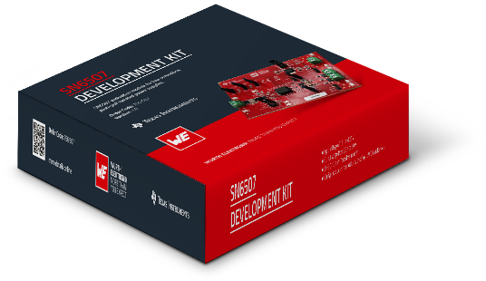
Image source: Würth Elektronik
Würth Elektronik’s development kit simplifies evaluation of SN6507 IC.

About the Würth Elektronik eiSos Group
Würth Elektronik eiSos Group is a manufacturer of electronic and electromechanical components for the electronics industry and a technology company that spearheads pioneering electronic solutions. Würth Elektronik eiSos is one of the largest European manufacturers of passive components and is active in 50 countries. Production sites in Europe, Asia and North America supply a growing number of customers worldwide.
The product range includes passive components, power modules, digital isolators, optoelectronics, electromechanical components, thermal management solutions, sensors and wireless modules. The portfolio is rounded off by customer-specific solutions.
The unrivaled service orientation of the company is characterized by the availability of all catalog components from stock without minimum order quantity, free samples and extensive support through technical sales staff and selection tools.
Würth Elektronik is part of the Würth Group, the global market leader in the development, production, and sale of fastening and assembly materials, and employs around 7,500 people. The Würth Elektronik Group generated sales of 1 Billion Euro (all figures according to preliminary results for 2024).

Würth Elektronik: more than you expect!
Further information at www.we-online.com

Further information:  Wurth Electronics Midcom, Inc.  Amelia Thompson  121 Airport Drive  PO Box 1330  Watertown, SD 57201 USA  Phone: +1 605 886 4385  Toll-free (in the U.S.):  Phone: +1 800 643 2661  E-mail: amelia.thompson@we-online.com  www.we-online.com | Press contact:  HighTech communications GmbH  Brigitte Basilio  Brunhamstrasse 21  81249 Munich  Germany  Phone: +49 89 500778-20  E-mail: b.basilio@htcm.de  www.htcm.de

