PRESS RELEASE
OPEN MIND Releases hyperMILL® 2025
Ease of use for CAM models and powerful CAD functions
Wessling (Germany), April 28, 2025 – OPEN MIND presents the 2025 release of its hyperMILL® CAD/CAM suite. The highlight of the new version is the easy-to-use, automatic deburring function. The 2025 release includes a new tessellation algorithm and a simplified element display for CAD models, which help further accelerate the CAD part of the software.
Deburred edges and holes are not only crucial from a functional point of view, but also contribute significantly to the quality and value of the end product. hyperMILL® 2025 offers a package with three new strategies for deburring directly on the machine. Users can deburr a wide variety of component geometries quickly and reliably. 5-axis Deburring is an effective solution for breaking the sharp edges of a component. Once the edges have been selected, the strategy calculates all toolpaths automatically. The strategy supports both a 3-axis and a 5-axis mode, in which machining is indexed where possible. The same applies to the strategy for deburring edges on holes and intersecting holes. Another strategy in this context is hole brushing, in which a special brushing tool deburrs cross holes, threads, or other features or improves the surface quality. The machining process is divided into different phases, and the machining parameters such as spindle, feedrate, speed, coolant, and dwell time can be defined for each phase.
5-axis automatic mode
The new 5-axis algorithm in hyperMILL® calculates an optimum machining sequence of simultaneous and indexed tool movements, thanks to the pre-analysis of the entire toolpath. Indexed processing (which is preferred, as it runs faster) and simultaneous processing phases are selected automatically. The new 5-axis ISO Machining strategy allows surfaces to be machined according to the course of the ISO lines (U and V). A new high-precision surface mode with a homogeneous point distribution can be used here, in addition to feed adjustment for curvatures and 3D radius correction. This is also available in 5-axis profile finishing for surface and cavity machining. Both strategies are adaptations of proven 3D techniques.
Milling and turning
The pocket milling algorithm has been redeveloped for 3D-optimized roughing in order to achieve greater efficiency during roughing, especially when machining large lateral infeeds. You can better control toolpath rounding by defining the contour radius and the path radius separately. This is important for the new “Axis Parallel mode” machining strategy when machining flat surfaces. There are also new functions for turning. It is now possible to use the 3D model to create a V-sketch for turning contours very quickly and easily. You can use the V-sketch to define the dimensions and tolerances. Based on these values, the turning contour can be moved to the center of the tolerance.
The new automatic stock chain provides security, especially when switching between turning and milling operations or other projects with a large number of process steps. hyperMILL® creates all stock automatically and in the correct sequence, even if the job sequence has been changed.
hyperMILL® VIRTUAL Machining
Lathes with a turret and a main spindle are mapped as a digital twin for hyperMILL® VIRTUAL Machining. Turning in hyperMILL® now supports FANUC and Mitsubishi controls as well as Siemens controls. Another new feature is job calculation with the virtual machine. This means that the machine model is available to hyperMILL® during toolpath calculation. Collision control and avoidance are carried out taking machine geometry and limits into account. It results in more precise, optimized toolpaths, especially in tight spaces.
hyperMILL® and Hummingbird-MES: Improved tool management
The integration between hyperMILL® and Hummingbird-MES is also progressing, for example, in the area of tool management. The release of the new version means that users can benefit from an even deeper integration of both systems. Tool data from the hyperMILL® tool database can now be managed consistently and conveniently across systems. Tools can be exported directly from hyperMILL®, including all relevant technology parameters. These tools are automatically locked in hyperMILL® as soon as they are transferred to Hummingbird in order to avoid inconsistent tool data. This creates a consistent, reliable, and efficient process for tool management – from the CAM system to Hummingbird and other systems such as a tool presetter.

Available images
The following images are available for download in printable format at:
https://kk.htcm.de/press-releases/open-mind/
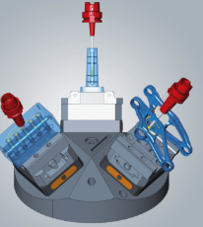  Source: OPEN MIND  hyperMILL® 2025 offers a package with comprehensive strategies for deburring directly on the machine. | 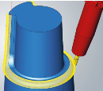  Source: OPEN MIND  5-axis machining of ISO surfaces with increased surface quality and programming support through intelligent algorithms.

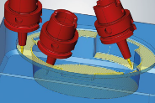  Source: OPEN MIND  The improved version of 5-axis profile finishing incorporates many familiar and innovative functions from 3D profile finishing. | 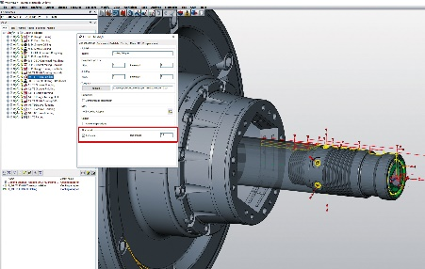  Source: OPEN MIND  New handling of stock: hyperMILL® creates all stock automatically and in the correct sequence across all processing modes.

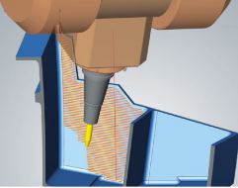  Source: OPEN MIND  Job calculation with a virtual machine: More precise and optimized toolpaths, especially in tight spaces or when the machine head is working close to the component or at the machine’s limits. | 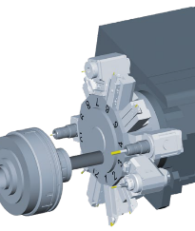  Source: OPEN MIND  hyperMILL® VIRTUAL Machining technology now provides support for lathes with a turret and a main spindle in conjunction with FANUC and Mitsubishi controls.

Available videos
You can find the following videos on our YouTube channel:
https://youtu.be/JuMSalWzua0?si=DrCwaRwugeNj_tly
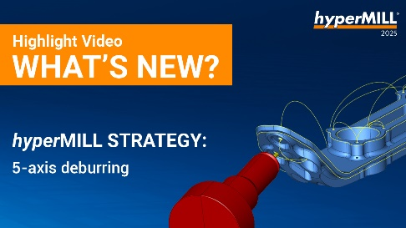
Source: OPEN MIND

hyperMILL® 5-axis Deburring: The ability to program precise and efficient deburring processes.

About OPEN MIND Technologies AG
OPEN MIND Technologies AG is one of the world’s leading developers of powerful CAD/CAM solutions for machine and controller-independent programming.
OPEN MIND develops optimized CAD/CAM solutions that include innovative and unique features that can deliver significantly higher performance in both programming and machining.
hyperMILL® is a completely modular CAD/CAM solution that provides state-of-the-art CAM technologies on its own CAD platform: from 2.5D, 3D and 5-axis machining as well as turning strategies and solutions for additive manufacturing, HSC and HPC machining. Whether automation, simulation or virtual machine – trendsetting technologies expand the product range and enable continuous digital process chains. Special applications, seamless interaction with all popular CAD solutions and exceptional customer service rounds out the company’s products and capabilities.
According to the “NC Market Analysis Report 2024” compiled by CIMdata, hyperMILL® is a leading, worldwide CAD/CAM solution. Innovative CAD/CAM technologies fulfill the highest demands in the aerospace, automotive, tool and mold manufacturing, production machining, medical, job shops, energy and semiconductor industries.
OPEN MIND's majority stake in manufacturing execution system (MES) developer Hummingbird expands the CAD/CAM manufacturer's product portfolio and enhances the range of connected digitalized manufacturing technologies.
OPEN MIND is a Mensch und Maschine company and has subsidiaries and qualified sales partners on all continents.
You can find more information at www.openmind-tech.com.

OPEN MIND Technologies UK Ltd., Oxford
Unit 3
Bicester Business Park
Telford Road
Bicester
Oxfordshire OX26 4LN
England
Phone: +44 1869 290 003
Fax: +44 1869 369 429
E-mail: Info.UK@openmind-tech.com

OPEN MIND Technologies USA, Inc.
1492 Highland Avenue, Unit 3
Needham MA 02492
USA
Phone: +1 339 225 4557 office
Phone: +1 888 516 1232 x0 toll-free
Fax: +1 270 912 5822
E-mail: Info.Americas@openmind-tech.com

OPEN MIND Technologies Asia Pacific Pte Ltd
MOVA Building, 22 Jalan Kilang #03-00
Singapore 159419
Phone: +65 6742 95-56
E-mail. Info.Asia@openmind-tech.com

Head office:
OPEN MIND Technologies AG, Argelsrieder Feld 5, 82234 Wessling, Germany
Tel.: (+49-8153) 933-500, Fax: (+49-8153) 933-501
E-mail: Info@openmind-tech.com, website: www.openmind-tech.com

Press contact:
HighTech communications GmbH
Brigitte Basilio
Brunhamstrasse 21
81249 Munich
Germany
Tel.: (+49-89) 500778-20
E-mail: b.basilio@htcm.de
Website: www.htcm.de

