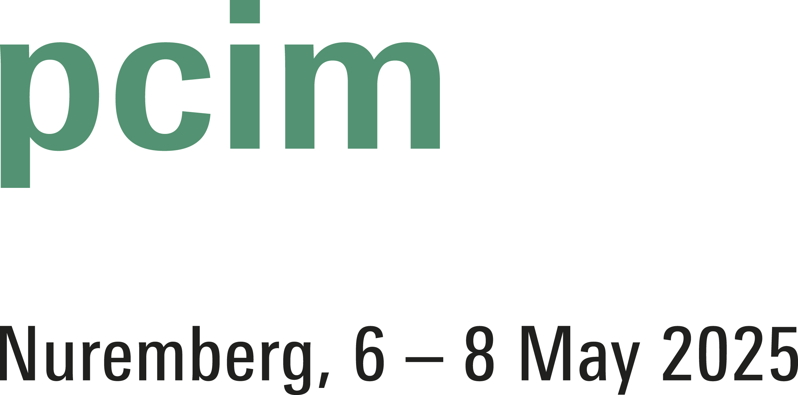
PRESS RELEASE
Würth Elektronik ICS at PCIM Europe 2025
PowerBasket – the reliable board-to-board connection solution
Hall A6 Stand 337
Niedernhall (Germany), April 14, 2025 – Würth Elektronik ICS will be exhibiting at PCIM in Nuremberg from 6 to 8 May 2025. The specialist for PCB connection solutions in the high-current sector and inventor of Powerelements will be focussing on power electronics at exhibition stand 337 in hall A6. Taking centre stage: the lead-free Powerelement ‘LF PowerBasket’, an innovative pluggable high-current contact for contacting printed circuit boards in demanding industrial and automotive applications.
The LF PowerBasket can be connected to the PCB using press-fit technology, SMT or THT. Thanks to a special contact alloy, the LF PowerBasket can be used at a continuous operating temperature of 150 °C. The contact springs of the LF PowerBasket form a basket that is optimally designed to hold the contact pins and blades with low insertion forces. This basket design of the LF PowerBasket without a plastic housing is characterised by a high position tolerance of 0.6 mm. The Powerelement can therefore be used very well for board-to-board connections with multiple contacts. Additional advantages of the pluggable connections include reduced installation effort and simplified maintenance procedures. A 3D-printed oversized version of the LF PowerBasket SMD will provide entertainment at the trade fair stand, where visitors can prove their marksmanship in a basketball game.
PowerBusbar PCB
The PowerBusbar PCB busbars are another highlight at the exhibition stand. These copper busbars are ideal for the systematic distribution of high currents to PCBs. In combination with Powerelements such as LF PowerOne Press-Fit and LF PowerPlus, they are pressed together with the PCB in a single operation. The solid press-fit technology creates a gas-tight cold-welded connection with low contact resistance, which guarantees a very high current-carrying capacity. The busbar design is customised based on the PCB layout, ensuring optimum adaptation to the respective application. Offering a wide range of design options, the busbars are typically manufactured in thicknesses of 1.0 or 1.5 mm.
On the online platform powerelement.com, interested parties can find detailed information on Powerelements and PowerBusbars, order samples and get quick answers to their questions via chat.

Available images
The following images can be downloaded from the Internet in printable quality: https://kk.htcm.de/press-releases/wuerth-ics/
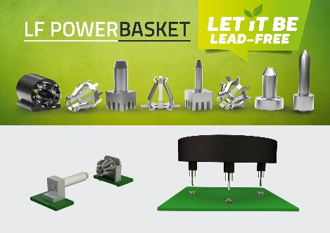  Image source: Würth Elektronik ICS  The lead-free Powerelement LF PowerBasket is an innovative pluggable high-current contact. | 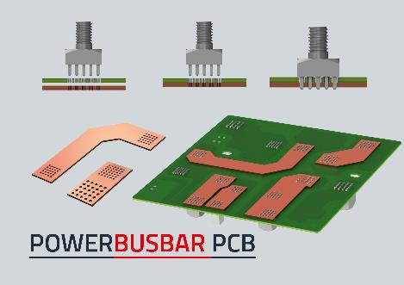  Image source: Würth Elektronik ICS  PowerBusbar PCB: These copper busbars are ideal for the systematic distribution of high currents to PCBs.

About Würth Elektronik ICS GmbH & Co. KG
Würth Elektronik ICS is a system supplier for electromechanical and electronic solutions for signal and power distribution, control, and display and operating solutions. The company’s key customers include well-known manufacturers of construction and agricultural machinery as well as commercial vehicles. Sectors such as industrial technology or renewable energies also benefit from products and services provided by ICS. The company is headquartered in Niedernhall-Waldzimmern (Germany). Further subsidiaries are located in France, Great Britain, Italy, the USA, China, and India.
Würth Elektronik is part of the Würth Group, the global market leader in the development, production, and sale of fastening and assembly materials, and employs 7,500 people. In 2024, the Würth Elektronik Group generated sales of 1.03 billion Euro.
Würth Elektronik: more than you expect!
Further info at www.we-online.com/ics

More information:  Würth Elektronik ICS GmbH & Co. KG  Sandra Herter  Gewerbepark Waldzimmern  Würthstrasse 1  74676 Niedernhall  Germany  Phone: +49 7940 9810-1503  E-mail: sandra.herter@we-online.de  www.we-online.com/ics | Press contact:  HighTech communications GmbH  Marcus Planckh  Brunhamstrasse 21  81249 Munich  Germany  Phone: +49 89 500778-22  E-mail: m.planckh@htcm.de  www.htcm.de

