FOR THE MEDIA
ASMPT Semiconductor Solutions at PCIM
Focus on automotive power electronics
Regensburg (Germany), April 15, 2025 – At this year’s PCIM trade event in Nuremberg, ASMPT focuses on power electronics for the vehicle of the future at booth 145 in hall 6. With its comprehensive machine portfolio, the market and technology leader offers innovative solutions for the entire production process of automotive power modules.
“Hardly any other area is influenced as much by the energy transition as the automotive industry,” said Dr. Johann Weinhändler, Regional Head of ASMPT Semiconductor Solutions Europe and Managing Director of ASMPT AMICRA in Regensburg. “The vehicle of the future will be fully electric and is basically a high-performance computer on wheels. This requires a new generation of efficient and reliable power electronics – i.e., power modules. To produce these, we offer semiconductor manufacturers innovative high-performance solutions from a single source.”
The spectrum of technology platforms offered by ASMPT covers the entire production cycle of modern power electronics, ranging from wafer separation, printing and curing to die and module tracking, silver-sintering, and finally encapsulation. Four machines that are particularly relevant for the demanding applications in automotive power electronics will be highlighted at the PCIM event:
Gentle separation with ALSI LASER1205
The ALSI LASER1205 platform for wafer grooving and separation processes even highly sensitive dies with precision thanks to its integrated V-DOE technology which greatly reduces the area affected by heat. The machine’s ergonomic design and user-friendly touchscreen interface enable intuitive operation and speed up training.

Ag/Cu sintering with POWER VECTOR
This innovative die tacking solution for Ag/Cu sintering features a heated thermo-compression bonding head and processes various silver sintering materials, including silver film stamping and the automated handling of silver film for mass production. The heated workpiece holder has a generously sized platen measuring 140 mm × 340 mm.
Silver sintering with SilverSAM™
Designed for high-volume production, the SilverSAM silver sintering platform features an oxidation-free, copper-friendly operating environment. It processes various substrate formats and produces highly reliable connections that are clearly superior to classic soldered joints in terms of mechanical and thermal resilience and electrical conductivity.
Flexible encapsulation with 3GeP
The 3GeP molding platform encapsulates multiple power modules measuring in total up to100 mm × 300 mm per work piece carrier fitting 2 work piece carrier per mold shot. Depending on the production requirements, the machine can be equipped with one to four presses and be integrated seamlessly into existing production lines – both in front-of-line (FOL) and post-encapsulation (PEP) areas with full inline capability.

Illustrations for downloading
The following print-ready artwork is available on the internet for downloading:
https://kk.htcm.de/press-releases/asmpt/

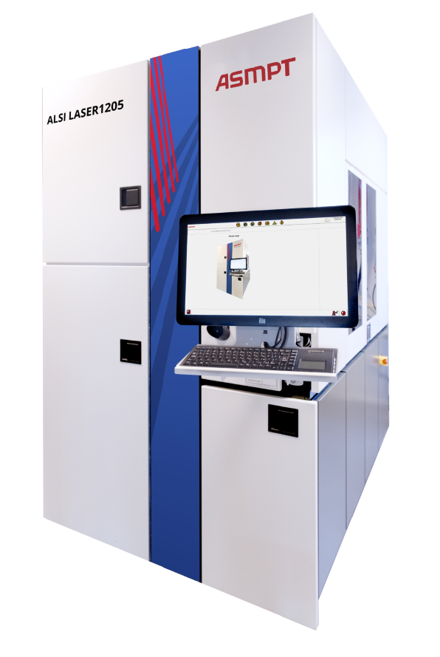 | 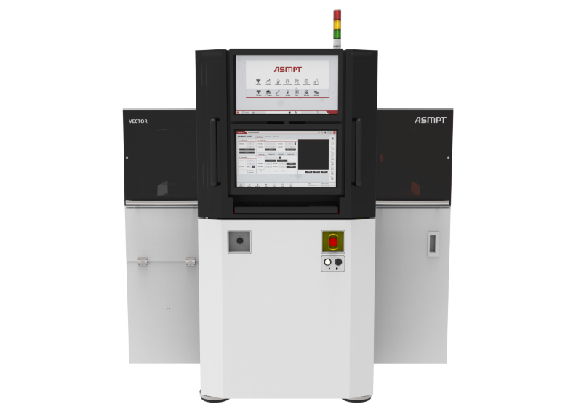
Top process quality with maximum yields: The ALSI LASER1205 features patented V-DOE (Vertical Diffractive Optical Element) technology.  Image credit: ASMPT | Powerhouse for power electronics: With a bonding force of up to 600 N, the POWER VECTOR is the ideal component for state-of-the-art power module production lines in the automotive sector.  Image credit: ASMPT
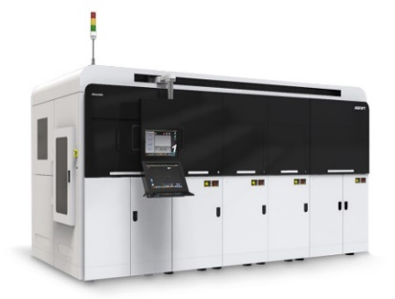 | 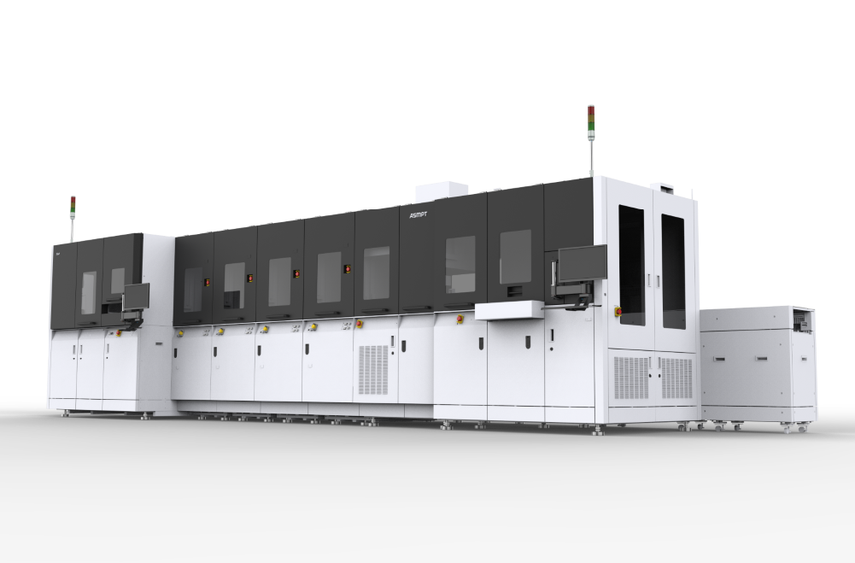
High-volume production with up to three presses: The SilverSAM™ sintering platform features an oxidation-free, copper-friendly environment for the production of power modules.  Image credit: ASMPT | The 3GeP universal power molding platform enables manufacturers to meet the diverse requirements of the automobile industry with unparalleled flexibility and efficiency.  Image credit: ASMPT

About ASMPT Limited (“ASMPT”)
ASMPT Limited is a leading global supplier of hardware and software solutions for the manufacture of semiconductors and electronics. Headquartered in Singapore, ASMPT’s offerings encompass the semiconductor assembly & packaging, and SMT (surface mount technology) industries, ranging from wafer deposition to the various solutions that organize, assemble and package delicate electronic components into a vast range of end-user devices, which include electronics, mobile communications, computing, automotive, industrial and LED (displays). ASMPT partners with customers very closely, with continuous investments in R&D helping to provide cost-effective, industry-shaping solutions that achieve higher productivity, greater reliability, and enhanced quality. ASMPT is a founding member of the Semiconductor Climate Consortium.
To learn more about ASMPT, please visit www.asmpt.com.

About ASMPT Semiconductor Solutions (“ASMPT SEMI”)
ASMPT SEMI is the leading provider of forward-looking solutions for advanced packaging and semiconductor assembly. With its commitment to innovation and customer satisfaction, ASMPT SEMI offers a comprehensive range of products and services that meet the evolving needs of the microelectronics industry. Expert knowledge covers areas such as flip-chip and wafer-level packaging, advanced interconnect technologies, and more. ASMPT SEMI’s state-of-the-art solutions enable customers to achieve higher performance, greater reliability, and improved cost-efficiency in the manufacturing of their semiconductor devices.
For more information about ASMPT SEMI, visit semi.asmpt.com.

Media contacts:
Global ASMPT Press Office
ASMPT Ltd
Susanne Oswald
Rupert-Mayer-Strasse 48
81379 Munich
Germany
Tel: +49 89 20800-26439
E-mail: susanne.oswald@asmpt.com
Website: asmpt.com

HighTech communications GmbH
Barbara Ostermeier
Brunhamstrasse 21
81249 Munich
Germany
Tel.: +49-89 500778-10|
E-mail: b.ostermeier@htcm.de
Website: www.htcm.de

