PRESS RELEASE

Würth Elektronik adds to its robust LED family
More Compact and Heat-Resistant
Waldenburg (Germany), April 9, 2025 – Würth Elektronik adds to its successful WL-SMTW LED series with two new variants. The SMT-mountable mono-color top-view LEDs are now available in a 1608 package. New LEDs are being added in the standard 3528 package, which feature an increased operating temperature of up to 100°C. The water-clear glass used enables precise color rendering at maximum intensity in five or six different colors.
With dimensions of just 1.6 × 0.8 × 0.55 mm, the new 1608 variant expands the WL-SMTW product line with particularly compact LEDs. These LEDs have proven to be highly reliable and energy-efficient. The miniature components are available in blue, green, yellow, amber, and two shades of red with wavelengths of 630 or 640 nm. Like all LEDs in the series, they emit no UV and IR.
The WE-SMTW 3258 HIGHTA is the third series of LEDs from Würth Elektronik following WL-SMCW 0603 and WL-SMTD that can withstand temperatures up to 100°C. The 3.5 × 2.8 × 1.85 mm LEDs are available in blue, green, yellow, amber, and red.
The application options for the robust and energy-efficient LEDs are wide ranging. They are suitable for signage and indirect lighting, backlighting in telecommunications applications or LCDs, as well as in fiber optic technology, Industrial and medical technology applications. As usual, Würth Elektronik offers all products in the series from stock with no minimum order quantity.

Available images
The following images can be downloaded from the Internet in printable quality: https://kk.htcm.de/press-releases/wuerth/

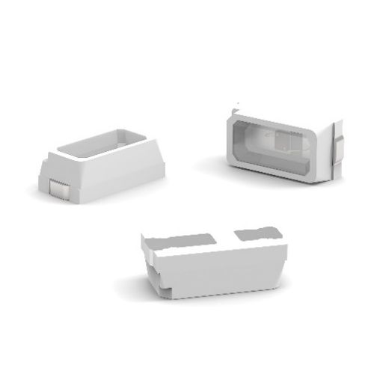
Image source: Würth Elektronik
1608 package – the reliable and energy-efficient LEDs of the WL-SMTW series with a miniature-format addition.

About the Würth Elektronik eiSos Group
Würth Elektronik eiSos Group is a manufacturer of electronic and electromechanical components for the electronics industry and a technology company that spearheads pioneering electronic solutions. Würth Elektronik eiSos is one of the largest European manufacturers of passive components and is active in 50 countries. Production sites in Europe, Asia and North America supply a growing number of customers worldwide.
The product range includes passive components, power modules, digital isolators, optoelectronics, electromechanical components, thermal management solutions, sensors and wireless modules. The portfolio is rounded off by customer-specific solutions.
The unrivaled service orientation of the company is characterized by the availability of all catalog components from stock without minimum order quantity, free samples and extensive support through technical sales staff and selection tools.
Würth Elektronik is part of the Würth Group, the global market leader in the development, production, and sale of fastening and assembly materials, and employs around 7,500 people. The Würth Elektronik Group generated sales of 1 Billion Euro (all figures according to preliminary results for 2024).
Würth Elektronik: more than you expect!
Further information at www.we-online.com

Further information:  Würth Elektronik eiSos GmbH & Co. KG  Sarah Hurst  Clarita-Bernhard-Strasse 9  81249 Munich  Germany  Phone: +49 7942 945-5186  E-mail: sarah.hurst@we-online.de  www.we-online.com | Press contact:  HighTech communications GmbH  Brigitte Basilio  Brunhamstrasse 21  81249 Munich  Germany  Phone: +49 89 500778-20  E-mail: b.basilio@htcm.de  www.htcm.de

