Press Release
Symeo Enhances LPR-1DHP-291 Radar Sensor with Bidirectionality
Measurement data available on both secondary radar sensors
Neubiberg, Germany, 03 April 2025 – LPR-1DHP-291 is a radar sensor from Symeo operating in the 60-GHz band. The sensor, which is based on the patented LPR® technology (Local Positioning Radar), has a proven track record in safeguarding gantry cranes in container handling areas and in bulk goods logistics applications, among others. In secondary radar applications, where two LPR-1DHP-291 units can determine distances of up to 300 meters, bidirectionality is now implemented as an optional feature by default. This means that the measured values are available at both sensors.
With secondary radar, one sensor transmits a radar signal that is reflected by a second sensor. This is more reliable than reflection by an object. Thanks to a firmware extension, the two sensors can now alternate between sending and responding. The most important use of this function is the implementation of an anti-collision solution between two crane bridges on the same level. Without bidirectionality, the measured values would only be available at the master sensor and the data would have to be transmitted to the second crane bridge via a cable or radio connection to alert the crane operator to a collision risk, for example.
With the introduction of bidirectionality on the LPR-1DHP-291 all Symeo radar sensors are now equipped with this feature.

Available image material
The following printable images are available for download on the Internet:
https://kk.htcm.de/press-releases/symeo/

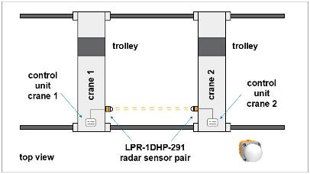  Image source: Symeo  A typical application of bidirectionality is an anti-collision solution for two crane bridges on the same level. | 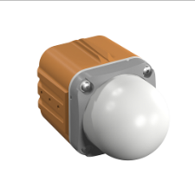  Image source: Symeo  LPR-1DHP-291 is an extremely robust radar sensor from Symeo for precision distance measurement over longer distances.

Symeo
Symeo develops and markets products and solutions for precise, non-contact, maintenance-free position detection, distance measurement, and collision avoidance. Symeo’s products feature extremely robust designs to make them suitable for applications in harsh industrial environments.
Symeo’s LPR® locating technology offers a wireless and real-time-capable measuring system that is ideally suited for industrial applications. Symeo has many years of experience in the development of cost-efficient and customer-specific industrial solutions on the basis of LPR® technology.
The company delivers standardized products and complete solutions to system integrators, original equipment manufacturers (OEMs), and end customers worldwide.
Headquarters: Symeo GmbH, Prof.-Messerschmitt-Strasse 3 a, 85579 Neubiberg, Germany
Phone: (+49-89) 6607-7960, Fax: (+49-89) 66077-96190
E-mail: info@symeo.com, Website: www.symeo.com

Press contact:
HighTech communications GmbH
Marcus Planckh
Brunhamstrasse 21 (Building 202/2nd floor)
81249 Munich
Germany
Phone: (+49-89) 500-77822
E-mail: m.planckh@htcm.de
Website: www.htcm.de

