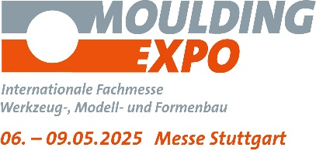
PRESS RELEASE

Hufschmied Zerspanungssysteme at the Moulding Expo 2025
Three materials, three special tools
Hall 6, Stand 6E35
Bobingen (Germany), April 2, 2025 – At this year's Moulding Expo (Stuttgart, May 6-9, 2025), Hufschmied Zerspanungssysteme GmbH, which specializes in process-optimized precision tools, is focusing on three tools in Hall 6, Stand 6E35: Graftor for graphite, HHF646 for hardened steel and C-Razor for copper.
The patented Graftor for the production of graphite electrodes not only enables more delicate structures than conventional tools but is also very efficient as a roughing-finishing tool with high material removal rates. One user was able to reduce machining time from 11 hours to less than 2 hours and has since been increasingly relying on EDM due to the faster availability of electrodes. Hufschmied now also has a special solution for users who prefer copper electrodes. The C-Razor will be presented for the first time at Moulding Expo 2025. To do justice to the soft material, a special geometry and coating, for example, prevent chip adhesion.
High-speed machining of hardened steel
Another new addition is the HHF646 high-speed roughing tool for steels up to 72 HRC. Thanks to its low cutting forces and extremely smooth running, the HHF646 enables exceptional surface quality and maximum process reliability. To raise awareness on this tool, Hufschmied is currently offering a low-cost starter kit.
“Continuous innovation and the development of customer-specific solutions are crucial to remaining competitive as a European tool manufacturer. With patented solutions like the Graftor, we are increasing production capacity, quality and cost-effectiveness. Visitors to our stand can find out about our latest developments and tools,” says Christel Hufschmied, Managing Director of Hufschmied Zerspanungssysteme GmbH.

Available images
The following images can be downloaded from the Internet in printable quality:
https://kk.htcm.de/press-releases/hufschmied/

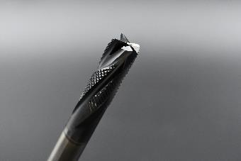  Image source: Hufschmied Zerspanungssysteme  Graftor, the patented tool for machining graphite. | 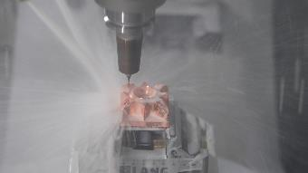  Image source: Hufschmied Zerspanungssysteme  The C-Razor is the ideal tool for producing copper electrodes.
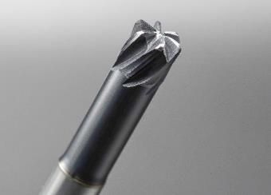
Image source: Hufschmied Zerspanungssysteme
The high-speed roughing tool HHF646 for steels up to 72 HRC.

About Hufschmied Zerspanungssysteme GmbH
Established in 1991 and headquartered in Bobingen near Augsburg, Hufschmied Zerspanungssysteme GmbH is a manufacturer of high-quality tools for machinable production and friction stir welding. By specializing at an early stage in the machining of plastics, fiberglass materials and carbon fiber, Hufschmied has become a leader in Europe in the development of solutions for new materials. The company is an established system supplier to renowned machine tool manufacturers. Tools and manufacturing process consulting from Hufschmied are particularly valued in the automotive and aerospace industries as well as in medical technology. The company is involved in numerous organizations, including Composites United Deutschland e. V. Hufschmied's manufacturing operations are located in Bobingen, Winterlingen and Sigmaringen on the Swabian Alb. Hufschmied is certified according to ISO 9001:2015 (quality management) and ISO 14001:2015 (environmental management).

Hufschmied Zerspanungssysteme GmbH – One Cut Ahead
For more information: www.hufschmied.net

Additional information:  Hufschmied Zerspanungssysteme GmbH  Marco Beigl  Edisonstrasse 11d  86399 Bobingen  Germany  Phone: +49 8234 9664-0  Telefax: +49 8234 9664-99  E-Mail: info@hufschmied.net  www.hufschmied.net | Press contact:  HighTech communications GmbH  Brigitte Basilio  Brunhamstrasse 21  81249 Munich  Germany  Phone: +49 89 500778-20  E-Mail: b.basilio@htcm.de  www.htcm.de

