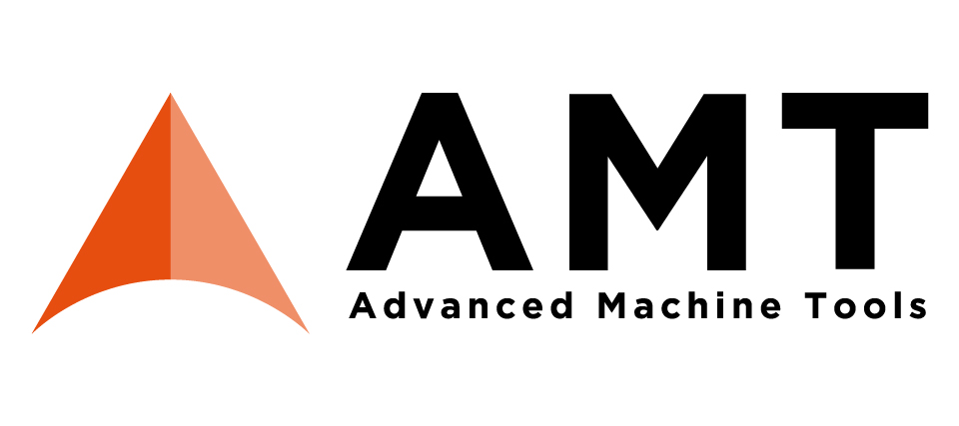Press release

Schröder Group at Advanced Machine Tools in Barcelona

**April 8–10, 2025**

**Hall 5, Stand 5D420**

Extrem folding

Wessobrunn-Forst (Germany), April 1, 2025 – The Schröder Group will be represented by its Spanish sales partner Josep Muntal S.L. at the Advanced Machine Tools exhibition. From April 8 to 10, 2025, the PowerBend Industrial UD folding machine will be on display at booth 5D420 in hall 5 of the Fira Barcelona Gran Via. The machine makes life much easier for companies that regularly process large, thick sheets.

Anyone who has previously only bent 6 mm thick sheets on press brakes will be amazed at the AMT 2025: The Schröder PowerBend Industrial UD machine effortlessly bends steel sheets up to 6.0 mm thick over a width of 3200 mm. Even large sheets can be processed by one person: Once attached, the suction plate stop takes over and, thanks to the up-and-down folding beam, all bends and counter-bends on one side are carried out automatically. The PowerBend Industrial UD was completely redesigned last year and equipped with improved servomotors throughout. It is designed for highly efficient series production. The clamping beam stroke of 850 mm provides the necessary clearance so that four-sided products with a depth of up to 400 mm can be bent.

The PowerBend Industrial UD is equipped with the POS 3000 graphic control system, with which the Schröder Group has set standards in the control of industrial sheet metal processing. Folding programs can be created quickly and easily from a wide range of file formats, such as STEP, DXF, GEO or via the in-house product editor, and simulated in advance.

**Available images**

The following images are available for download in printable format at:  
<https://kk.htcm.de/press-releases/schroeder/>

|  |  |
| --- | --- |
| Image source: Schröder Group  The PowerBend Industrial UD folding machine will be on display at booth 5D420 in hall 5 of AMT 2025. | Image source: Schröder Group  The clamping beam stroke of 850 mm provides the necessary clearance so that four-sided products with a depth of up to 400 mm can be bent. |

**About Schröder Group**

The Schröder Group consists of Hans Schröder Maschinenbau GmbH, which is located in Wessobrunn-Forst, Germany, SCHRÖDER-FASTI Technologie GmbH, located in Wermelskirchen, Germany and the SMU GmbH, located in Leinburg-Weißenbrunn.

Founded in 1949, Hans Schröder Maschinenbau GmbH unifies traditional and modern approaches in machine building: Successfully managed as a quality and customer-oriented, family-owned company, Hans Schröder Maschinenbau is specialized in the development of modern machine concepts for bending and cutting sheet metal.

The successful integration of the Fasti Company in 2006 and its worldwide presence make the Schröder Group one of today‘s leading providers of machines for bending, cutting, beading, flanging, and circular bending all types of sheet metal. The company‘s precision machines range from proven solutions for craftsmen to innovative, high-performance machines for automatic industrial production processes. 2021 the Schröder Group was expanded by the tool manufacturer SMU GmbH. Overall, the Schröder Group currently employs more than 300 people at various locations at home and abroad.

Further information is available at [www.schroedergroup.eu/en](http://www.schroedergroup.eu/en).

**Press contact:**

Schröder Group  
Hans Schröder Maschinenbau GmbH  
Janina Biró  
Feuchten 2   
82405 Wessobrunn-Forst  
Germany  
T: +49 8809 9220-68  
E-mail: jj@schroedergroup.eu  
Website: www.schroedergroup.eu

HighTech communications GmbH   
Brigitte Basilio  
Brunhamstraße 21  
81249 München   
Germany  
T: +49 89 500778-20  
E-mail: b.basilio@htcm.de  
Website: www.htcm.de