FOR THE MEDIA
Dr. Thomas Marktscheffel of ASMPT honored for his work on open interfaces
IPC President’s Award
Atlanta (USA), March 25, 2025 – Dr. Thomas Marktscheffel, Director Product Management Software Solutions at ASMPT, was honored by the IPC at this year's IPC APEX EXPO in Anaheim, California, for his many years of commitment to the organization. The non-proprietary interface standards he helped develop form the basis for ASMPT’s intelligent factory concept.
“Especially in the age of big data, having standardized interfaces is more important than ever,” said Dr. Thomas Marktscheffel. “They are indispensable for using data across lines and locations in order to make electronics manufacturing more transparent, efficient and resilient, and to continuously improve the quality of your production.”
Basis for the intelligent factory
Dr. Marktscheffel began his professional career at Siemens AG in 1989 and has worked for ASMPT in the areas of R&D and product management software solutions since 2004. As part of his work for ASMPT, the proven software expert was involved in the development of the widely used industrial interface standards IPC-HERMES-9852 for M2M communication and IPC-2591 CFX for M2H communication, among others. Based on these interfaces and its intelligent factory concept, ASMPT has developed numerous software features, such as the Automated Program Change function of the WORKS Software Suite, which allows PCB data to travel from machine to machine via IPC-HERMES-9852 and trigger automatic downloads of new production programs when the product changes. The IPC-2591 CFX standard forms the basis for many other line- and factory-encompassing software solutions from ASMPT for intelligent automation in the areas of planning, work preparation, production, quality assurance, and production-wide material flow optimization.
Commitment to the unhindered flow of data
“Collecting and processing data throughout the factory and using it where it is needed and delivers benefits is what describes the essence of the intelligent factory strategy,” says Dr. Marktscheffel. “For ASMPT and me, this was and continues to be an important reason to consistently push the issue of interface standardization within the IPC. Fortunately, I can rely on the active support of ASMPT in this endeavor, and we will continue to work on ensuring that data can flow unhindered and in a non-proprietary manner in the Intelligent Factory so that it can be used to improve quality and efficiency.”
The IPC (Institute for Printed Circuits) is a global trade association for the electronics industry. It defines interface standards, offers training and certification, and helps electronics manufacturers to improve their competitiveness, to name just a few of its activities. The IPC also organizes the IPC APEX EXPO, one of the most important annual trade fairs and conferences for the electronics industry that brings together industry leaders, experts and companies from electronics manufacturing all over the world.

Illustrations for downloading
The following print-ready artwork is available on the internet for downloading:
https://kk.htcm.de/press-releases/asmpt/

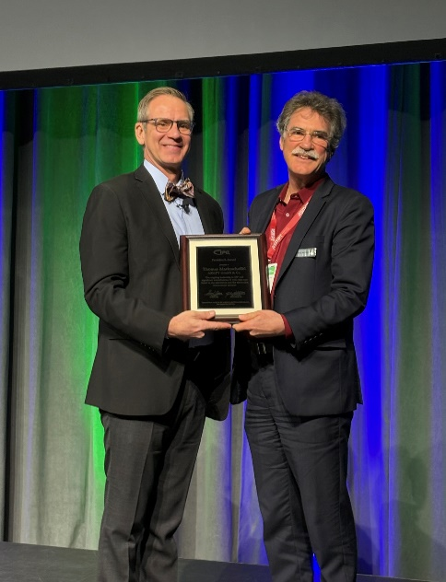

Image credit: ASMPT

Dr. John W. Mitchell, IPC President and CEO (l.) and Dr. Thomas Marktscheffel, Director Product Management Software Solutions at ASMPT (r.)

Image credit: ASMPT

About ASMPT Limited (“ASMPT”)
ASMPT Limited is a leading global supplier of hardware and software solutions for the manufacture of semiconductors and electronics. Headquartered in Singapore, ASMPT’s offerings encompass the semiconductor assembly & packaging, and SMT (surface mount technology) industries, ranging from wafer deposition to the various solutions that organize, assemble and package delicate electronic components into a vast range of end-user devices, which include electronics, mobile communications, computing, automotive, industrial and LED (displays). ASMPT partners with customers very closely, with continuous investments in R&D helping to provide cost-effective, industry-shaping solutions that achieve higher productivity, greater reliability, and enhanced quality. ASMPT is a founding member of the Semiconductor Climate Consortium.
To learn more about ASMPT, please visit www.asmpt.com.

The ASMPT SMT Solutions segment
The mission of the SMT Solutions segment within ASMPT is to implement and support the Intelligent Factory at electronics manufacturers worldwide.
ASMPT solutions support the networking, automation, and optimization of central workflows with hardware, software and services that enable electronics manufacturers to transition to the Intelligent Factory in stages and enjoy dramatic improvements in productivity, flexibility, and quality. With its integrated open automation concept, ASMPT opens the door for its customers to economically feasible automation, entirely in accordance with their individual requirements – modular, flexible, and vendor-independent.
The product range includes hardware and software such as SIPLACE placement solutions, DEK printing solutions, inspection and storage solutions, and the WORKS Software Suite. With WORKS, ASMPT offers electronics manufacturers high-quality software for planning, controlling, analyzing and optimizing all processes on the shop floor. Maintaining close relationships with customers and technology partners is a central component of ASMPT’s strategy.
For more information about ASMPT SMT Solutions, visit smt.asmpt.com.

Media contacts:
AMCAS ASMPT Press Office
SMT Solutions
Mark Ogden
Phone: +1 (770) 797 3189
E-mail: ogden.mark@asmpt.com
Website: smt.asmpt.com

Global ASMPT Press Office
ASMPT Ltd.
Susanne Oswald
Rupert-Mayer-Strasse 48
81379 Munich
Germany
Phone: +49 89 20800-26439
E-Mail: susanne.oswald@asmpt.com
Website: asmpt.com

