PRESS RELEASE
OPEN MIND strengthens hyperMILL® support in Sweden
OPEN MIND expands hyperMILL® technical team in Sweden
Wessling (Germany), Hässleholm (Sweden), March 25, 2025 – OPEN MIND Technologies AG, a leading developer of CAD/CAM solutions, is expanding its team in Sweden. Lennie Gustafsson, an experienced application engineer, is joining the team at the OPEN MIND Technologies Scandinavia AB subsidiary in Hässleholm. The CAD/CAM expert, with many years of experience in various manufacturing industries, Lennie Gustafsson aims to support the growing number of hyperMILL® users in making optimum use of the software.
Lennie Gustafsson has more than 20 years of experience in the manufacturing industry. He began his career as a lathe and machining center operator before becoming a specialist in NC programming and CAD/CAM. Through his experience in various industries, he has gained first-hand knowledge of the requirements and challenges of modern manufacturing processes. Gustafsson will now apply this practical expertise to support hyperMILL® users in Sweden.
"I am very pleased to join OPEN MIND and support users in making the best use of the software and further establish the market leading CAD/CAM solution hyperMILL® in Sweden," says Lennie Gustafsson, Application Engineer at OPEN MIND Technologies Scandinavia AB. "My role is to show current and prospective customers how they can efficiently set up their processes - from CAD/CAM programming to the final part - using our software.
I appreciate hyperMILL®’s flexibility and intuitive user interface, which enable fast and reliable programming of even highly complex parts. I look forward to providing users with expert support, especially customers working with our powerful and exciting technologies like hyperMILL® VIRTUAL Machining and hyperMILL® AUTOMATION Center."

Exploiting the full potential of hyperMILL®
Claudio Jorio, Sales Director DACH (Germany, Austria, and Switzerland) and Executive Board Member at OPEN MIND Technologies Scandinavia AB, is pleased to welcome his new colleague to the team: “hyperMILL® has an excellent reputation in the Scandinavian manufacturing industry—not only for its impressive 5-axis capabilities. To realize the full potential of automation, connected manufacturing, additive machining, and working with digital twins requires in-depth practical expertise. With Lennie Gustafsson, we have gained exactly the right expert for the job.”

Available image material
The following printable images are available for download on the Internet:
https://kk.htcm.de/press-releases/open-mind/
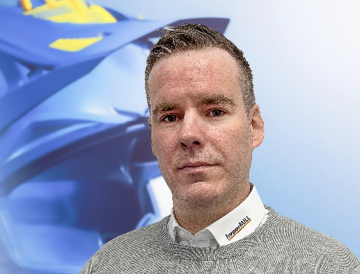
Source: OPEN MIND

Lennie Gustafsson, Application Engineer at OPEN MIND Technologies Scandinavia AB.

About OPEN MIND Technologies AG
OPEN MIND Technologies AG is one of the world’s leading developers of powerful CAD/CAM solutions for machine and controller-independent programming.
OPEN MIND develops optimized CAD/CAM solutions that include innovative and unique features that can deliver significantly higher performance in both programming and machining.
hyperMILL® is a completely modular CAD/CAM solution that provides state-of-the-art CAM technologies on its own CAD platform: from 2.5D, 3D and 5-axis machining as well as turning strategies and solutions for additive manufacturing, HSC and HPC machining. Whether automation, simulation or virtual machine – trendsetting technologies expand the product range and enable continuous digital process chains. Special applications, seamless interaction with all popular CAD solutions and exceptional customer service rounds out the company’s products and capabilities.
According to the “NC Market Analysis Report 2024” compiled by CIMdata, hyperMILL® is a leading, worldwide CAD/CAM solution. Innovative CAD/CAM technologies fulfill the highest demands in the aerospace, automotive, tool and mold manufacturing, production machining, medical, job shops, energy and semiconductor industries.
OPEN MIND's majority stake in manufacturing execution system (MES) developer Hummingbird expands the CAD/CAM manufacturer's product portfolio and enhances the range of connected digitalized manufacturing technologies.
OPEN MIND is a Mensch und Maschine company and has subsidiaries and qualified sales partners on all continents.
You can find more information at www.openmind-tech.com.

OPEN MIND Technologies UK Ltd., Oxford
Unit 3
Bicester Business Park
Telford Road
Bicester
Oxfordshire OX26 4LN
England
Phone: +44 1869 290 003
Fax: +44 1869 369 429
E-mail: Info.UK@openmind-tech.com

OPEN MIND Technologies USA, Inc.
1492 Highland Avenue, Unit 3
Needham MA 02492
USA
Phone: +1 339 225 4557 office
Phone: +1 888 516 1232 x0 toll-free
Fax: +1 270 912 5822
E-mail: Info.Americas@openmind-tech.com

OPEN MIND Technologies Asia Pacific Pte Ltd
MOVA Building, 22 Jalan Kilang #03-00
Singapore 159419
Phone: +65 6742 95-56
E-mail. Info.Asia@openmind-tech.com

Head office:
OPEN MIND Technologies AG, Argelsrieder Feld 5, 82234 Wessling, Germany
Tel.: (+49-8153) 933-500, Fax: (+49-8153) 933-501
E-mail: Info@openmind-tech.com, website: www.openmind-tech.com

Press contact:
HighTech communications GmbH
Brigitte Basilio
Brunhamstrasse 21
81249 Munich
Germany
Tel.: (+49-89) 500778-20
E-mail: b.basilio@htcm.de
Website: www.htcm.de

