FOR THE MEDIA
ASMPT at the Optical Fiber Communication Conference and Exposition (OFC)
Accelerating into the AI Era at Light-Speed Innovation
Billerica (USA), March 24, 2025 – ASMPT, the world’s leading provider of pioneering solutions for advanced packaging and semiconductor assembly, will present its pioneering AMICRA NANO, AMICRA NOVA PRO and MEGA bonding solutions at the ASMPT booth 5675 during the OFC 2025 trade event being held April 1-3 at the Moscone Center in San Francisco, California (USA).
“Both the OFC and ASMPT celebrate their 50th anniversaries this year,” says Jean-Marc Peallat, PhD, Regional Head ASMPT Semiconductor Solutions Americas and General Manager ASMPT AEi Inc. in Billerica, Massachusetts, USA. “We have been exhibiting at this event, the world’s most important congress and exhibition for optical communication technology, IT and software, for many years and will once again present forward-looking solutions this year.” Also on site will be Dr. Johann Weinhändler, Regional Head ASMPT Semiconductor Solutions Europe and General Manager ASMPT AMICRA GmbH in Regensburg, Germany.
AMICRA NANO: Hybrid bonding for data highways
One major exhibit at the ASMPT booth will be the AMICRA NANO high-precision die and flip-chip bonder, which was specially developed for the production of innovative communication components that feature optical and electronic components co-packaged in a single housing. With its exceptional process stability, a placement accuracy of ±0.2 μm @ 3 σ, bonding forces ranging from of 0.1 to 20 N and a throughput rating of up to 400 components per hour, the AMICRA NANO sets new standards. The machine employs an innovative hybrid bonding technology that does not require any solder or glue but uses atomic diffusion to create stable mechanical and electrical connections. Hybrid bonding will soon be crucial in applications that require maximum performance in the smallest of spaces – for example, in high-performance and quantum computers, AI systems, IoT devices, or autonomous vehicles.
Die Bonding solutions for a wide range of applications
The AMICRA NOVA Pro will be another highlight at the OFC Exhibition. As one of the most advanced die bonding systems currently available, it places dies ranging from 0.1 to 25 millimeters in size with a maximum accuracy of ±1 μm @ 3 σ at speeds of up to 1,000 units per hour. The AMICRA NOVA Pro achieves this impressive performance even in flip-chip mode. With its very generous substrate area of 550 × 600 mm, the NOVA Pro is also aimed at the die-bonding market in advanced packaging applications.
Trade visitors will also be able to find out more about the MEGA multi-chip bonder, a state-of-the-art platform that integrates multiple chips in a single housing with the unequaled precision of ±2 μm. With an automatic bond tool changer, up to ten bond tool buffers and five ejector tools, the MEGA system processes chips ranging in size from 0.15 × 0.15 mm to 10 × 10 mm and substrates measuring up to 130 × 300 mm. This means that the machine can be used in a wide variety of manufacturing processes for products like optical transceivers, photonics and sensors, as well as for lighting technology in the automotive sector.

Illustrations for downloading
The following print-ready artwork is available on the internet for downloading:
https://kk.htcm.de/press-releases/asmpt/

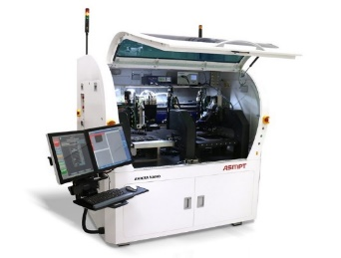 | 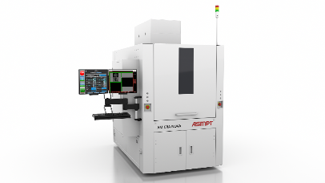
Leading-edge technology at OFC: The AMICRA NANO high-precision die and flip-chip bonder was specially designed for the production of co-packaged optics and features a placement accuracy of ±0.2 μm @ 3 σ.  Image credit: ASMPT | AMICRA NOVA Pro meets the growing demand for die-bond- and flip-chip-capable machines with high throughput (1,000 UPH) and maximum precision in the 1 μm range.  Image credit: ASMPT
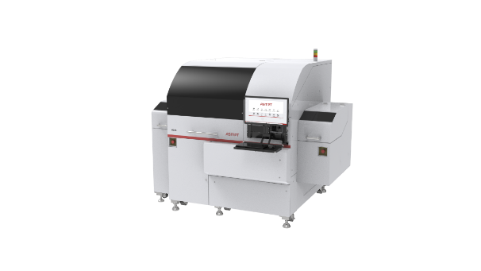
As a die bonder for high-performance computing chips, MEGA perfectly meets the requirements for the next generation of server clusters and AI edge devices such as smartphones and advanced driver assistance systems (ADAS), as well as data and telecommunication applications.

Image credit: ASMPT

About ASMPT Limited (“ASMPT”)
ASMPT Limited is a leading global supplier of hardware and software solutions for the manufacture of semiconductors and electronics. Headquartered in Singapore, ASMPT’s offerings encompass the semiconductor assembly & packaging, and SMT (surface mount technology) industries, ranging from wafer deposition to the various solutions that organize, assemble and package delicate electronic components into a vast range of end-user devices, which include electronics, mobile communications, computing, automotive, industrial and LED (displays). ASMPT partners with customers very closely, with continuous investments in R&D helping to provide cost-effective, industry-shaping solutions that achieve higher productivity, greater reliability, and enhanced quality. ASMPT is a founding member of the Semiconductor Climate Consortium.
To learn more about ASMPT, please visit www.asmpt.com.

About ASMPT Semiconductor Solutions (“ASMPT SEMI”)
ASMPT SEMI is the leading provider of forward-looking solutions for advanced packaging and semiconductor assembly. With its commitment to innovation and customer satisfaction, ASMPT SEMI offers a comprehensive range of products and services that meet the evolving needs of the microelectronics industry. Expert knowledge covers areas such as flip-chip and wafer-level packaging, advanced interconnect technologies, and more. ASMPT SEMI’s state-of-the-art solutions enable customers to achieve higher performance, greater reliability, and improved cost-efficiency in the manufacturing of their semiconductor devices.
For more information about ASMPT SEMI, visit semi.asmpt.com.

Media contacts:
Global ASMPT Press Office
ASMPT Ltd
Susanne Oswald
Rupert-Mayer-Strasse 48
81379 Munich
Germany
Tel: +49 89 20800-26439
E-mail: susanne.oswald@asmpt.com
Website: asmpt.com

HighTech communications GmbH
Barbara Ostermeier
Brunhamstrasse 21
81249 Munich
Germany
Tel.: +49-89 500778-10|
E-mail: b.ostermeier@htcm.de
Website: www.htcm.de

