PRESS RELEASE
ASMPT Semiconductor Solutions under new management in Europe and Americas with Dr. Johann Weinhändler and Jean-Marc Peallat, PhD
ASMPT Strengthens its Global Footprint
Regensburg (Germany), March 21, 2024 – ASMPT, the global market and technology leader for hardware and software solutions in the semiconductor and electronics industries, continues to drive the growth of its semiconductor solutions in strategically important markets. To do this, the company relies on experienced industry experts like Dr. Johann Weinhändler, who assumes the role of Regional Head ASMPT Semiconductor Solutions Europe, and Jean-Marc Peallat, PhD, who will take on the role of Regional Head ASMPT Semiconductor Americas. With these appointments, ASMPT is strengthening its market position, expanding its global presence, and underscoring its commitment to innovation paired with proximity to the customer.
In addition to taking on the newly created role of Regional Head SEMI Europe, Dr. Weinhändler is also Managing Director of ASMPT’s AMICRA subsidiary in Regensburg, Germany, responsible for sales, marketing, business development and quality management; he is also in charge of the company’s Global Customer Operations Division. Dr. Weinhändler is respected as a very internationally-oriented visionary with more than 30 years of global sales and marketing experience, including stints with Lam Research, Datacon/BESI and Oerlikon Systems.
Jean-Marc Peallat succeeds Leroy Christie as Regional Head SEMI Americas. With almost 30 years of experience in the electronics industry, Peallat is ideally positioned to advance the strategic development of SEMI Americas. Peallat is also General Manager at ASMPT’s AEi Subsidiary in Billerica, Massachusetts, driving customer satisfaction through high-quality standards and innovative products. Prior to this, he was with Vi Technology, involved with the company’s global expansion plans, holding various positions and ultimately leading international teams as Vice President of Sales and Applications.
“Our customers all over the world expect technological excellence and proximity to their trusted partners. With these new appointments, we underscore our commitment to locate experienced leaders in all major regions for our semiconductor solutions business,” said Robin Ng, Group CEO, ASMPT. “Dr. Johann Weinhändler and Jean-Marc Peallat are seasoned, highly-respected experts in the industry. I have confidence that with their expertise, they will further accelerate our global growth and intensify our customer relationships.”
“In addition to the Americas and Asia, the semiconductor industry plays an increasingly important role in Europe. We will play a central role in this development and move the industry forward with innovative solutions. We have been working for quite some time with leading European semiconductor companies to promote technological innovations and continuously improve manufacturing processes. My goal is to further strengthen our local team in order to unlock the potential of ASMPT SEMI’s solutions to the fullest. In a time of rapid technological progress and increasing regionalization, having a strong local presence is more critical than ever,” said Dr. Johann Weinhändler.

Illustrations for downloading
The following print-ready artwork is available on the internet for downloading:
https://kk.htcm.de/press-releases/asmpt/

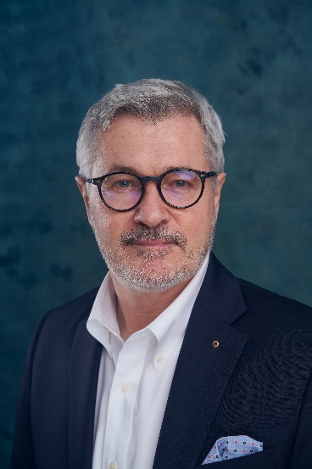 | 
Dr. Johann Weinhändler, Regional Head ASMPT Semiconductor Solutions Europe, and General Manager ASMPT AMICRA GmbH in Regensburg (Germany)  Image credit: ASMPT | Jean-Marc Peallat, PhD, Regional Head ASMPT Semiconductor Solutions Americas, and General Manager ASMPT AEi Inc. in Billerica, Massachusetts (USA)  Image credit: ASMPT

About ASMPT Limited (“ASMPT”)
ASMPT Limited is a leading global supplier of hardware and software solutions for the manufacture of semiconductors and electronics. Headquartered in Singapore, ASMPT’s offerings encompass the semiconductor assembly & packaging, and SMT (surface mount technology) industries, ranging from wafer deposition to the various solutions that organize, assemble and package delicate electronic components into a vast range of end-user devices, which include electronics, mobile communications, computing, automotive, industrial and LED (displays). ASMPT partners with customers very closely, with continuous investments in R&D helping to provide cost-effective, industry-shaping solutions that achieve higher productivity, greater reliability, and enhanced quality. ASMPT is a founding member of the Semiconductor Climate Consortium.
To learn more about ASMPT, please visit www.asmpt.com.

About ASMPT Semiconductor Solutions (“ASMPT SEMI”)
ASMPT SEMI is the leading provider of forward-looking solutions for advanced packaging and semiconductor assembly. With its commitment to innovation and customer satisfaction, ASMPT SEMI offers a comprehensive range of products and services that meet the evolving needs of the microelectronics industry. Expert knowledge covers areas such as flip-chip and wafer-level packaging, advanced interconnect technologies, and more. ASMPT SEMI’s state-of-the-art solutions enable customers to achieve higher performance, greater reliability, and improved cost-efficiency in the manufacturing of their semiconductor devices.
For more information about ASMPT SEMI, visit semi.asmpt.com.

Media contacts:
Global ASMPT Press Office
ASMPT Ltd
Susanne Oswald
Rupert-Mayer-Strasse 48
81379 Munich
Germany
Tel: +49 89 20800-26439
E-mail: susanne.oswald@asmpt.com
Website: asmpt.com

HighTech communications GmbH
Barbara Ostermeier
Brunhamstrasse 21
81249 Munich
Germany
Tel.: +49-89 500778-10|
E-mail: b.ostermeier@htcm.de
Website: www.htcm.de

