FOR THE MEDIA
New stationary camera for SIPLACE
placement machines
Fast, flexible, high-resolution
Shanghai (China), March 13, 2025 – Market and technology leader ASMPT is offering a new stationary camera available for its placement machines equipped with SIPLACE placement heads CPP and TWIN. It delivers significantly faster processing speeds as well as more component flexibility – from highly integrated ball grid arrays (BGAs) to large-format odd shape components (OSCs).
Effective immediately, SIPLACE placement machines with SIPLACE placement heads CPP and TWIN can be equipped with the new camera model 56, which features a detection area of 66 × 50 mm and a resolution of 16.2 microns per pixel.
Advantages at both ends of the size scale
Thanks to its high resolution, the new camera offers clear quality improvements because it can detect balls with diameters of 80 microns. For complex BGA structures like those on AI chips, the new camera delivers images with six times more pixels per ball than the conventional system, making it much easier to detect faults. At the other end of the size scale, the camera’s high resolution enables significantly faster and more accurate stereoscopic measurements of special components, which makes the new camera system particularly attractive for the automobile industry.
Retrofits are easy
“Our new stationary camera, which can be easily retrofitted, delivers significant advances in quality, performance and component flexibility for electronics manufacturers,” explains Sven Buchholz, Vice President Portfolio Management at ASMPT SMT Solutions. “It enables them to process even highly detailed BGAs reliably and move many complex OSCs from manual to machine-based placement.”
Superb synergy with SIPLACE placement heads
In combination with SIPLACE placement heads, the new stationary camera delivers outstanding results in terms of speed and flexibility. The highly flexible, software-controlled SIPLACE CPP head adapts easily to varying requirements by switching seamlessly between its three placement modes: collect-and-place, pick-and-place, and mixed mode. Thanks to this capability, lines can stay perfectly balanced even during frequent product changeovers with no time-consuming configuration or head changes. The SIPLACE TWIN head, on the other hand, is a high-precision pick-and-place twin head that was specially developed for the end-of-line placement of large, heavy and complex components. The TWIN VHF version of this head can place components weighing up to 300 g with precisely adjustable forces of up to 100 N.

Illustrations for downloading
The following print-ready artwork is available on the internet for downloading:
https://kk.htcm.de/press-releases/asmpt/

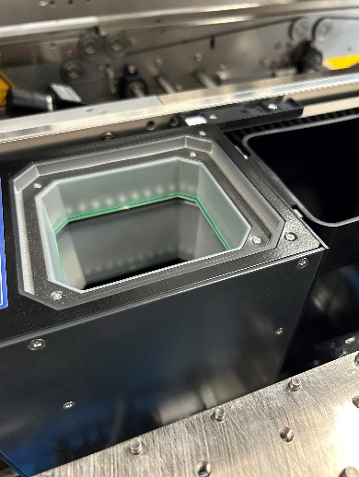 | 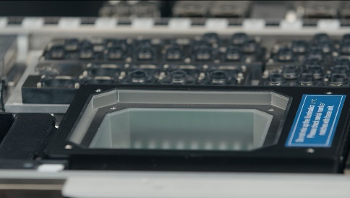
The new stationary camera type 56 can be easily retrofitted  Image credit: ASMPT | Stationary camera type 56 in SIPLACE SX placement machine  Image credit: ASMPT
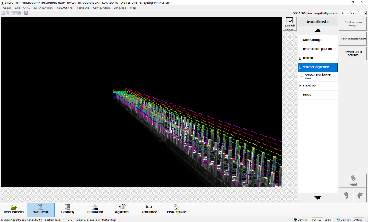 | 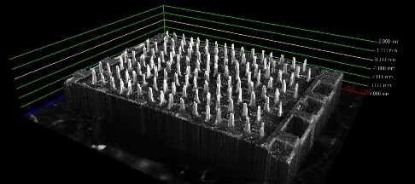
Stereometric measurement of a connector with camera type 56  Image credit: ASMPT | Stereometric measurement of a pressfit THT connector in size 0.4 mm × 0.3 mm × 1.5 mm with camera type 56  Image credit: ASMPT

About ASMPT Limited (“ASMPT”)
ASMPT Limited is a leading global supplier of hardware and software solutions for the manufacture of semiconductors and electronics. Headquartered in Singapore, ASMPT’s offerings encompass the semiconductor assembly & packaging, and SMT (surface mount technology) industries, ranging from wafer deposition to the various solutions that organize, assemble and package delicate electronic components into a vast range of end-user devices, which include electronics, mobile communications, computing, automotive, industrial and LED (displays). ASMPT partners with customers very closely, with continuous investments in R&D helping to provide cost-effective, industry-shaping solutions that achieve higher productivity, greater reliability, and enhanced quality. ASMPT is a founding member of the Semiconductor Climate Consortium.
ASMPT is listed on the Hong Kong Stock Exchange (HKEX stock code: 0522) and is one of the constituent stocks of the Hang Seng TECH Index, the Hang Seng Composite MidCap Index, the Hang Seng Composite Information Technology Industry Index under Hang Seng Composite Industry Indexes, the Hang Seng Corporate Sustainability Benchmark Index, and the Hang Seng HK 35 Index.
To learn more about ASMPT, please visit www.asmpt.com.

The ASMPT SMT Solutions segment
The mission of the SMT Solutions segment within ASMPT is to implement and support the Intelligent Factory at electronics manufacturers worldwide.
ASMPT solutions support the networking, automation, and optimization of central workflows with hardware, software and services that enable electronics manufacturers to transition to the Intelligent Factory in stages and enjoy dramatic improvements in productivity, flexibility, and quality. With its integrated open automation concept, ASMPT opens the door for its customers to economically feasible automation, entirely in accordance with their individual requirements – modular, flexible, and vendor-independent.
The product range includes hardware and software such as SIPLACE placement solutions, DEK printing solutions, inspection and storage solutions, and the WORKS Software Suite. With WORKS, ASMPT offers electronics manufacturers high-quality software for planning, controlling, analyzing and optimizing all processes on the shop floor. Maintaining close relationships with customers and technology partners is a central component of ASMPT’s strategy.
For more information about ASMPT SMT Solutions, visit smt.asmpt.com.

Media contacts:
China ASMPT Press Office
SMT Solutions
Guan Jing
Phone: +86 (755) 26934550-2109
E-mail: jing.guan@asmpt.com
Website: smt.asmpt.com

Global ASMPT Press Office
ASMPT Ltd.
Susanne Oswald
Rupert-Mayer-Strasse 48
81379 Munich
Germany
Phone: +49 89 20800-26439
E-Mail: susanne.oswald@asmpt.com
Website: asmpt.com

