PRESS RELEASE
Würth Elektronik ICS at bauma 2025
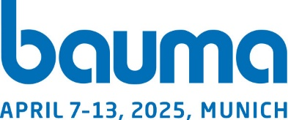
Innovative solutions for power distribution and control in construction machinery
Hall A5, booth 248
Niedernhall (Germany), 12 March 2025 – Würth Elektronik ICS will be exhibiting at bauma in Munich, the world’s leading trade fair for construction machinery, building material machines, mining machines, construction vehicles and construction equipment, from 7 to 13 April 2025. At booth 248 in hall A5, the manufacturer of systems for power distribution, signal transmission and function control in mobile machinery and commercial vehicles will be presenting its latest power distribution solutions in the low-voltage and high-voltage range as well as innovative controllers.
The economical and adaptable REDline Power Boxes product family will take centre stage at the trade fair. These platform-based power distribution solutions for mobile machines are characterised by their short time-to-market and high modularity, among other things. The modular design covers various requirements in terms of power and signal distribution as well as the installation condition. Two new models are presented: The REDline Power Box Medium 2.0 and the REDline Power Box Xtra.
The REDline Power Box Medium 2.0 is a revision of the Power Box Medium with an improved housing from IP64 to IP66/IP69K, a larger PCB surface area and modularly customisable inputs and outputs for currents and signals. With a PCB size of 285 × 192 mm, the REDline Power Box Xtra offers even more space for the integration of relays, fuses and other components and is available in 12, 24 and 48 V versions.
Electrification of the powertrain
Würth Elektronik ICS supports construction machinery manufacturers in the electrification of the powertrain with customised HV power distribution units (PDUs). The various functions of the PCB-based HV PDUs can be experienced in action at the exhibition booth using an HV PDU application example. The PDUs in the voltage range from 60 to 1000 VDC ensure stable and safe connections for optimum power distribution between the battery, on-board charger, inverter and other consumers such as heaters or DC/DC converters.
Intelligent control for power management
The latest developments in the electronics sector will also be presented. In particular, this includes the ePDM 70-150, an innovative control unit for commercial vehicles and mobile machinery that changes the way power is distributed in vehicle electrics. The compact module combines function control, communication interfaces, a wide range of diagnostic options, intelligent power distribution and high-current outputs in a single device. It therefore offers interesting approaches for the further development of vehicle electrics and electronics in construction machinery.

Available images
The following images can be downloaded from the Internet in printable quality: https://kk.htcm.de/press-releases/wuerth-ics/
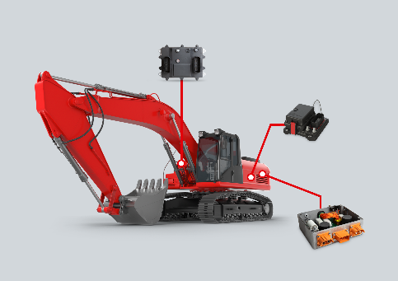Image source: Würth Elektronik ICS
Würth Elektronik ICS presents various solutions for the power supply and function control of construction machinery.

About Würth Elektronik ICS GmbH & Co. KG
Würth Elektronik ICS is a system supplier for electromechanical and electronic solutions for signal and power distribution, control, and display and operating solutions. The company’s key customers include well-known manufacturers of construction and agricultural machinery as well as commercial vehicles. Sectors such as industrial technology or renewable energies also benefit from products and services provided by ICS. The company is headquartered in Niedernhall-Waldzimmern (Germany). Further subsidiaries are located in France, Great Britain, Italy, the USA, China, and India.
Würth Elektronik is part of the Würth Group, the global market leader in the development, production, and sale of fastening and assembly materials, and employs 7,500 people. In 2024, the Würth Elektronik Group generated sales of 1.03 billion Euro.

Würth Elektronik: more than you expect!
Further info at www.we-online.com/ics

More information:  Würth Elektronik ICS GmbH & Co. KG  Sandra Herter  Gewerbepark Waldzimmern  Würthstrasse 1  74676 Niedernhall  Germany  Phone: +49 7940 9810-1503  E-mail: sandra.herter@we-online.de  www.we-online.com/ics | Press contact:  HighTech communications GmbH  Marcus Planckh  Brunhamstrasse 21  81249 Munich  Germany  Phone: +49 89 500778-22  E-mail: m.planckh@htcm.de  www.htcm.de

