PRESS RELEASE

Wi-Fi module for IoT security
Encrypted Communication
Waldenburg (Germany), March 11, 2025 – Würth Elektronik introduces its new Cordelia-I Wi-Fi module, specifically designed for secure IoT and ‘edge computing’ applications. This versatile module is ideal for applications in Industry 4.0, Smart City / Smart Home, eMobility, smart agricultural, and medical devices, to name a few. It meets the requirements of RED (Radio Equipment Directive) including the Cybersecurity Regulation 2022/30 in accordance with EN 18031-1, which will become mandatory for all devices with radio technology in the EU as of August 2025. The Cordelia-I module was developed in collaboration with British cybersecurity company Crypto Quantique – to ensure the highest security standards. With a compact size of just 19 × 27.5 × 4 mm, it is designed to operate over a temperature range of -40 °C to +85 °C, and consumes less than 10 μA in standby mode.
The new Wi-Fi module from Würth Elektronik independently manages secure cloud connections, thus reducing the workload on the host MCU. MQTT over TLS is used as the primary protocol for connecting to the cloud. The module features a secure Root of Trust (a fundamental security concept in information technology) that is unique and tamper-proof. All cryptographic keys are securely generated and stored within the module.
Cordelia-I supports cloud connectivity via Crypto Quantique's QuarkLink platform, ensuring secure and scalable zero-touch provisioning as well as cloud onboarding of the end device in the field. This SaaS platform (Software as a Service) allows implementation of the first security layer for an IoT device. The necessary steps include: secure provisioning of devices, onboarding with a cloud service provider or an in-house server-based application, and managing the devices throughout their lifecycle.
The Cordelia-I module complies with the IEEE 802.11 b/g/n Wi-Fi standard and operates in the 2.4 GHz band. In Transparent Mode, it provides a secure UART-to-Cloud bridge. The transmission power goes up to +18 dBm (peak), while the receiver sensitivity is -92 dBm.
Würth Elektronik offers an evaluation kit, SDK and PC tools for evaluation of this product as an additional service. This simplifies the development of hardware and software for IoT applications using Cordelia-I.

Available images
The following images can be downloaded from the Internet in printable quality: https://kk.htcm.de/press-releases/wuerth/
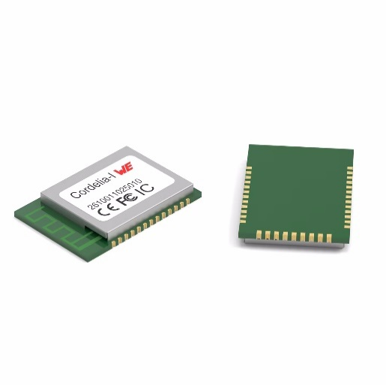
Image source: Würth Elektronik
Secure communication made easy: Cordelia-I radio module

About the Würth Elektronik eiSos Group
Würth Elektronik eiSos Group is a manufacturer of electronic and electromechanical components for the electronics industry and a technology company that spearheads pioneering electronic solutions. Würth Elektronik eiSos is one of the largest European manufacturers of passive components and is active in 50 countries. Production sites in Europe, Asia and North America supply a growing number of customers worldwide.
The product range includes passive components, power modules, digital isolators, optoelectronics, electromechanical components, thermal management solutions, sensors and wireless modules. The portfolio is rounded off by customer-specific solutions.
The unrivaled service orientation of the company is characterized by the availability of all catalog components from stock without minimum order quantity, free samples and extensive support through technical sales staff and selection tools.
Würth Elektronik is part of the Würth Group, the global market leader in the development, production, and sale of fastening and assembly materials, and employs around 7,500 people. The Würth Elektronik Group generated sales of 1 Billion Euro (all figures according to preliminary results for 2024).
Würth Elektronik: more than you expect!
Further information at www.we-online.com

Further information:  Würth Elektronik eiSos GmbH & Co. KG  Sarah Hurst  Clarita-Bernhard-Strasse 9  81249 Munich  Germany  Phone: +49 7942 945-5186  E-mail: sarah.hurst@we-online.de  www.we-online.com | Press contact:  HighTech communications GmbH  Brigitte Basilio  Brunhamstrasse 21  81249 Munich  Germany  Phone: +49 89 500778-20  E-mail: b.basilio@htcm.de  www.htcm.de

