PRESS RELEASE

Hufschmied Zerspanungssysteme presents the aluminum milling tool BoneCrusher
Sustainable machining without the use of cooling lubricants
Bobingen (Germany), March 12, 2025 – Hufschmied Zerspanungssysteme is introducing the “BoneCrusher”, a tool for dry machining of aluminum extruded profiles that revolutionizes the processes for machining these profiles. BoneCrusher achieves improved surface qualities without the use of cooling lubricants. This makes machining resource-efficient and sustainable and also protects health by eliminating toxic vapors. Dry chips spare the user the laborious cleaning of the workpieces from clumped, adhering chips. The new process- and material-optimized, specially coated tools are available immediately in 16 standard sizes; Hufschmied supplies customized tools on request.
High-quality, burr-free milling results without any lubrication – with the BoneCrusher, Hufschmied is setting new standards in sustainability and efficiency when processing aluminum extruded profiles. Until now, wet chips that sometimes stuck in cavities had to be laboriously removed. There was a risk that the wet chips, which sometimes stuck in hollow spaces, would damage surfaces with an aluminum oxide coating or disrupt the CPC. Entire cleaning process steps can be eliminated thanks to Hufschmied's dry processing tool. The machine operators are no longer exposed to coolant contaminants and dry chips are easier to recycle.
“We are pleased that with the BoneCrusher tool we have succeeded in developing an efficient, long-lasting tool for process optimization for machining aluminum extruded profiles. This tool is also resource-saving and sustainable because, for the first time in this application, it allows cooling and lubrication to be omitted,” explains Christel Hufschmied, managing director of Hufschmied Zerspanungssysteme GmbH.

Available images
The following images can be downloaded from the Internet in printable quality:
https://kk.htcm.de/press-releases/hufschmied/
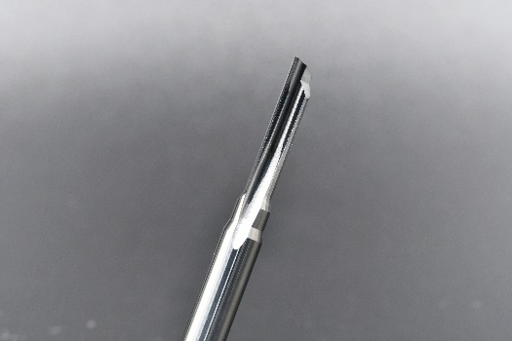
Image source: Hufschmied Zerspanungssysteme
An innovative cutting edge geometry and a specially developed coating make the “BoneCrusher” from Hufschmied the perfect dry machining tool for aluminum extrusion profiles.

Available video material
The following video material can be found on our YouTube channel:
https://www.youtube.com/watch?v=9GNPqoT26iU
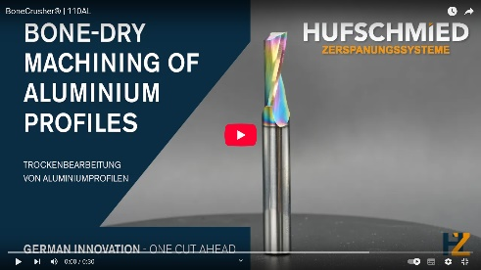
Source: Hufschmied Zerspanungssysteme

Video on dry machining

About Hufschmied Zerspanungssysteme GmbH
Established in 1991 and headquartered in Bobingen near Augsburg, Hufschmied Zerspanungssysteme GmbH is a manufacturer of high-quality tools for machinable production and friction stir welding. By specializing at an early stage in the machining of plastics, fiberglass materials and carbon fiber, Hufschmied has become a leader in Europe in the development of solutions for new materials. The company is an established system supplier to renowned machine tool manufacturers. Tools and manufacturing process consulting from Hufschmied are particularly valued in the automotive and aerospace industries as well as in medical technology. The company is involved in numerous organizations, including Composites United Deutschland e. V. Hufschmied's manufacturing operations are located in Bobingen, Winterlingen and Sigmaringen on the Swabian Alb. Hufschmied is certified according to ISO 9001:2015 (quality management) and ISO 14001:2015 (environmental management).

Hufschmied Zerspanungssysteme GmbH – One Cut Ahead
For more information: www.hufschmied.net

Additional information:  Hufschmied Zerspanungssysteme GmbH  Marco Beigl  Edisonstrasse 11d  86399 Bobingen  Germany  Phone: +49 8234 9664-0  Telefax: +49 8234 9664-99  E-Mail: info@hufschmied.net  www.hufschmied.net | Press contact:  HighTech communications GmbH  Brigitte Basilio  Brunhamstrasse 21  81249 Munich  Germany  Phone: +49 89 500778-20  E-Mail: b.basilio@htcm.de  www.htcm.de

