

***NEWS RELEASE***

For Release: **IMMEDIATELY With Art**:TwoDigital Images

Editorial Michael McCue OPEN MIND Alan Levine

Contact: McCue & Associates LLC Contact: OPEN MIND Technologies USA, Inc.

978-733-1353 339-225-4557 [mmccue@mccueassociates.com](mailto:mmccue@mccueassociates.com) [alan.levine@openmind-tech.com](mailto:alan.levine@openmind-tech.com)

**OPEN MIND Technologies to Debut New Innovations, Enhancements in**

***hyper*MILL® 2025 CAM Software at Manufacturing Technology Series East**

*NEEDHAM, MA U.S.A.* *(March 3, 2025) –* [OPEN MIND Technologies](https://www.openmind-tech.com/en-us/) , a leading developer of CAD/CAM software solutions worldwide, announced it will be demonstrating a range of innovative technology and enhanced features in its *hyper*MILL® 2025 CAD/CAM Software Suite at Manufacturing Technology Series East (formerly named EASTEC) in Booth #5228 located at Eastern States Exposition, West Springfield, MA from May 13th – 15th, 2025. Highly productive programming and machining strategies in *hyper*MILL® enable accurate, efficient 2.5D, 3D, precision 5-Axis and mill/turn machining.

Attendees will learn how the innovative5-axis automatic tool orientation mode in *hyper*MILL® 2025 ensures optimized machining, guaranteeing efficient and reliable tool paths on the most complex components. The 5-axis automatic tool orientation mode algorithm uses a pre-analysis of the entire tool path to calculate machining sequences of simultaneous and indexed tool movements, reducing the number of inputs required for 5-axis machining and saving time when programming challenging parts.

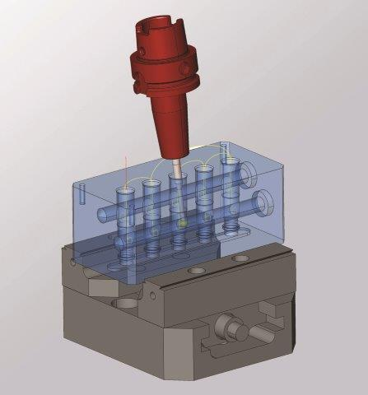

A new, fast, easy, and safe 5-axis hole deburring strategy excels at deburring sharp edges on holes and intersecting holes. By using CAM Plan programming assistance and analysis technology to automatically recognize all the holes, the sharp edges in the model are marked for selecting the desired edges. The hole deburring technology automatically calculates toolpaths, and supports 3-axis and 5-axis modes. Also, *hyper*MILL® now offers a 5-axis deburring strategy for fast and efficient deburring of component edges. Users may choose between 3-axis machining and a 5-axis option which enables greater reach to more component edges, automatically generating the required inclinations as well as collision avoidance.

5-axis Hole Deburring with *hyper*MILL® 2025

The pocket milling algorithm for high feed cutters in *hyper*MILL® 2025 has been redeveloped for 3D-optimized roughing, achieving greater efficiency during roughing as well as better machining control, especially helpful when machining large lateral in-feeds and remaining material. Contour and path radii can also be defined, resulting in improved toolpath rounding.

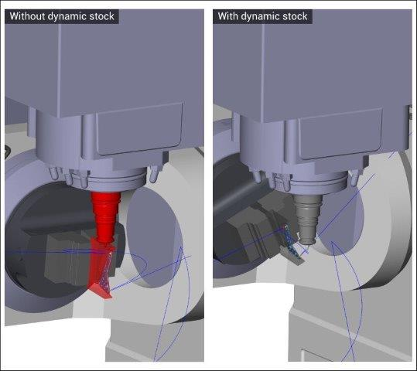

Linking movements via *hyper*MILL® VIRTUAL Machining Optimizer have been further optimized for actual stock conditions with *new* Dynamic Stock technology. Using Dynamic Stock, an updated stock is automatically generated for all machining jobs and accounted for when calculating linking movements.

Linking with *hyper*MILL® Dynamic Stock technology

About OPEN MIND Technologies AG

OPEN MIND Technologies AG is one of the world’s leading developers of powerful CAD/CAM software solutions for machine and controller-independent programming. OPEN MIND develops optimized CAD/CAM solutions that include innovative and unique features that can deliver significantly higher performance in both programming and machining. *hyper*MILL® is a completely modular CAD/CAM solution that provides state-of-the-art CAM technologies on its own CAD platform: from 2.5D, 3D and 5-axis machining as well as turning strategies and solutions for additive manufacturing, HSC and HPC machining. Whether automation, simulation or virtual machine – trendsetting technologies expand the product range and enable continuous digital process chains. Special applications, seamless interaction with all popular CAD solutions and exceptional customer service rounds out the company’s products and capabilities.

According to the "NC Market Analysis Report 2024" compiled by CIMdata, *hyper*MILL® is a leading, worldwide CAD/CAM solution. Innovative CAD/CAM technologies fulfill the highest demands in the automotive, tool and mold manufacturing, production machining, medical, job shops, energy, semiconductor and aerospace industries.OPEN MIND is a Mensch und Maschine company and has subsidiaries and qualified sales partners on all continents. You can find more information at<https://www.openmind-tech.com/en-us/>.

# # # # #