FOR THE MEDIA
New Managing Director at ASMPT SMT Solutions for the Asia region (excluding China)
DaeSung Kim takes over Sales and Service Organization
Singapore, March 5, 2025 – ASMPT, the global technology and market leader in hardware and software solutions for semiconductor and electronics manufacturers, has appointed DaeSung Kim as Managing Director of the ASMPT SMT Solutions Sales and Service Organization in Asia (excluding China).
DaeSung Kim has contributed to ASMPT’s success in the region for more than 25 years, holding many important positions in key areas during his career at the global player. He started as a sales representative in Korea and later became Managing Director, responsible for all Korean customers worldwide as well as the company‘s business activities in Korea, Thailand and Vietnam. In all these positions he was able to strengthen customer relationships and develop new markets in many areas. In his new position, DaeSung Kim is now responsible for all strategic market coverage and growth initiatives in the region.
Innovation and customer focus as the key to success
“In these exciting times, where one electronic innovation follows another, I am convinced that we will continue to strengthen our position as a global technology and innovation leader,” said Kim. “Our highly motivated ASMPT team is committed to meeting the current and future needs of our customers. I appreciate the close and trusting cooperation between the Semiconductor and SMT Solutions teams, which has already produced impressive results. A perfect example is the SIPLACE CA2 hybrid placement machine, which integrates the processing of SMDs and dies directly from the wafer into the SMT line in a highly productive, cost-efficient and sustainable way. Innovations such as these in advanced packaging, together with our strong customer relationships, make us the partner of choice for the electronics manufacturing industry.”

Illustrations for downloading
The following print-ready artwork is available on the internet for downloading:
https://kk.htcm.de/press-releases/asmpt/

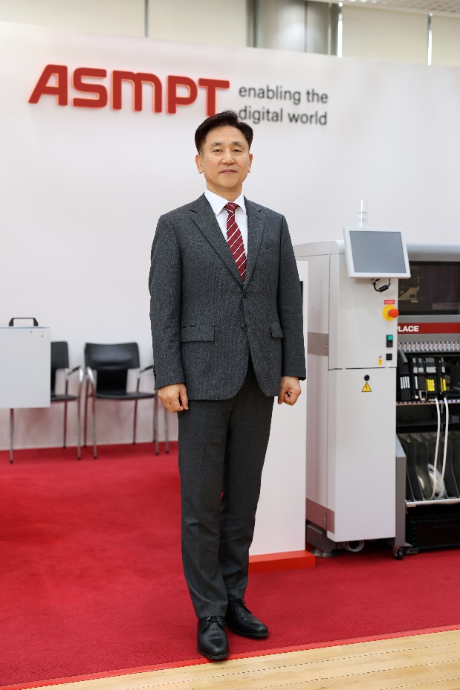

DaeSung Kim is the new Managing Director of the Sales and Service Organization in the Asia region (excluding China).

Image source: ASMPT

About ASMPT Limited (“ASMPT”)
ASMPT Limited is a leading global supplier of hardware and software solutions for the manufacture of semiconductors and electronics. Headquartered in Singapore, ASMPT’s offerings encompass the semiconductor assembly & packaging, and SMT (surface mount technology) industries, ranging from wafer deposition to the various solutions that organize, assemble and package delicate electronic components into a vast range of end-user devices, which include electronics, mobile communications, computing, automotive, industrial and LED (displays). ASMPT partners with customers very closely, with continuous investments in R&D helping to provide cost-effective, industry-shaping solutions that achieve higher productivity, greater reliability, and enhanced quality. ASMPT is a founding member of the Semiconductor Climate Consortium.
ASMPT is listed on the Hong Kong Stock Exchange (HKEX stock code: 0522) and is one of the constituent stocks of the Hang Seng TECH Index, the Hang Seng Composite MidCap Index, the Hang Seng Composite Information Technology Industry Index under Hang Seng Composite Industry Indexes, the Hang Seng Corporate Sustainability Benchmark Index, and the Hang Seng HK 35 Index.
To learn more about ASMPT, please visit www.asmpt.com.

The ASMPT SMT Solutions segment
The mission of the SMT Solutions segment within ASMPT is to implement and support the Intelligent Factory at electronics manufacturers worldwide.
ASMPT solutions support the networking, automation, and optimization of central workflows with hardware, software and services that enable electronics manufacturers to transition to the Intelligent Factory in stages and enjoy dramatic improvements in productivity, flexibility, and quality. With its integrated open automation concept, ASMPT opens the door for its customers to economically feasible automation, entirely in accordance with their individual requirements – modular, flexible, and vendor-independent.
The product range includes hardware and software such as SIPLACE placement solutions, DEK printing solutions, inspection and storage solutions, and the WORKS Software Suite. With WORKS, ASMPT offers electronics manufacturers high-quality software for planning, controlling, analyzing and optimizing all processes on the shop floor. Maintaining close relationships with customers and technology partners is a central component of ASMPT’s strategy.
For more information about ASMPT SMT Solutions, visit smt.asmpt.com.

Media contacts:
ASMPT ROA Press Office
SMT Solutions
ASMPT SMT Singapore Pte. Ltd.
Janet Loh
Phone: +65 6877 3948
E-mail: Janet.loh@asmpt.com
Website: smt.asmpt.com

Global ASMPT Press Office
ASMPT Ltd.
Susanne Oswald
Rupert-Mayer-Strasse 48
81379 Munich
Germany
Phone: +49 89 20800-26439
E-Mail: susanne.oswald@asmpt.com
Website: asmpt.com

