FOR THE MEDIA
ASMPT at IPC APEX EXPO 2025
Component flexibility from the technology leader
Suwanee (USA), March 3, 2025 – ASMPT, the leading provider of hardware and software for semiconductor and electronics manufacturing, will again demonstrate its technology leadership in component flexibility and software solutions at this year’s IPC APEX EXPO being held March 18-20 in Anaheim, California. Also present at booth 1813 will be Critical Manufacturing, a member of the ASMPT Group, with its pioneering manufacturing execution systems.
At the center of ASMPT’s trade fair presence will be a highly flexible production line consisting of a DEK TQ solder paste printer, a Process Lens SPI system, and SIPLACE TX and SIPLACE SX placement machines. A DEK TQ L printer will also be shown at the booth.
“Today, a modern SMT production line must operate with maximum speed and precision across the entire component spectrum,” explained Mark Ogden, Senior Manager Marketing Americas at ASMPT. “Modern hybrid circuit boards hold everything from super-miniaturized 0201m components to large and heavy ball grid arrays (BGAs). We will demonstrate to trade visitors at our booth how effectively ASMPT is able to master these challenges.”
Precision and flexibility in a single line
The SIPLACE machines’ ability to measure very small as well as very large components individually with a head-mounted camera is critically important. Rotating segments ensure the high-precision assembly of even the smallest components with exceptional placement densities.
Size, weight and center of gravity play increasingly important roles at the opposite end of the component scale. SIPLACE placement machines measure the inertia of heavy BGA components with precisely defined rotating motions to determine the maximum permissible acceleration, while specially shaped nozzles ensure a reliable pickup. The component is then subjected to a precise coplanarity check so that all balls make optimal contact with the solder paste even on large-area shapes.
With the help of PCB cameras that are integrated into the placement machine, both the solder pads and the presence and correct placement of spacer pins can be checked. Foreign bodies and/or contaminants in the placement area are also reliably detected. Only when all prerequisites regarding the component and the PCB have been fully met will the often very expensive BGA component get placed with a precisely defined force.
“Large and heavy BGAs are particularly common on server boards used for AI (artificial intelligence) applications. These BGAs require very special handling, and ASMPT is the master of this process,” said Mark Ogden.
Seamlessly optimized material management
A major highlight of our software solutions being presented at the IPC APEX EXPO will be our seamlessly automated material flow optimization for the intelligent factory with its multi-location connectivity and consistent information exchange via open interfaces in accordance with the IPC industry standard. Using this data, intelligent software solutions combine inventory and demand data in real time to ensure efficient and automated material supplies. With the Factory Material Manager and WORKS Logistics applications, ASMPT enables seamless material tracking, optimized inventory management and demand-based replenishments on the SMT line – without excess inventories and material bottlenecks.
MES for Industry 4.0
Critical Manufacturing will present at the same booth its industry-leading manufacturing execution system. The MES, which is specially tailored to the needs of electronics manufacturers, features process orchestration and standardization based on Industry 4.0 as well as maximum degrees of freedom for speedy product innovations.

Illustrations for downloading
The following print-ready artwork is available on the internet for downloading:
https://kk.htcm.de/press-releases/asmpt/

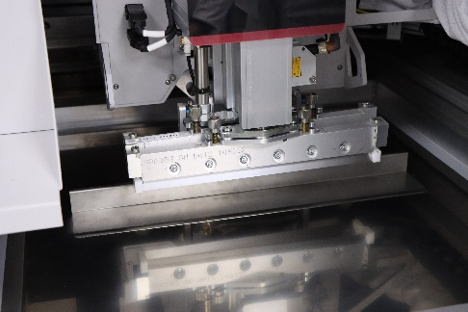 | 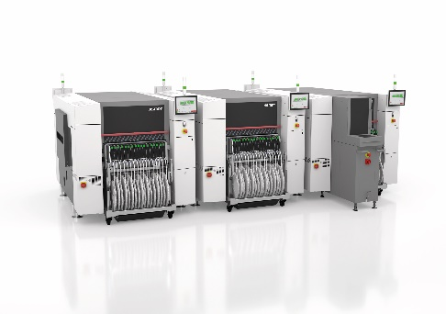
Live at the booth: The DEK TQ and DEL TQ L solder paste printers with their new Automated Paste Transfer and Quick Change Squeegee functions.  Image credit: ASMPT | SIPLACE placement systems equipped with the TWIN Very High Force head and the latest software can securely handle larger, heavier components and feature state-of-the-art vision and inspection capabilities for both the component and the board.  Image credit: ASMPT
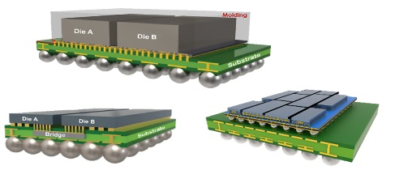 | 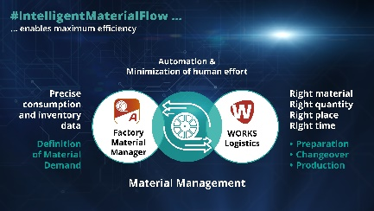
Most large, modern BGAs have multiple bare dies and passive components inside.  Image credit: ASMPT | A strong pair: Factory Material Manager and WORKS Logistics ensure the seamlessly automated flow of materials in the entire factory.  Image credit: ASMPT

About ASMPT Limited (“ASMPT”)
ASMPT Limited is a leading global supplier of hardware and software solutions for the manufacture of semiconductors and electronics. Headquartered in Singapore, ASMPT’s offerings encompass the semiconductor assembly & packaging, and SMT (surface mount technology) industries, ranging from wafer deposition to the various solutions that organise, assemble and package delicate electronic components into a vast range of end-user devices, which include electronics, mobile communications, computing, automotive, industrial and LED (displays). ASMPT partners with customers very closely, with continuous investment in R&D helping to provide cost-effective, industry-shaping solutions that achieve higher productivity, greater reliability, and enhanced quality. ASMPT is also a founding member of the Semiconductor Climate Consortium.
ASMPT is listed on the Stock Exchange of Hong Kong (HKEX stock code: 0522), and is one of the constituent stocks of the Hang Seng TECH Index, Hang Seng Composite MidCap Index under the Hang Seng Composite Size Indexes, the Hang Seng Composite Information Technology Industry Index under the Hang Seng Composite Industry Indexes, the Hang Seng Corporate Sustainability Benchmark Index, and the Hang Seng HK 35 Index.
To learn more about ASMPT, please visit us at asmpt.com.

The ASMPT SMT Solutions segment
The mission of the SMT Solutions segment within ASMPT is to implement and support the Intelligent Factory at electronics manufacturers worldwide.
ASMPT solutions support the networking, automation, and optimization of central workflows with hardware, software and services that enable electronics manufacturers to transition to the Intelligent Factory in stages and enjoy dramatic improvements in productivity, flexibility, and quality. With its integrated open automation concept, ASMPT opens the door for its customers to economically feasible automation, entirely in accordance with their individual requirements – modular, flexible, and vendor-independent.
The product range includes hardware and software such as SIPLACE placement solutions, DEK printing solutions, inspection and storage solutions, and the Software Suite WORKS. With WORKS, ASMPT offers electronics manufacturers high-quality software for planning, controlling, analyzing and optimizing all processes on the shop floor. Maintaining close relationships with customers and technology partners is a central component of ASMPT’s strategy.
For more information about ASMPT SMT Solutions visit smt.asmpt.com.
Media contacts:
AMCAS ASMPT Press Office
SMT Solutions
Mark Ogden
Phone: +1 (770) 797 3189
E-mail: ogden.mark@asmpt.com
Website: smt.asmpt.com

Global ASMPT Press Office
ASMPT Ltd.
Susanne Oswald
Rupert-Mayer-Strasse 48
81379 Munich
Germany
Phone: +49 89 20800-26439
E-Mail: susanne.oswald@asmpt.com
Website: asmpt.com

