FOR THE MEDIA

ASMPT: Great Success at SEMICON Korea 2025

Lead the Edge: ASMPT Enabling the AI World
Singapore, March 3, 2025 – ASMPT, the global market and technology leader in semiconductor and electronics manufacturing solutions achieved great success at SEMICON Korea 2025. The company showcased its latest cutting-edge hardware and software innovations, attracting significant attention from industry professionals, partners, and potential customers. By focusing on the “edge” of technology, ASMPT demonstrated how these innovations drive transformative change across industries, enabling the AI World. With the advanced solutions presented, ASMPT has once again underlined its leadership in the industry.
ASMPT's participation at SEMICON Korea 2025 highlighted the growing role of artificial intelligence and automation for the semiconductor and electronics industries. With the increasing demand for high-speed data processing, advanced computing and smart device integration, ASMPT demonstrated how its solutions address these industry trends and contribute to the rapid transformation of the global technology landscape.
Innovations for the AI World at the Forefront
One of the key attractions was the SIPLACE CA2 platform. The hybrid solution for high-speed SiP placement seamlessly combines bare dies and SMT components at wafer and panel level – without compromising speed. It achieves up to 54,000 dies or 76,000 SMDs per hour with 10 μm @ 3σ accuracy, processing both SMDs and dies directly from the wafer in a single step. With minimal personnel requirements, high connectivity and intelligent data integration, the SIPLACE CA2 is designed to complement the intelligent factory and enable high-volume advanced packaging.
The AERO PRO wire bonder, featuring X-Power 2.0 technology, was another outstanding product. This next-level wire bonder is designed for high-density applications, supporting BGA, LGA, SiP, MCM, Memory, and Leaded QFP packages. With X-Power 2.0, it ensures exceptional precision and flexibility, handling fine wires as small as 0.5 mil. Real-time monitoring, predictive maintenance, and advanced automation optimize performance while enabling seamless integration into intelligent manufacturing. Leveraging data analytics and machine learning, AERO PRO enhances efficiency, making it a key enabler in the AI-driven semiconductor landscape.
Visitors to the booth were also impressed by MEGA, a high-precision IC bonding solution for advanced computing. The advanced die bonding solution for multi-chip module (MCM) applications in high-end IC chiplet packaging delivers ±2 µm precision, ensuring optimal alignment for multi-chip positioning. Designed for next-generation server clusters, AI-edge devices, ADAS, and telecom applications, MEGA sets the benchmark for high-performance die bonding in powerful computing chips.
Also highlighted on the booth was DALA, a universal and fully automated pick-and-place system for camera module assembly, designed for smart electronics. Its LEGO-like modular design enables universal component handling, configurable inputs, and flexible bonding modes. With ±7 µm precision, DALA ensures consistent quality while optimizing total cost of ownership through efficient, adaptable in-line processes. Ideal for AI-driven consumer sensing and imaging, it supports smartphone cameras, electronic sensors, automotive technologies, and more.
Intelligent Factory and Digital Transformation
In addition to showcasing its hardware solutions, ASMPT highlighted its commitment to digital transformation through its intelligent factory concept. The integration of AI, automation and data-driven manufacturing was a key focus at SEMICON Korea 2025. ASMPT demonstrated how its software solutions improve efficiency and productivity in modern electronics manufacturing.
SMT Analytics provides an in-depth analysis of the entire SMT manufacturing process, uncovering hidden, often unnoticed productivity barriers and identifying targeted optimization opportunities. Factory Equipment Center automatically connects with machines and sensors from mobile assets, offering a comprehensive overview and precise analytics of the entire production environment. This application supports predictive maintenance planning and maximizes the availability of machines, placement heads, conveyors, and even nozzles. Virtual Assist leverages advanced AI capabilities to provide each employee with precisely the information they need at any given moment. This intelligent system understands complex queries in natural language, continuously learns, and shares its knowledge with the entire team.
Next-Level Learning with the ASMPT Academy
Recognizing the importance of continuous learning and upskilling, ASMPT introduced visitors to the ASMPT Academy, which offers face-to-face learning and hands-on training with Virtual Reality. The ASMPT Academy enables specialists to gain new knowledge, refresh existing skills, and stay technologically up to date. This empowers factory floor specialists with the know-how to work more productively and efficiently.
Strong Response and Positive Feedback
Summing up the event, JinWoo Kim, Korea Country Manager for ASMPT SEMI Solutions, said: "SEMICON Korea 2025 was an excellent opportunity for us to showcase our latest innovations and engage in valuable discussions. The strong interest in our cutting-edge solutions highlights the importance of our work in shaping the future of semiconductor manufacturing". AnKyong Sung, General Manager of ASMPT SMT Solutions Korea Branch, added: "The increasing digitalization and automation in electronics manufacturing is undeniable. With our advanced hardware and software solutions and expertise, we are ready to help our customers increase efficiency and flexibility while preparing for the future."

Illustrations for downloading

The following images are available for download in printable format at:
https://kk.htcm.de/press-releases/asmpt/

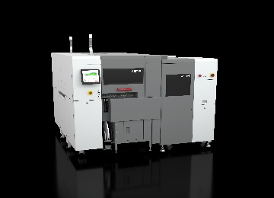 | 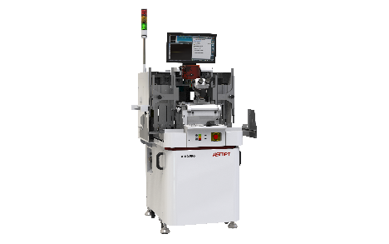
The SIPLACE CA2 boosts productivity in advanced packaging by combining classic surface-mount technology with die-attach and flip-chip assembly.  Image credit: ASMPT | AERO PRO: next-level wire bonding  Image credit: ASMPT
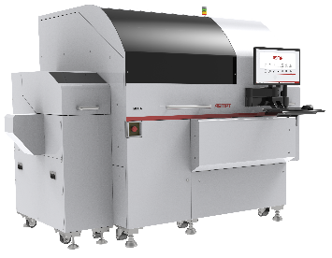 | 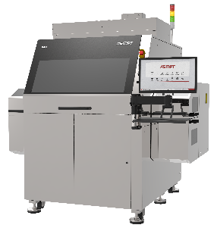
MEGA: high-precision IC bonding for advanced computing  Image credit: ASMPT | DALA: universal pick & place system for camera module assembly  Image credit: ASMPT
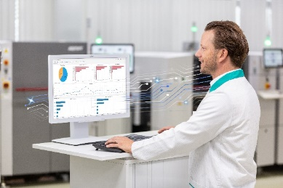 | 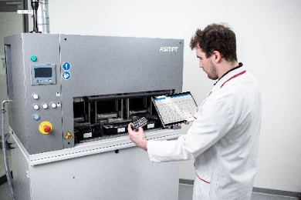
SMT Analytics: Material analysis with the Reject Analysis use case  Image credit: ASMPT | Factory Equipment Center: Each SmartNozzle has its own ID with which it can be scanned and evaluated – whether it is in use or, as shown here, in the Nozzle Cleaning Station.  Image credit: ASMPT
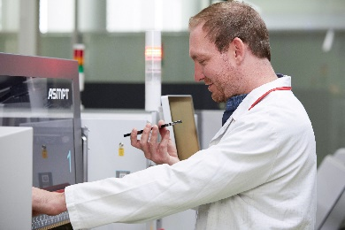 | 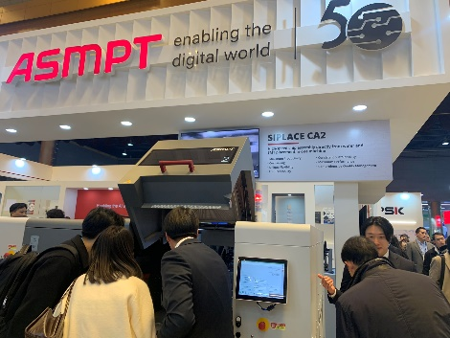
Thanks to NLP technology, users can ask Virtual Assist questions just like a human colleague.  Image credit: ASMPT | The showcased SIPLACE CA2 hybrid placement platform was one of the key attractions at the ASMPT booth.  Image credit: ASMPT
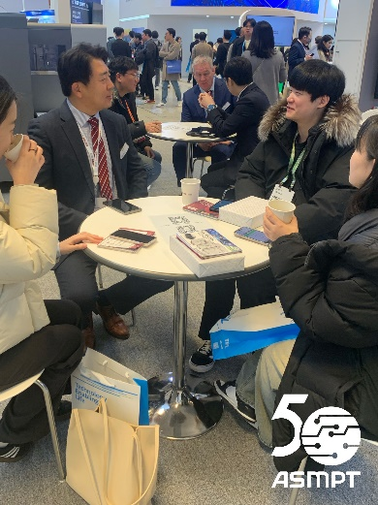 | 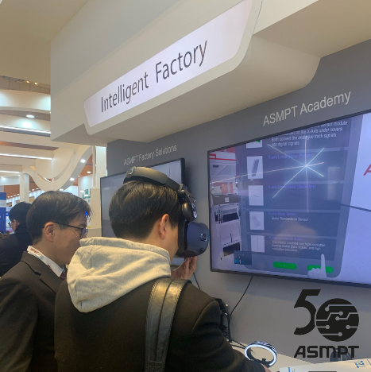
The well-attended ASMPT booth offered numerous opportunities for networking and professional dialogue.  Image credit: ASMPT | Visitors to the booth also showed great interest in ASMPT's portfolio of software solutions for the intelligent factory.  Image credit: ASMPT

About ASMPT Limited (“ASMPT”)
ASMPT Limited is a leading global supplier of hardware and software solutions for the manufacture of semiconductors and electronics. Headquartered in Singapore, ASMPT’s offerings encompass the semiconductor assembly & packaging, and SMT (surface mount technology) industries, ranging from wafer deposition to the various solutions that organise, assemble and package delicate electronic components into a vast range of end-user devices, which include electronics, mobile communications, computing, automotive, industrial and LED (displays). ASMPT partners with customers very closely, with continuous investment in R&D helping to provide cost-effective, industry-shaping solutions that achieve higher productivity, greater reliability, and enhanced quality. ASMPT is also a founding member of the Semiconductor Climate Consortium.
ASMPT is listed on the Stock Exchange of Hong Kong (HKEX stock code: 0522), and is one of the constituent stocks of the Hang Seng TECH Index, Hang Seng Composite MidCap Index under the Hang Seng Composite Size Indexes, the Hang Seng Composite Information Technology Industry Index under the Hang Seng Composite Industry Indexes, the Hang Seng Corporate Sustainability Benchmark Index, and the Hang Seng HK 35 Index.
To learn more about ASMPT, please visit us at asmpt.com.

Media contacts:
Global ASMPT Semiconductor Solutions Press Office
ASMPT Limited
Jessica Ho
Semiconductor Solutions
E-mail: ul.ho@asmpt.com
Website: semi.asmpt.com

Global ASMPT Press Office
ASMPT Ltd.
Susanne Oswald
Rupert-Mayer-Strasse 48
81379 Munich
Germany
Tel: +49 89 20800-26439
E-Mail: susanne.oswald@asmpt.com
Website: asmpt.com

