Press Release
Symeo Expands Radar Sensor Functionality
Bidirectional secondary radar
Neubiberg, Germany, 27 February 2025 – Symeo extends the feature set of its LPR®-1DHP-350 radar sensor to include bidirectionality. This means that measured data is now available on both sensors in a secondary radar application, making it easier to set up collision warning systems for crane operators working on the same level.
A single radar sensor employs passive echo, so accurate distance measurement is dependent on reliably hitting the target object. Secondary radar, which works by using a second sensor that responds, is therefore more reliable. Secondary radar applications previously depended on a fixed hierarchy between the master and slave sensors. This meant that measurement data was only available on the master side. With the new, optional function of the LPR-1DHP-350 Symeo sensor, the sensors alternate between sending and responding, so the measured values can now be called up on both sides. This makes it easier, for example, to set up an anti-collision solution between two crane bridges on the same level. Until now, users had to rely on a WLAN connection or invest in a trailing cable.
Robust sensors
LPR-1DHP-350 is based on Symeo’s patented LPR (Local Positioning Radar) technology, which facilitates extremely robust and maintenance-free sensor solutions and is insensitive to environmental influences and vibrations. The radar system operates in the 120-GHz frequency range. In cooperative secondary radar mode with two LPR-1DHP-350s, the Symeo sensors achieve ranges of up to 100 meters.

Available image material
The following printable images are available for download on the Internet:
https://kk.htcm.de/press-releases/symeo/

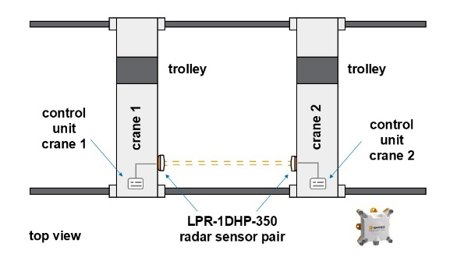
Bildquelle: Symeo
The typical application of bidirectionality is an anti-collision solution for two crane bridges on one level.

Symeo
Symeo develops and markets products and solutions for precise, non-contact, maintenance-free position detection, distance measurement, and collision avoidance. Symeo’s products feature extremely robust designs to make them suitable for applications in harsh industrial environments.
Symeo’s LPR® locating technology offers a wireless and real-time-capable measuring system that is ideally suited for industrial applications. Symeo has many years of experience in the development of cost-efficient and customer-specific industrial solutions on the basis of LPR® technology.
The company delivers standardized products and complete solutions to system integrators, original equipment manufacturers (OEMs), and end customers worldwide.
Headquarters: Symeo GmbH, Prof.-Messerschmitt-Strasse 3 a, 85579 Neubiberg, Germany
Phone: (+49-89) 6607-7960, Fax: (+49-89) 66077-96190
E-mail: info@symeo.com, Website: www.symeo.com

Press contact:
HighTech communications GmbH
Marcus Planckh
Brunhamstrasse 21 (Building 202/2nd floor)
81249 Munich
Germany
Phone: (+49-89) 500-77822
E-mail: m.planckh@htcm.de
Website: www.htcm.de

