PRESS RELEASE

Würth Elektronik presents its LEDs with focused emission
Precise, Space-Saving, and Energy-Efficient Light Sources
Waldenburg (Germany), February 25, 2025 – Würth Elektronik expands its two LED product series: “WL-SMCW SMT Mono-color Chip LED Waterclear” now includes a compact model with a footprint of just 1.6 mm × 0.8 mm, in which a dome lens focuses the light. This enables the LED to produce a bright and concentrated beam with an emission angle of just 30 degrees. The “WL-SMTD SMT Mono-color TOP LED Diffused Dome” series now also includes versions with 30-degree and 60-degree emission angles and offers an additional black housing, providing higher contrast in dark-design blinking lights, for example.
The WL-SMCW in the 0603 package with a dome lens is a high-precision, space-saving, and energy-efficient light source for applications that depend on focused light control. With the LED, light can be precisely directed onto a small area while minimizing light scattering and energy loss. It is suitable for consumer electronics, medical devices, handheld products, and symbol or text displays. The available LED colors are blue, green, light green, yellow, amber, and red.
The new WL-SMTD series models are aimed at developers seeking robust, aesthetically attractive lighting solutions with higher contrast. Precise, glare-free illumination for demanding applications is achieved with the selectable 30-degree or 60-degree emission angle, a diffuse dome lens, and a black 3528 package designed to minimize light loss.
All new LEDs are now available without a minimum order quantity.

Available images
The following images can be downloaded from the Internet in printable quality: https://kk.htcm.de/press-releases/wuerth/

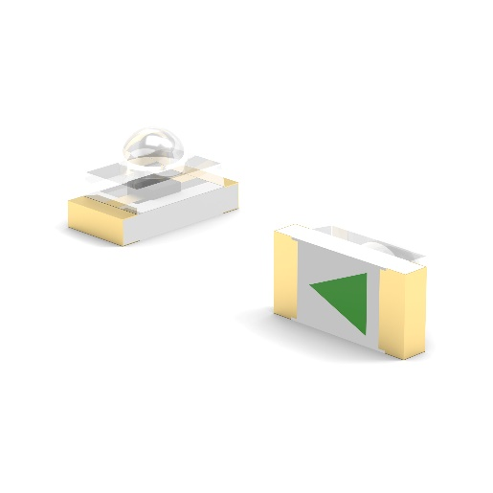  Image source: Würth Elektronik  The WL-SMCW with a dome lens is a high-precision, space-saving and energy-efficient light source. | 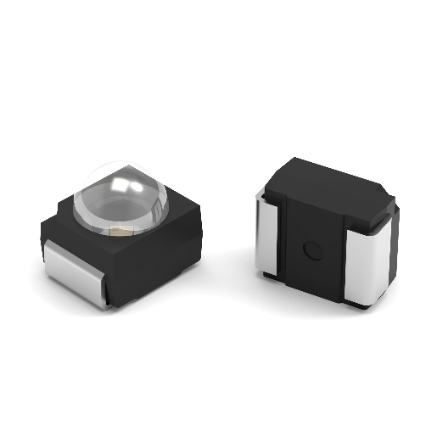  Image source: Würth Elektronik  The WL-SMTD emits diffuse light with a 30-degree or 60-degree emission angle and is now available in a black housing.

About the Würth Elektronik eiSos Group
Würth Elektronik eiSos Group is a manufacturer of electronic and electromechanical components for the electronics industry and a technology company that spearheads pioneering electronic solutions. Würth Elektronik eiSos is one of the largest European manufacturers of passive components and is active in 50 countries. Production sites in Europe, Asia and North America supply a growing number of customers worldwide.
The product range includes EMC components, inductors, transformers, RF components, varistors, capacitors, resistors, quartz crystals, oscillators, power modules, Wireless Power Transfer, LEDs, sensors, radio modules, connectors, power supply elements, switches, push-buttons, connection technology, fuse holders and solutions for wireless data transmission. The portfolio is complemented by customized solutions.
The unrivaled service orientation of the company is characterized by the availability of all catalog components from stock without minimum order quantity, free samples and extensive support through technical sales staff and selection tools.
Würth Elektronik is part of the Würth Group, the global market leader in the development, production, and sale of fastening and assembly materials, and employs 7,900 people. In 2023, the Würth Elektronik Group generated sales of 1.24 Billion Euro.
Würth Elektronik: more than you expect!
Further information at www.we-online.com

Further information:  Würth Elektronik eiSos GmbH & Co. KG  Sarah Hurst  Clarita-Bernhard-Strasse 9  81249 Munich  Germany  Phone: +49 7942 945-5186  E-mail: sarah.hurst@we-online.de  www.we-online.com | Press contact:  HighTech communications GmbH  Brigitte Basilio  Brunhamstrasse 21  81249 Munich  Germany  Phone: +49 89 500778-20  E-mail: b.basilio@htcm.de  www.htcm.de

