
PRESS RELEASE
Hall 6, Stand 6 E 104

Hufschmied Zerspanungssysteme at JEC World in Paris
Natural fiber-reinforced composites with smooth edges
Bobingen (Germany), February 25, 2025 – Hufschmied Zerspanungssysteme will be exhibiting at stand 6 E 104 in hall 6 of the Paris Nord Villepinte Exhibition Center from March 4 to 6, 2025. This time, the manufacturer of process-optimized cutting tools will be focusing on the machining of natural fibre-reinforced plastics and the requirements of the aerospace industry.
Composite materials based on natural fibers are currently in vogue. Milling them cleanly and without reworking poses a challenge, as the fibers are much more difficult to cut than conventional materials. Hufschmied presents the solution with T-REX (194/198). Thanks to its unique cutting geometry, this tool performs a compression cut that enables smooth edges.
Two other tools are in the spotlight. 068ECO features a new milling cutter geometry developed in collaboration with aerospace users based on the proven HEXACUT geometry. The vibration behavior of the components has been greatly reduced, especially for large components, so that the requirements for component clamping are reduced. The cutting pressure is particularly low with the 068ECO series. Also new: the 108 series of FIBER-LINE tools. The carbon milling cutters are available in various toothing types. In combination with wear-resistant carbides and coatings, even highly abrasive materials can be machined.
Diamond coating DIP7
In addition to the tool geometry, the coating also has a major influence on the behavior of milling tools. For CFRP machining in aircraft construction, Hufschmied recommends its highly wear-resistant multilayer diamond coating DIP7. The gradient-free coating thickness ensures a homogeneous wear pattern and the high thermal conductivity ensures rapid heat dissipation. Thick-walled CFRP components in particular can be reliably machined with DIP7-coated tools. The cutting edges are so sharp and the coating so smooth that the fibers do not get caught and the components do not start to vibrate. Uniform workpiece surfaces are produced without delamination or fiber protrusions.

Ultrasonic cutting
SoniCut GmbH will be co-exhibiting at the Hufschmied stand. The solid carbide monoblock blades from Hufschmied enable the performance of SoniCut's ultrasonic-assisted cutting systems to be exploited to the full and are also sold together with them. This cutting method is particularly recommended for fragile honeycomb panels or fiber stacks.

Available images
The following images can be downloaded from the Internet in printable quality:
https://kk.htcm.de/press-releases/hufschmied/
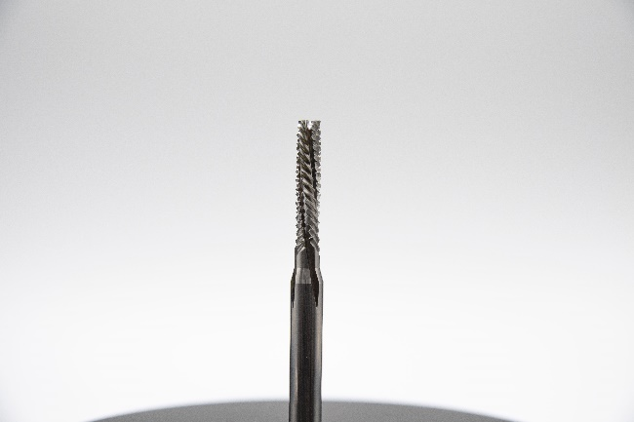Image source: Hufschmied Zerspanungssysteme
T-REX (194/198) is a tool optimized for processing natural fibre-reinforced composite materials.

About Hufschmied Zerspanungssysteme GmbH
Established in 1991 and headquartered in Bobingen near Augsburg, Hufschmied Zerspanungssysteme GmbH is a manufacturer of high-quality tools for machinable production and friction stir welding. By specializing at an early stage in the machining of plastics, fiberglass materials and carbon fiber, Hufschmied has become a leader in Europe in the development of solutions for new materials. The company is an established system supplier to renowned machine tool manufacturers. Tools and manufacturing process consulting from Hufschmied are particularly valued in the automotive and aerospace industries as well as in medical technology. The company is involved in numerous organizations, including Composites United Deutschland e. V. Hufschmied's manufacturing operations are located in Bobingen, Winterlingen and Sigmaringen on the Swabian Alb. Hufschmied is certified according to ISO 9001:2015 (quality management) and ISO 14001:2015 (environmental management).

Hufschmied Zerspanungssysteme GmbH – One Cut Ahead
For more information: www.hufschmied.net

Additional information:  Hufschmied Zerspanungssysteme GmbH  Marco Beigl  Edisonstrasse 11d  86399 Bobingen  Germany  Phone: +49 8234 9664-0  Telefax: +49 8234 9664-99  E-Mail: info@hufschmied.net  www.hufschmied.net | Press contact:  HighTech communications GmbH  Brigitte Basilio  Brunhamstrasse 21  81249 Munich  Germany  Phone: +49 89 500778-20  E-Mail: b.basilio@htcm.de  www.htcm.de

