PRESS RELEASE
PCB threaded connections using press-fit technology
Automotive Quality up to 250 A
Waldenburg (Germany), February 18, 2025 – Würth Elektronik, manufacturer of electronic and electromechanical components for the electronics industry, presents its “REDCUBE PRESS-FIT for Automotive”, a new range of threaded connections specially optimized for the automotive industry. The robust components can carry currents of up to 250 A and are manufactured according to particularly stringent quality standards.
The automotive industry includes some of the most demanding customers. Reworked products aren’t acceptable. High requirements apply to the components used, especially for current-carrying connections. They must be mechanically stable, highly conductive, and not thermally stress the circuit board.
Reliable press-fit technology
Würth Elektronik now serves this demanding market with its new screw connectors for circuit board assembly using press-fit technology. The process ensures an even contact between the pin and the copper layer, especially on PCBs with very thick coatings, and offers greater reliability and stability than soldering. The new connectors enable a gas-tight and extremely strong mechanical connection. The contact resistance for the new automotive series is less than 200 µOhm. Three variants are available:
- WE-PFIFUA with internal thread (Full Plain Automotive)
- WE-PFEFUA with external thread (Automotive)
- WE-PFICFA with internal thread (Circumference Automotive)
Each connector is available in the thread sizes M3, M4, M5, M6 and M8.
Visually checked individually
Each and every component is visually inspected for dimensional accuracy during manufacture. The pins are particularly robust to prevent bending during transport or assembly. This ensures consistently high-quality production results. REDCUBE PRESS-FIT connectors made from RoHS-compliant CuZn39Pb3 alloy can be pressed in without thermally stressing the PCB.
The high-quality threaded connections are used wherever large amounts of energy need to be carried safely and with minimal loss, such as in IGBT power modules, inverters for electric vehicles, or charging stations.

Available images
The following images can be downloaded from the Internet in printable quality: https://kk.htcm.de/press-releases/wuerth/
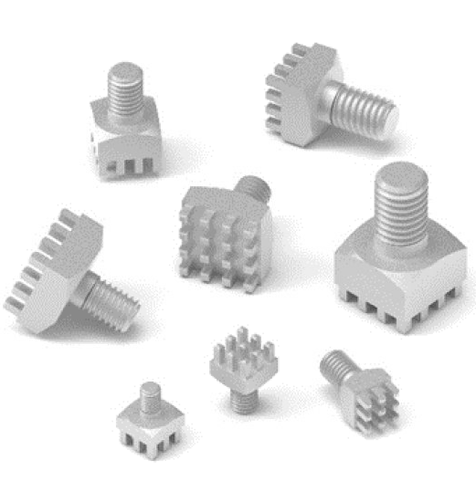
Image source: Würth Elektronik
REDCUBE PRESS-FIT for Automotive: The individually tested press-fit connectors can carry high currents and are mechanically very stable.

About the Würth Elektronik eiSos Group
Würth Elektronik eiSos Group is a manufacturer of electronic and electromechanical components for the electronics industry and a technology company that spearheads pioneering electronic solutions. Würth Elektronik eiSos is one of the largest European manufacturers of passive components and is active in 50 countries. Production sites in Europe, Asia and North America supply a growing number of customers worldwide.
The product range includes EMC components, inductors, transformers, RF components, varistors, capacitors, resistors, quartz crystals, oscillators, power modules, Wireless Power Transfer, LEDs, sensors, radio modules, connectors, power supply elements, switches, push-buttons, connection technology, fuse holders and solutions for wireless data transmission. The portfolio is complemented by customized solutions.

The unrivaled service orientation of the company is characterized by the availability of all catalog components from stock without minimum order quantity, free samples and extensive support through technical sales staff and selection tools.
Würth Elektronik is part of the Würth Group, the global market leader in the development, production, and sale of fastening and assembly materials, and employs 7,900 people. In 2023, the Würth Elektronik Group generated sales of 1.24 Billion Euro.
Würth Elektronik: more than you expect!
Further information at www.we-online.com

Further information:  Würth Elektronik eiSos GmbH & Co. KG  Sarah Hurst  Clarita-Bernhard-Strasse 9  81249 Munich  Germany  Phone: +49 7942 945-5186  E-mail: sarah.hurst@we-online.de  www.we-online.com | Press contact:  HighTech communications GmbH  Brigitte Basilio  Brunhamstrasse 21  81249 Munich  Germany  Phone: +49 89 500778-20  E-mail: b.basilio@htcm.de  www.htcm.de

