FOR THE MEDIA

ASMPT at SEMICON Korea 2025

Lead the Edge: ASMPT Enabling the AI World
Singapore, February 18, 2025 – ASMPT, the global leader in semiconductor and electronics manufacturing solutions, will demonstrate its cutting-edge technologies at SEMICON Korea 2025, February 19-21, at COEX, Seoul (Hall D, Booth D432). Under the theme "Lead the Edge: ASMPT Enabling the AI World," the company will present innovations driving the future of intelligent manufacturing.
Visitors to the ASMPT booth can experience groundbreaking hardware and software solutions – enhancing efficiency and digital transformation towards intelligent factories. The highlights are:
Innovations for advanced packaging and optoelectronics
The SIPLACE CA2 hybrid platform seamlessly combines bare dies and SMT components at wafer and panel level at high speed. It complements the intelligent factory and enables high-volume advanced packaging. The AERO PRO wire bonder is designed for high-density applications, supporting BGA, LGA, SiP, MCM, Memory, and Leaded QFP packages. It uses data analytics and machine learning to improve efficiency, making it a key enabler in the AI-driven semiconductor landscape. MEGA is an advanced die bonding solution for multi-chip module (MCM) applications in high-end IC chiplet packaging. It sets the benchmark for high-performance die bonding in powerful computing chips.
DALA is a fully automated pick-and-place system for camera module components, designed for smart electronics. Ideal for AI-driven consumer sensing and imaging, it supports smartphone cameras, electronic sensors, automotive technologies, and more.
State-of-the-art software solutions for intelligent factories
SMT Analytics provides an in-depth analysis of the entire SMT manufacturing process, uncovering hidden, often unnoticed productivity barriers and identifying targeted optimization opportunities. Factory Equipment Center automatically connects with machines and sensors from placement heads, feeders, and nozzles, supporting predictive maintenance planning and maximizing uptime. AI-based Virtual Assist understands complex queries in natural language, provides each employee with exactly the information they need, continuously learns, and shares its knowledge with the team.
Modern learning with the ASMPT Academy
The ASMPT Academy offers face-to-face learning and hands-on training with Virtual Reality, enabling employees to gain new knowledge, refresh existing skills, and stay technologically up to date.
"In this era of rapid AI advancement, ASMPT is at the forefront of electronics and semiconductor assembly solutions," said JinWoo Kim, Korea Country Manager for ASMPT SEMI Solutions. "As Korea strengthens its role in AI, we continue to drive innovation, providing cutting-edge equipment for advanced packaging, smart automotive technologies, and high-speed communication." AnKyong Sung, General Manager for ASMPT SMT Solutions Korea adds: "By integrating best-in-class equipment with highly networked, automated software solutions, we are shaping the next level of digital transformation – the intelligent factory – where efficiency and intelligence seamlessly converge."
About SEMICON Korea 2025, please visit the official website: https://www.semiconkorea.org/en

Illustrations for downloading

The following images are available for download in printable format at:
https://kk.htcm.de/press-releases/asmpt/

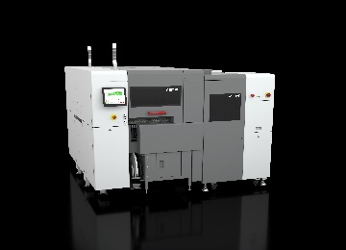 | 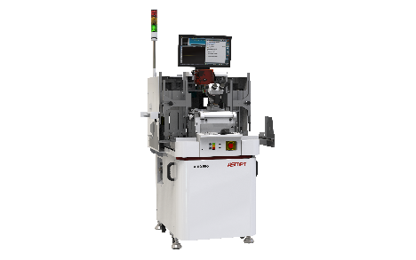
The SIPLACE CA2 boosts productivity in advanced packaging by combining classic surface-mount technology with die-attach and flip-chip assembly.  Image credit: ASMPT | AERO PRO: next-level wire bonding  Image credit: ASMPT
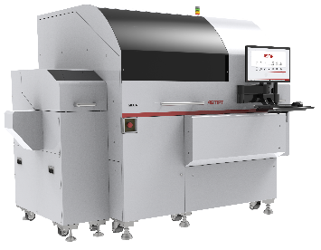 | 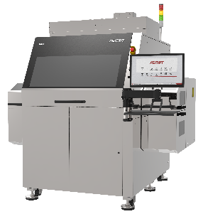
MEGA: high-precision IC bonding for advanced computing  Image credit: ASMPT | DALA: universal pick & place system for camera module assembly  Image credit: ASMPT
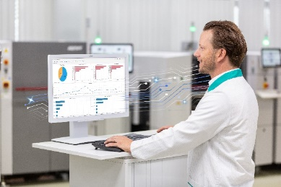 | 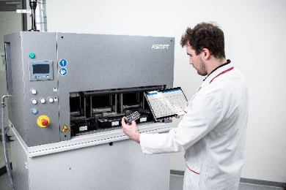
SMT Analytics: Material analysis with the Reject Analysis use case  Image credit: ASMPT | Factory Equipment Center: Each SmartNozzle has its own ID with which it can be scanned and evaluated – whether it is in use or, as shown here, in the Nozzle Cleaning Station.  Image credit: ASMPT
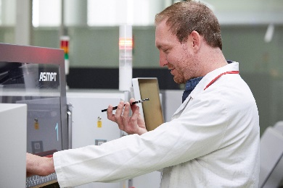
Thanks to NLP technology, users can ask Virtual Assist questions just like a human colleague.
Image credit: ASMPT

About ASMPT Limited (“ASMPT”)
ASMPT Limited is a leading global supplier of hardware and software solutions for the manufacture of semiconductors and electronics. Headquartered in Singapore, ASMPT’s offerings encompass the semiconductor assembly & packaging, and SMT (surface mount technology) industries, ranging from wafer deposition to the various solutions that organise, assemble and package delicate electronic components into a vast range of end-user devices, which include electronics, mobile communications, computing, automotive, industrial and LED (displays). ASMPT partners with customers very closely, with continuous investment in R&D helping to provide cost-effective, industry-shaping solutions that achieve higher productivity, greater reliability, and enhanced quality. ASMPT is also a founding member of the Semiconductor Climate Consortium.
ASMPT is listed on the Stock Exchange of Hong Kong (HKEX stock code: 0522), and is one of the constituent stocks of the Hang Seng TECH Index, Hang Seng Composite MidCap Index under the Hang Seng Composite Size Indexes, the Hang Seng Composite Information Technology Industry Index under the Hang Seng Composite Industry Indexes, the Hang Seng Corporate Sustainability Benchmark Index, and the Hang Seng HK 35 Index.
To learn more about ASMPT, please visit us at asmpt.com.

Media contacts:
Global ASMPT Semiconductor Solutions Press Office
ASMPT Limited
Jessica Ho
Semiconductor Solutions
E-mail: ul.ho@asmpt.com
Website: semi.asmpt.com

Global ASMPT Press Office
ASMPT Ltd.
Susanne Oswald
Rupert-Mayer-Strasse 48
81379 Munich
Germany
Tel: +49 89 20800-26439
E-Mail: susanne.oswald@asmpt.com
Website: asmpt.com

