
PRESS RELEASE
Swissbit at Embedded World 2025
March 11-13, 2025
Hall 1 | Booth 1-510

Storage solutions for server and industrial applications +++ Premiere of the e.MMC M1100 +++ Security upgrade for embedded systems
Bronschhofen, Switzerland, February 18, 2025 – Swissbit continues to develop and expand its portfolio of server and industrial storage solutions. At Embedded World 2025 in Nuremberg (March 11-13, Hall 1, Booth 1-510), the company will present high-performance PCIe SSDs for network, telecommunications and edge server applications as well as robust industrial storage solutions for automation, robotics, etc. Highlights include the PCIe Gen4 SSD A1200, an eight-channel SSD that combines consistently high performance with low latency and maximum data integrity, and the new e.MMC M1100, which will be presented for the first time in Nuremberg. Another focus is on embedded security, led by the Security Upgrade Kit to Security Level 2 with a microSD card for data protection and secure access control.
PCIe Gen4 SSD A1200: Powerful, efficient, reliable
The A1200 combines consistently high performance with low latency and maximum data integrity. Thanks to its TLC Direct firmware architecture, it is optimized for sustained write loads and ensures consistent, reliable performance at the highest level. An eight-channel DRAM-based controller delivers true PCIe Gen4 speed with minimal latency. The A1200 is available in M.2-2280 format and is available with or without a heat sink. With storage capacities ranging from 480 GB to 1.92 TB and an operating temperature range of 0 °C to 70 °C, it is ideal for server applications, high-end industrial applications, and as a reliable data center boot drive. The product line is complemented by the A1000, which features the same technological structure but is designed for an extended temperature range from -25 °C to 85 °C.
Premiere at Embedded World: e.MMC M1100
With the e.MMC M1100, Swissbit is expanding its industrial storage portfolio with a compact and efficient solution for applications with low storage requirements. The 153-ball e.MMC 5.1 uses MLC NAND technology and offers a capacity of 8 GB, optimized for long-lasting industrial applications. Thanks to integrated power fail protection, optimized firmware and effective read-disturb management, the M1100 sets new standards in reliability and performance. The standard M1100 is designed for the industrial temperature range of -40 °C to +85 °C. To meet the requirements of demanding automotive environments, a special version is available for the extended temperature range of -40 °C to +105 °C.
Security for retrofitting: the Security Upgrade Kit
With the Security Upgrade Kit, Swissbit offers a user-friendly and powerful solution for protecting embedded systems and meeting cyber-security requirements. The kit consists of a robust industrial-grade microSD card as well as complementary software, tools and documentation. It combines hardware-based access control with real-time AES-256 data encryption and enables the customization of protection profiles. Typical applications include protecting sensitive data from unauthorized access and ensuring system integrity through secure boot. Thanks to the microSD form factor, the Security Upgrade Kit can be used to retrofit existing systems.

Available images
The following images are available for download in printable format at: https://kk.htcm.de/press-releases/swissbit/
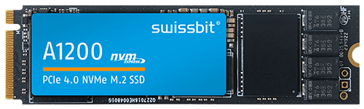  Image source: Swissbit  New in the server and enterprise storage sector: the PCIe Gen4 SSD A1200. | 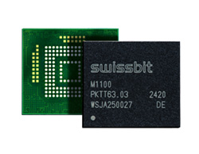  Image source: Swissbit  Back and front of the Swissbit e.MMC M1100.
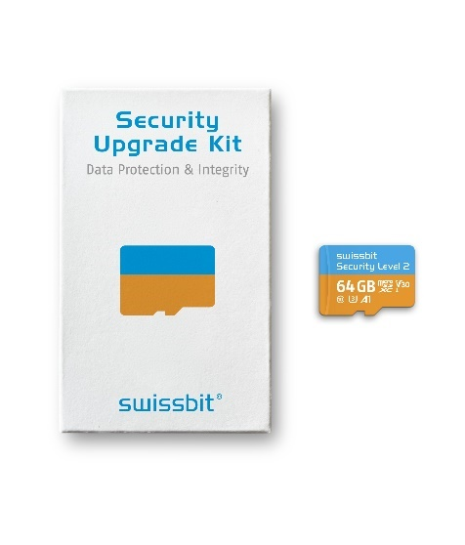  Image source: Swissbit  Retrofittable security for embedded systems: the Security Upgrade Kit. | 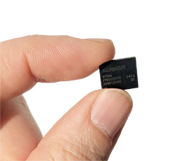  Image source: Swissbit  New in the portfolio of miniaturized memory solutions: the Swissbit e.MMC M1100.

About Swissbit
Swissbit AG is the leading European technology company for data storage and security solutions. Our vision is to build a connected world where data and identities are trusted, ensuring digital sovereignty. Combining unique expertise in hardware and firmware design with advanced packaging know-how, Swissbit develops and manufactures innovative data storage, data protection, and digital identity solutions.
Swissbit's solutions are utilized across diverse industries, including industrial automation, networking & communications, edge computing, transportation, critical infrastructure, defense, and the public sector.
Founded in 2001, Swissbit operates offices in Switzerland (HQ), Germany, the USA, Japan, and Taiwan, and maintains its own semiconductor production facility in Berlin, Germany.
For further information, please visit www.swissbit.com.
Regional Headquarters:  Swissbit Germany AG  Bitterfelder Strasse 22  12681 Berlin  Germany  Tel: +49 30 936 954 0  Email: info@swissbit.com  www.swissbit.com | Headquarters:  Swissbit AG  Industriestrasse 4  9552 Bronschhofen  Switzerland  Tel: +41 71 913 03 00  Email: info@swissbit.com  www.swissbit.com
Contact:  Swissbit AG  Marian Weber  Industriestrasse 4  9552 Bronschhofen  Switzerland  Tel: +49 172 854 88 26  Email: marian.weber@swissbit.com  www.swissbit.com | Press Agency:  HighTech communications GmbH  Brigitte Basilio  Brunhamstrasse 21  81249 Munich  Germany  Tel: +49 89 500778-20  Email: b.basilio@htcm.de  www.htcm.de

