FOR THE MEDIA
ASMPT presents high-performance
LED die bonder

Vortex II: Precision for Mini LED Displays
Munich (Germany), February 28, 2024 – ASMPT, the world's leading supplier of hardware and software for semiconductor and electronics manufacturing, presents Vortex II, a high-performance die bonder for the production of mini LED displays, such as those used in the automotive industry.
“High-resolution, ergonomic LED displays in modern cars ensure drivers have all important and safety-relevant information in view at all times,” explains Jonathan Ku, Senior Director of Business Development at ASMPT. “This is where very small LEDs are used, which have to be assembled highly precisely and reliably – because customers from the automotive industry do not accept reworked products. It is exactly for such demanding tasks that we designed and developed Vortex II.”
Innovative bond head
The highly innovative die bonder can process Mini LEDs with a minimum size of 2 mil × 4 mil (50 µm × 100 µm), for example for direct view RGB LED displays with ultra-fine pitch. The machine uses a newly developed bond head with automatic delay-free XYθ correction. The precision of XY placement can achieve ± 10 µm @ 3σ, with a die rotation of ± 1° @ 3σ.
Highly effective bin mixing
Process stability and high one-pass rates, even at maximum throughput, are guaranteed by an automatic correction function combined with ASMPT's patented bond head technology. The light-up yield is up to 99.999 percent. Thanks to fully automatic RGB wafer handling, this enables one-stop production and highly effective bin mixing and therefore uniform screen colors.
Vortex II is also 'ready for Industry 4.0 system architectures' through automation with ASMPT's In-Line Linker System, which enables efficient material handling, a specialized system that allows seamless integration of high-precision bonding systems into automated manufacturing processes."

Illustrations for downloading
The following images are available for download in printable format at:
https://kk.htcm.de/press-releases/asmpt/
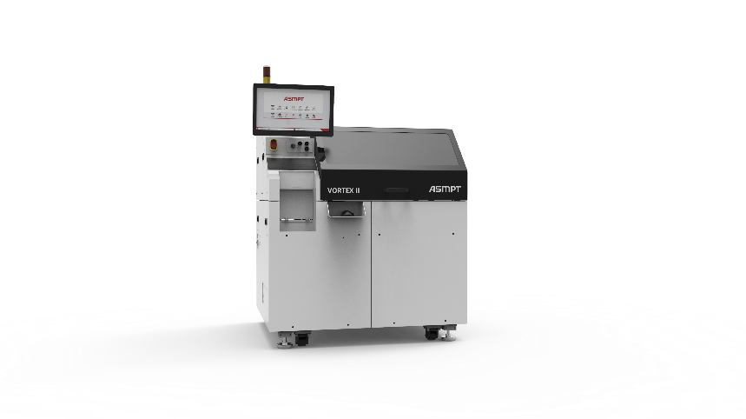
Vortex II, the high-performance LED die bonder for ultra-fine pitch direct view displays, revolutionizing visual experiences in modern vehicles.

Source: ASMPT

About ASMPT Limited (“ASMPT”)
ASMPT Limited is a leading global supplier of hardware and software solutions for the manufacture of semiconductors and electronics. Headquartered in Singapore, ASMPT’s offerings encompass the semiconductor assembly & packaging, and SMT (surface mount technology) industries, ranging from wafer deposition to the various solutions that organise, assemble and package delicate electronic components into a vast range of end-user devices, which include electronics, mobile communications, computing, automotive, industrial and LED (displays). ASMPT partners with customers very closely, with continuous investment in R&D helping to provide cost-effective, industry-shaping solutions that achieve higher productivity, greater reliability, and enhanced quality.
ASMPT is listed on the Stock Exchange of Hong Kong (HKEX stock code: 0522), and is one of the constituent stocks of the Hang Seng TECH Index, Hang Seng Composite MidCap Index under the Hang Seng Composite Size Indexes, the Hang Seng Composite Information Technology Industry Index under the Hang Seng Composite Industry Indexes, the Hang Seng Corporate Sustainability Benchmark Index, and the Hang Seng HK 35 Index.
To learn more about ASMPT, please visit us at asmpt.com.

About ASMPT Semiconductor Solutions (“ASMPT SEMI”)
ASMPT SEMI is the leading supplier in advanced packaging and semiconductor assembly solutions. With a commitment to innovation and customer satisfaction, ASMPT SEMI provides a comprehensive range of products and services that cater to the evolving needs of the microelectronics industry. Their expertise spans across areas such as flip-chip and wafer-level packaging, advanced interconnect technologies, and more. ASMPT SEMI's cutting-edge solutions enable customers to achieve higher performance, increased reliability, and improved cost-efficiency when producing their semiconductor devices.
For more information about ASMPT SEMI, visit semi.asmpt.com.
Media contacts:
Global ASMPT Press Office
ASMPT Ltd.
Susanne Oswald
Rupert-Mayer-Strasse 48
81379 Munich
Germany
Tel: +49 89 20800-26439
E-Mail: susanne.oswald@asmpt.com
Website: asmpt.com

HighTech communications GmbH
Barbara Ostermeier
Brunhamstrasse 21
81249 Munich
Germany
Tel.: +49-89 500778-10
E-Mail: b.ostermeier@htcm.de
Website: www.htcm.de

