PRESS RELEASE

Würth Elektronik introduces its Thyone-e
Extra slim 2.4 GHz radio module
Waldenburg (Germany), February 13, 2025 – The Thyone I radio module from Würth Elektronik now has a little sibling: Thyone-e, which takes up 30 percent less space and represents a cost-effective alternative for applications in which the long-range mode is not required. Like the other radio modules in the series, Thyone-e can be used to set up mesh networks, radio-based maintenance interfaces, and sensor networks in IoT and M2M applications. The WE-ProWare firmware from Würth Elektronik, which has been proven over many years, makes the chipsets extremely versatile as proprietary radio modules.
Thyone-e has an integrated PCB antenna and an RF pad for connecting an external antenna. It achieves a line-of-sight range of up to 350 meters. There is a choice between a 1 Mbps and a 2 Mbps radio profile. The module, measuring just 7 × 9 × 2 mm, can be used for unicast, multicast, or broadcast data transmission and offers AES128 encryption. Thyone-e achieves up to +4 dBm output power and is highly energy-efficient: The current consumption in standby mode is less than 0.4 µA.
Würth Elektronik offers evaluation boards, a wireless connectivity software development kit, as well as the WE-UART terminal for this product. This easy-to-use PC software allows complete control of the Würth Elektronik radio modules via an intuitive GUI. Together with the evaluation boards, the tool enables rapid prototyping and testing of various functions.
Thyone-e is available from stock without a minimum order quantity.

Available images
The following images can be downloaded from the Internet in printable quality: https://kk.htcm.de/press-releases/wuerth/

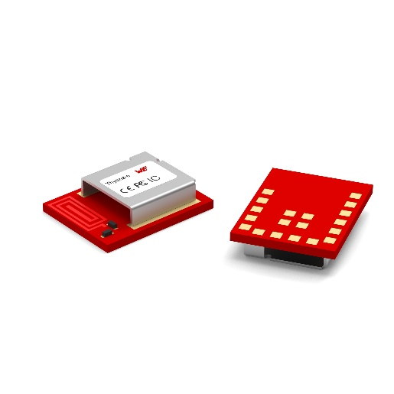
Image source: Würth Elektronik
Thyone-e is an especially compact and cost-effective proprietary radio module from Würth Elektronik.

About the Würth Elektronik eiSos Group
Würth Elektronik eiSos Group is a manufacturer of electronic and electromechanical components for the electronics industry and a technology company that spearheads pioneering electronic solutions. Würth Elektronik eiSos is one of the largest European manufacturers of passive components and is active in 50 countries. Production sites in Europe, Asia and North America supply a growing number of customers worldwide.
The product range includes EMC components, inductors, transformers, RF components, varistors, capacitors, resistors, quartz crystals, oscillators, power modules, Wireless Power Transfer, LEDs, sensors, radio modules, connectors, power supply elements, switches, push-buttons, connection technology, fuse holders and solutions for wireless data transmission. The portfolio is complemented by customized solutions.
The unrivaled service orientation of the company is characterized by the availability of all catalog components from stock without minimum order quantity, free samples and extensive support through technical sales staff and selection tools.
Würth Elektronik is part of the Würth Group, the global market leader in the development, production, and sale of fastening and assembly materials, and employs 7,900 people. In 2023, the Würth Elektronik Group generated sales of 1.24 Billion Euro.
Würth Elektronik: more than you expect!
Further information at www.we-online.com

Further information:  Würth Elektronik eiSos GmbH & Co. KG  Sarah Hurst  Clarita-Bernhard-Strasse 9  81249 Munich  Germany  Phone: +49 7942 945-5186  E-mail: sarah.hurst@we-online.de  www.we-online.com | Press contact:  HighTech communications GmbH  Brigitte Basilio  Brunhamstrasse 21  81249 Munich  Germany  Phone: +49 89 500778-20  E-mail: b.basilio@htcm.de  www.htcm.de

