Press release

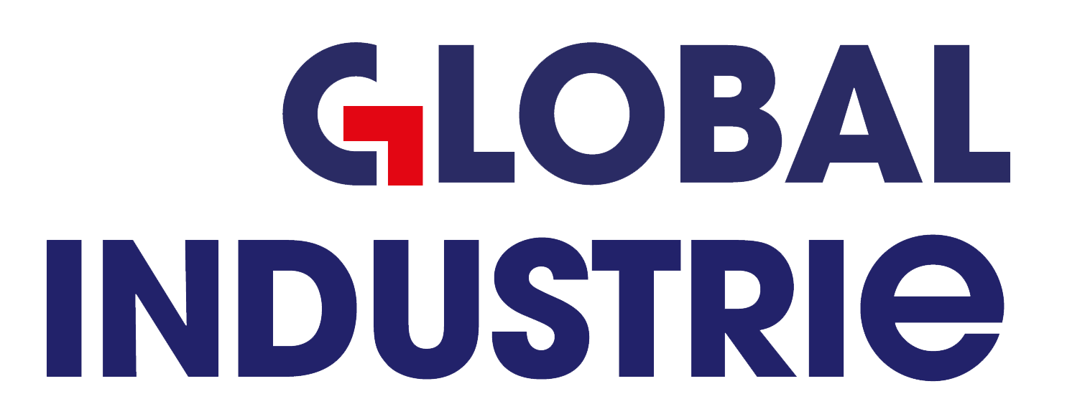Schröder Group at the Global Industrie 2025 in Lyon

PowerBend Professional for more efficiency in sheet metal folding

**March 11-14, 2025**

**Stand 6G63**

Wessobrunn-Forst (Germany), February 11, 2025 – Nesta Equipment, proven sales partner of the Schröder Group, will be exhibiting a Schröder folding machine with remarkable features at Global Industrie 2025. From March 11 to 14, 2025, a PowerBend Professional UD will be on display at booth 6G63 at Euroexpo Lyon. The machine is very popular with both industrial and craft users. At the trade fair in Lyon, the fully equipped machine will also represent a range of innovative technologies from the Schröder Group.

The Schröder machine exhibited by Nesta Equipment at Global Industrie 2025 folds 2.5 mm thick sheets over a working length of 4040 mm. Thanks to the up-and-down folding beam, counter bends can be made without turning the sheet. This makes operation much easier, especially with large sheets. In combination with the suction plate stop, this also enables partial automation. Once the sheet has been bent, all bends on one side are carried out automatically without any further manual intervention.

Highest precision

Motorized central crowning for the folding beam, motorized folding beam adjustment and bending centre point adjustment as well as high-quality drives ensure precision and maximum repeat accuracy. The 3D graphic control POS 3000, which is operated via a 19" TFT touch screen color display on the swiveling panel, offers several advantages to make your production process more efficient. In addition to the semi-automatic processing of folding programs, the so-called radius step bending function is also impressive. Here, curves are created by the clamping beam pressing the sheet metal in any number of fine steps against an angle created with the folding beam. With a stroke of 540 mm, the clamping beam offers plenty of space. On show at the trade fair: The version of the rotating clamping beam with which you can switch between two tool stations in no time at all.

**Available images**

The following images are available for download in printable format at:  
<https://kk.htcm.de/press-releases/schroeder/>

|  |
| --- |
| Image source: Schröder Group  Folding machine PowerBend Professional UD |

**About Schröder Group**

The Schröder Group consists of Hans Schröder Maschinenbau GmbH, which is located in Wessobrunn-Forst, Germany, SCHRÖDER-FASTI Technologie GmbH, located in Wermelskirchen, Germany and the SMU GmbH, located in Leinburg-Weißenbrunn.

Founded in 1949, Hans Schröder Maschinenbau GmbH unifies traditional and modern approaches in machine building: Successfully managed as a quality and customer-oriented, family-owned company, Hans Schröder Maschinenbau is specialized in the development of modern machine concepts for bending and cutting sheet metal.

The successful integration of the Fasti Company in 2006 and its worldwide presence make the Schröder Group one of today‘s leading providers of machines for bending, cutting, beading, flanging, and circular bending all types of sheet metal. The company‘s precision machines range from proven solutions for craftsmen to innovative, high-performance machines for automatic industrial production processes. 2021 the Schröder Group was expanded by the tool manufacturer SMU GmbH. Overall, the Schröder Group currently employs more than 300 people at various locations at home and abroad.

Further information is available at [www.schroedergroup.eu/en](http://www.schroedergroup.eu/en).

**Press contact:**

Schröder Group  
Hans Schröder Maschinenbau GmbH  
Janina Biró  
Feuchten 2   
82405 Wessobrunn-Forst  
Germany  
T: +49 8809 9220-68  
E-mail: jj@schroedergroup.eu  
Website: www.schroedergroup.eu

HighTech communications GmbH   
Brigitte Basilio  
Brunhamstraße 21  
81249 München   
Germany  
T: +49 89 500778-20  
E-mail: b.basilio@htcm.de  
Website: www.htcm.de