
PRESS RELEASE

Würth Elektronik Celebrates 40th Anniversary of APEC as Emerald Partner in 2025
Expertise and Innovation showcased at IEEE APEC in Atlanta
March 17-19, 2025
Booth 1839
Watertown (USA), February 11, 2025 – Würth Elektronik is proud to announce its participation as an Emerald Partner at the 40th IEEE Applied Power and Electronics Conference and Exhibition (APEC), North America’s premier event for power electronics professionals. The exhibition will take place from March 17–19, 2025, at the Georgia World Congress Center in Atlanta, Georgia, with pre-show workshops held March 15–16. Celebrating its 40th anniversary, APEC has established itself as the leading conference for power electronics professionals across North America. This year’s event will focus on innovation, collaboration, and advancements shaping the future of the industry.
Workshops and Presentations
The conference begins with the 10th Annual Magnetics @ High Frequency Workshop, co-organized by PSMA and PELS, on Saturday before the exhibition. Würth Elektronik’s experts will present cutting-edge insights during this workshop:
- Jens Kehl, Product Manager for Power Magnetics, will deliver "Inductive Components on Silicon Substrate 300mm Wafer" on Saturday morning.
- Efrain Bernal Alzate, Design Engineer Power Magnetics, will present "Simple and Effective Technique to Verify Impact of High Temperature and High Voltage High Frequency Stresses on Inductor Electrical Performance" on Saturday afternoon.
Throughout the APEC exhibition, Würth Elektronik will further contribute to the industry’s knowledge base with the following presentations:
- Richard Blakey, Modelling and Simulation Manager, "Small Language Model for the Netlist Generation of Passive Components."
- Cem Som, Power Transformers and Custom Magnetics Manager in Europe, "A New AC Rated Measurement Method for Wireless Power Transmission Coils Which Will Influence the Design of Wireless Power Systems."
- Efrain Bernal Alzate, "Verification of Additional Core Loss Due to Temperature, Voltage, and Time at High Frequencies with Accelerated Voltage and Thermal Test."
- Frank Puhane, Head of Product Management for the Capacitors and Resistors Division, "Considerations for Choosing Capacitors for High Power Applications."
- George Slama, Senior Application and Content Engineer, "PSMA Core Loss Data Base."
Würth Elektronik will also deliver Exhibitor Presentations on the show floor, including:
- Manish Khandelwal, Product Definition Engineer, "Advancing Power Solutions Using TLVR with WE-HCMD Inductors."
- Vidal Gonzalez, Product Definition Engineer, "Understanding EMI Noise and Mitigation Methods."
- Jared Birk, Technical Marketing Engineer, "Custom Transformers in Power Supplies: Achieving Precision, Efficiency, and Competitive Edge."
Interactive Booth Experience
Again in 2025, Würth Elektronik’s booth will feature interactive demonstrations and technical showcases, including:
- A traveling soldering station in partnership with Analog Devices.
- A laser engraving machine showcasing three reference designs from Texas Instruments and Renesas, allowing visitors to customize PCB nametags.
- A power tool pack and battery charger demo in partnership with ST Microelectronics.
- A demonstration from the automotive division.
- A photobooth for capturing memorable moments.
Networking Opportunities
As part of the conference’s festivities, Würth Elektronik will host its legendary Tuesday Night Party, offering an engaging networking opportunity for customers and industry professionals. Würth Elektronik invites attendees to join its experts at APEC 2025 to explore innovative solutions, gain valuable insights, and connect with leaders in the field of power electronics.

Available images
The following images can be downloaded from the Internet in printable quality: https://kk.htcm.de/press-releases/wuerth/

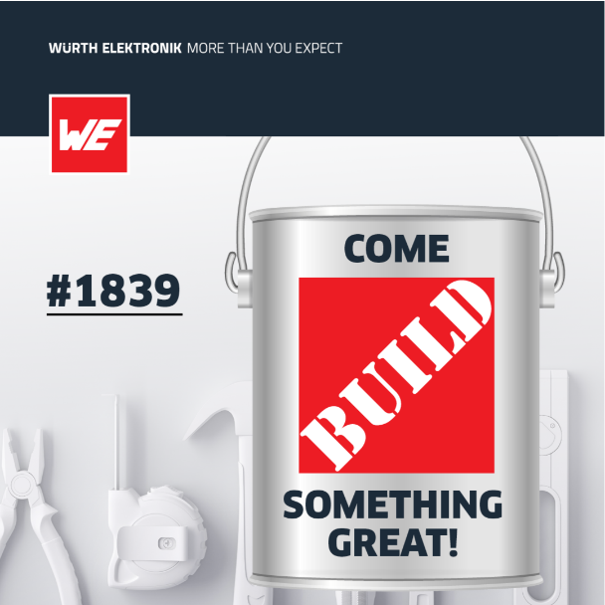Image source: Würth Elektronik  Würth Elektronik is an Emerald Partner at the 40th APEC (booth 1839). | 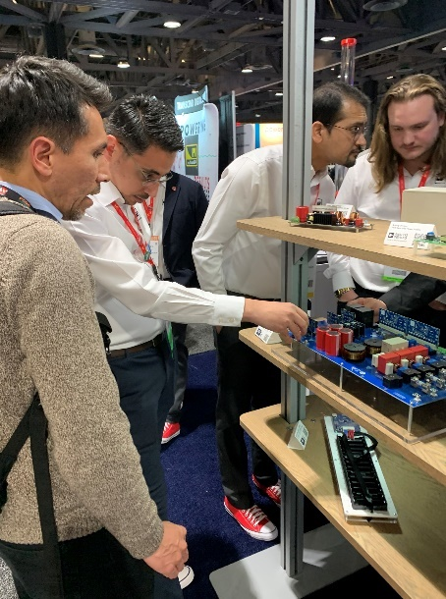Image source: Würth Elektronik  Hands on: Interactive booth experience at Würth Elektronik

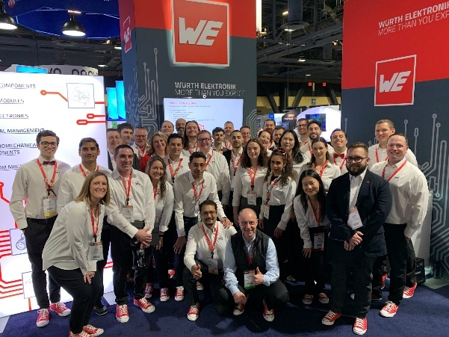Image source: Würth Elektronik
The Team: Würth Elektronik’s experts will present cutting-edge insights and will be available to answer your questions at any time. In the front: CTO Alexander Gerfer.

About the Würth Elektronik eiSos Group
Würth Elektronik eiSos Group is a manufacturer of electronic and electromechanical components for the electronics industry and a technology company that spearheads pioneering electronic solutions. Würth Elektronik eiSos is one of the largest European manufacturers of passive components and is active in 50 countries. Production sites in Europe, Asia and North America supply a growing number of customers worldwide.
The product range includes EMC components, inductors, transformers, RF components, varistors, capacitors, resistors, quartz crystals, oscillators, power modules, Wireless Power Transfer, LEDs, sensors, radio modules, connectors, power supply elements, switches, push-buttons, connection technology, fuse holders and solutions for wireless data transmission. The portfolio is complemented by customized solutions.
The unrivaled service orientation of the company is characterized by the availability of all catalog components from stock without minimum order quantity, free samples and extensive support through technical sales staff and selection tools.
Würth Elektronik is part of the Würth Group, the global market leader in the development, production, and sale of fastening and assembly materials, and employs 7,900 people. In 2023, the Würth Elektronik Group generated sales of 1.24 Billion Euro.
Würth Elektronik: more than you expect!
Further information at www.we-online.com

Further information:  Wurth Electronics Midcom, Inc.  Amelia Thompson  121 Airport Drive  PO Box 1330  Watertown, SD 57201 USA  Phone: +1 605 886 4385  Toll-free (in the U.S.):  Phone: +1 800 643 2661  E-mail: amelia.thompson@we-online.com  www.we-online.com | Press contact:  HighTech communications GmbH  Brigitte Basilio  Brunhamstrasse 21  81249 Munich  Germany  Phone: +49 89 500778-20  E-mail: b.basilio@htcm.de  www.htcm.de

