PRESS RELEASE


Würth Elektronik at embedded world 2025
Premiere for SPoE reference design and other electronic innovations
March 11–13, 2025
Hall 2, Stand 2-110
Waldenburg (Germany), 6 February, 2025 – In addition to new components from the fields of wireless connectivity, power magnetics, optoelectronics and electromechanics, Würth Elektronik will also be presenting a pioneering concept at embedded world from March 11 to 13: Single Pair Ethernet (SPE) with Power over Data Lines (PoDL). At Stand 2-110 in Hall 2 of the Nuremberg exhibition centre, the manufacturer will be presenting the first reference design for an EMC-compliant 10 Mbit/s Ethernet interface, which enables both data transmission and power supply via a single twisted pair of wires.
“With this reference design, we are demonstrating that we not only develop high-quality components for our customers, but we also take care of their optimal use, offering practical and sustainable solutions. Our new reference design helps to reduce cabling costs in industrial and IoT applications. It also reduces weight and saves costs - cutting copper consumption by 50%,” says Alexander Gerfer, CTO of the Würth Elektronik eiSos Group. “Single-pair Power over Ethernet (SPoE) is a space- and material-saving solution. Thanks to our reference design - which we provide including all the design files - it can now be implemented easily, conveniently, standard-compliant and EMC-safe.”
Würth Elektronik's contribution to the embedded world conference program is also dedicated to this topic: Dr. Heinz Zenkner and Adrian Stirn, EMC specialists at the company, will be giving a workshop entitled “Single Pair Ethernet Design with Power over Data Line with EMC Aspects” on 12 March 2025 from 2 to 5 pm.
Component news
At the trade fair in Nuremberg, Würth Elektronik will be presenting Cordelia-I, one of the first wireless modules to comply with the 2022/30 cyber security regulation in accordance with EN18031-1. In the field of storage inductors, for example, the WE-MXGI series is a product that enables maximum efficiency in switching regulator applications. The company's optoelectronics experts will be presenting the expansion of the WL-ICLED range to include dual-wire ICLEDs. The REDEXPERT ICLED Color Calculator is now also available for these RGB LEDs with integrated circuit (IC). This can be used to automatically generate exact PWM signals to display defined color values. Other new products include USB-C components and additional sizes of the popular WE-CNSW current-compensated data line filters.
Würth Elektronik’s subsidiary IQD will be co-exhibiting at the stand with quartz crystals and oscillators. In addition, the semiconductor manufacturers Analog Devices and onsemi will be guests at the stand as partners to present joint reference designs. Würth Elektronik is also once again taking part in the Students Day, which this time takes place on March 13.

Available images
The following images can be downloaded from the Internet in printable quality: https://kk.htcm.de/press-releases/wuerth/
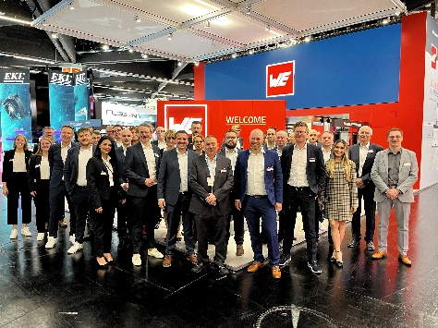  Image source: Würth Elektronik  The Würth Elektronik team is looking forward to the discussions at the stand. | 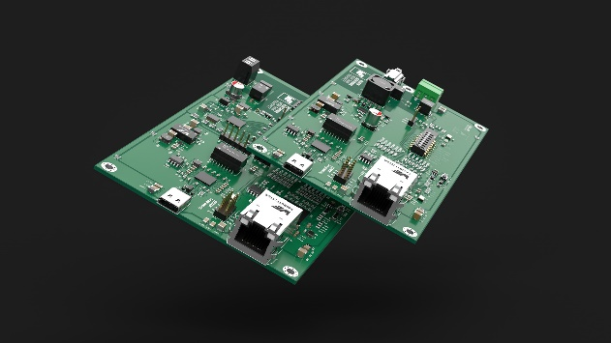Image source: Würth Elektronik  Two boards - Power Source Equipment (PSE) and Powered Device (PD) - to reduce cabling effort: the reference design of a single-pair Power over Ethernet application.

About the Würth Elektronik eiSos Group
Würth Elektronik eiSos Group is a manufacturer of electronic and electromechanical components for the electronics industry and a technology company that spearheads pioneering electronic solutions. Würth Elektronik eiSos is one of the largest European manufacturers of passive components and is active in 50 countries. Production sites in Europe, Asia and North America supply a growing number of customers worldwide.
The product range includes EMC components, inductors, transformers, RF components, varistors, capacitors, resistors, quartz crystals, oscillators, power modules, Wireless Power Transfer, LEDs, sensors, radio modules, connectors, power supply elements, switches, push-buttons, connection technology, fuse holders and solutions for wireless data transmission. The portfolio is complemented by customized solutions.

The unrivaled service orientation of the company is characterized by the availability of all catalog components from stock without minimum order quantity, free samples and extensive support through technical sales staff and selection tools.
Würth Elektronik is part of the Würth Group, the global market leader in the development, production, and sale of fastening and assembly materials, and employs 7,900 people. In 2023, the Würth Elektronik Group generated sales of 1.24 Billion Euro.
Würth Elektronik: more than you expect!
Further information at www.we-online.com

Further information:  Würth Elektronik eiSos GmbH & Co. KG  Sarah Hurst  Clarita-Bernhard-Strasse 9  81249 Munich  Germany  Phone: +49 7942 945-5186  E-mail: sarah.hurst@we-online.de  www.we-online.com | Press contact:  HighTech communications GmbH  Brigitte Basilio  Brunhamstrasse 21  81249 Munich  Germany  Phone: +49 89 500778-20  E-mail: b.basilio@htcm.de  www.htcm.de

