PRESS RELEASE
Würth Elektronik ICS unveils the ePDM 70-150: An innovative Power Distribution Controller for vehicle electrical systems.
Intelligent controller for power management in vehicles
Niedernhall (Germany), January 30, 2025 – Würth Elektronik ICS introduces the ePDM 70-150, an innovative controller that changes the way power is distributed in vehicle electrical systems. This intelligent solution combines logic processing, communication, advanced diagnostic possibilities and high-current outputs in a compact device, setting new standards in vehicle electrics and electronics.
The ePDM 70-150 is designed to meet the growing demands of intelligent and connected mobile machines and commercial vehicles. As a versatile controller with power distribution capabilities, it offers many benefits.
Performance and reliability
Equipped with nine analogue and 13 digital inputs and a variety of outputs up to 35A, the ePDM 70-150 is designed for demanding control and power distribution tasks. It operates efficiently over a temperature range of -30°C to +85°C, with a current carrying capacity of 150A at 70°C. IP67 / IP69K protection ensures reliable operation even in harsh environments.
Smart functions for modern vehicles
The ePDM 70-150 enables various wake-up scenarios, such as activating the in-cab HMI when the door opens. It also features "always on" outputs that remain active even in sleep mode, ensuring a protected power supply to critical components such as telematics modules.
Flexibility and cost efficiency
Offering a high degree of flexibility, the ePDM 70-150 supports software updates for continuous function development and optimisation without hardware changes. The use of identical hardware for different vehicle models reduces overall system costs, with development costs primarily limited to software development. Minor behavioural adjustments can be made by programming.
Seamless integration and maintenance
The ePDM 70-150 can be easily integrated into existing vehicle designs without the need for direct access and has a high degree of protection (IP67 / IP69K). This greatly simplifies both installation and cabin design. Extensive diagnostic functions, such as the recording of switching frequency or operating time per output, facilitate service and support preventive maintenance.
Programmability and adaptability
The ePDM 70-150 is fully programmable and supported by the powerful WEcontrol Designer programming environment. It offers a wide range of features, including a J1939 library and advanced online debugging functionality.
With the ePDM 70-150, Würth Elektronik ICS is setting new standards in vehicle electronics, providing OEMs with a future-proof control solution that excels in power distribution and meets the challenges of modern, connected vehicles.

Available images
The following images can be downloaded from the Internet in printable quality: https://kk.htcm.de/press-releases/wuerth-ics/
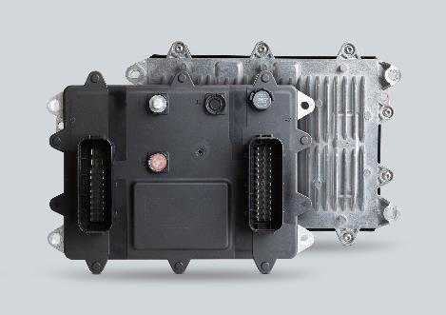 Image source: Würth Elektronik ICS  ePDM 70-150, the Power Distribution Controller for for vehicle electrical systems from Würth Elektronik ICS. | 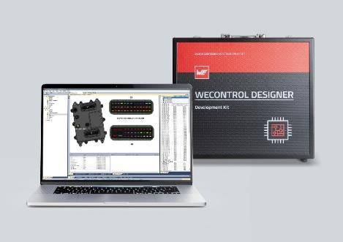 Image source: Würth Elektronik ICS  The ePDM 70-150 is fully programmable and supported by the powerful WEcontrol Designer programming environment.

About Würth Elektronik ICS GmbH & Co. KG
Würth Elektronik ICS is a system supplier for electromechanical and electronic solutions for signal and power distribution, control, and display and operating solutions. The company’s key customers include well-known manufacturers of construction and agricultural machinery as well as commercial vehicles. Sectors such as industrial technology or renewable energies also benefit from products and services provided by ICS. The company is headquartered in Niedernhall-Waldzimmern (Germany). Further subsidiaries are located in France, Great Britain, Italy, the USA, and India.
Würth Elektronik is part of the Würth Group, the global market leader in the development, production, and sale of fastening and assembly materials, and employs 7,900 people. In 2023, the Würth Elektronik Group generated sales of 1.24 billion Euro.
Würth Elektronik: more than you expect!
Further info at www.we-online.com/ics

More information:  Würth Elektronik ICS GmbH & Co. KG  Sandra Herter  Gewerbepark Waldzimmern  Würthstrasse 1  74676 Niedernhall  Germany  Phone: +49 7940 9810-1503  E-mail: sandra.herter@we-online.de  www.we-online.com/ics | Press contact:  HighTech communications GmbH  Marcus Planckh  Brunhamstrasse 21  81249 Munich  Germany  Phone: +49 89 500778-22  E-mail: m.planckh@htcm.de  www.htcm.de

