PRESS RELEASE
Würth Elektronik promotes sustainable innovations at Teknopark Istanbul
NextCube: Development support for environmentally conscious technologies
Waldenburg (Germany), January 30, 2025 – Würth Elektronik eiSos, a leading manufacturer of electronic and electromechanical components, is also committed to environmental protection and sustainable technologies internationally. Since May 2024, the Turkish Subsidiary of the company has been working with Teknopark Istanbul to promote sustainable products and technologies.
“Environmental protection knows no boundaries,” emphasizes Ahmet Çakır, General Manager of Würth Elektronik eiSos Türkiye. “In Teknopark Istanbul, we have found a strong partner to provide targeted support for sustainable projects in Türkiye. The Teknopark Istanbul for cutting-edge technology offers entrepreneurs and start-ups an ideal environment with acceleration programs and cooperation opportunities. Our development support complements this offer perfectly.”
Start-up support with know-how and infrastructure
The NextCube program includes classic startup support such as training, mentoring and risk analyses as well as support with performance evaluation and the search for investors. Experts from Würth Elektronik participate with online and classroom training. In addition, participants have access to a state-of-the-art electronics laboratory, which Würth Elektronik has already equipped with equipment and components in 2022, including more than 60 design kits as well as soldering stations and microscopes for developing prototypes.
“Supporting start-ups is of central importance to us,” emphasizes Würth Elektronik eiSos CTO Alexander Gerfer. “Of course, we are also implementing our successful concept of development support internationally. Teknopark Istanbul is an ideal platform for this: true to our mission of creating together, we give founders in Türkiye the chance to turn good ideas into successful products.”
The initiators of the three best projects will be invited to a presentation to Germany in September 2025.
Creating together, also at international level
Promoting start-ups is part of Würth Elektronik's Creating together mission: the aim is to promote environmentally conscious and sustainable ideas in particular through know-how transfer and networking and to develop them to series maturity.

Available images
The following images can be downloaded from the Internet in printable quality: https://kk.htcm.de/press-releases/wuerth/
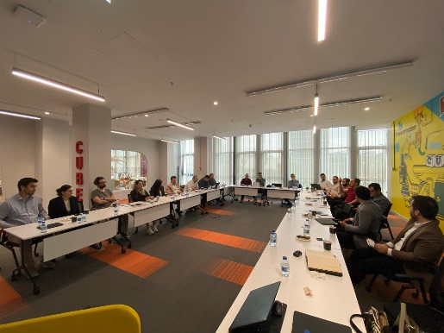  Image source: Würth Elektronik  NextCube program: online and face-to-face training Mentoring and risk analyses. | 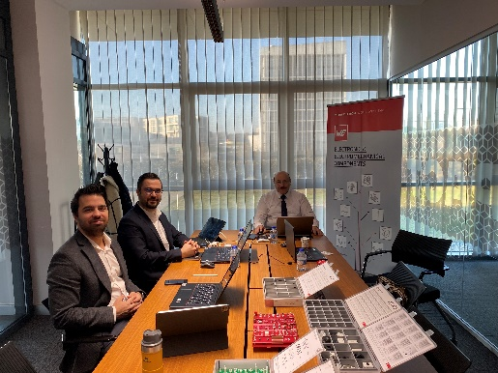  Image source: Würth Elektronik  Free choice: Würth Elektronik's support for Teknopark Istanbul includes the provision of design kits.

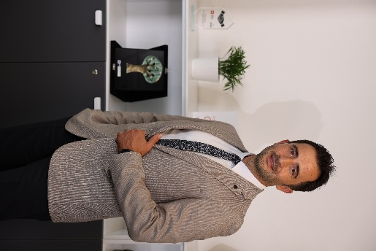

Image source: Würth Elektronik
Ahmet Çakır, General Manager of Würth Elektronik eiSos Türkiye: “environmental protection knows no borders.”

About the Würth Elektronik eiSos Group
Würth Elektronik eiSos Group is a manufacturer of electronic and electromechanical components for the electronics industry and a technology company that spearheads pioneering electronic solutions. Würth Elektronik eiSos is one of the largest European manufacturers of passive components and is active in 50 countries. Production sites in Europe, Asia and North America supply a growing number of customers worldwide.
The product range includes EMC components, inductors, transformers, RF components, varistors, capacitors, resistors, quartz crystals, oscillators, power modules, Wireless Power Transfer, LEDs, sensors, radio modules, connectors, power supply elements, switches, push-buttons, connection technology, fuse holders and solutions for wireless data transmission. The portfolio is complemented by customized solutions.
The unrivaled service orientation of the company is characterized by the availability of all catalog components from stock without minimum order quantity, free samples and extensive support through technical sales staff and selection tools.
Würth Elektronik is part of the Würth Group, the global market leader in the development, production, and sale of fastening and assembly materials, and employs 7,900 people. In 2023, the Würth Elektronik Group generated sales of 1.24 Billion Euro.
Würth Elektronik: more than you expect!
Further information at www.we-online.com

Further information:  Würth Elektronik eiSos GmbH & Co. KG  Sarah Hurst  Clarita-Bernhard-Strasse 9  81249 Munich  Germany  Phone: +49 7942 945-5186  E-mail: sarah.hurst@we-online.de  www.we-online.com | Press contact:  HighTech communications GmbH  Brigitte Basilio  Brunhamstrasse 21  81249 Munich  Germany  Phone: +49 89 500778-20  E-mail: b.basilio@htcm.de  www.htcm.de

