
Press release
Schröder folding machine at the International Roofing Expo
Pluggable profiles and perfect hems
February 19 to 21, 2025
Stand 11069
Wessobrunn-Forst (Germany), San Antonio, TX (USA), January 30, 2025 – Represented by its partner MetalForming Inc., the Schröder Group, a leading manufacturer of sheet metal working machines, will be at the International Roofing Expo in San Antonio, Texas, from February 19 to 21, 2025. The motorized folding machine PowerBend Multi, which bends 2 mm thick sheets at a working length of 3200 mm with maximum repeat accuracy, will be on display at booth 11069. Its POS 2000 Professional graphic software control system makes it easy to operate the machine. Moreover two innovative features are its unique selling points: conical bending and the closing function for folding hems in just one operation.
The PowerBend Multi folding machine is equipped with a rotating clamping beam. The clamping beam not only makes it possible to set up a second tool station in no time at all. It can also be set back so that it clamps the sheet metal further back. This creates space for the folding beam and a folded hem. The folding beam first creates a sharp angle, the clamping beam is set back and clamps the sheet metal. The folding beam then moves up to 190° to create a fold and press it shut. Instead of the traditional pressing with the clamping beam, the much stronger and crownable folding beam is now used for this task. This makes it possible to fold hems uniformly over the entire working length of a two millimeter thick steel sheet.
Conical bending
Another Schröder innovation is available on the PowerBend Multi: the electronically controlled two-axis back gauge. If profiles are required that are longer than the width of the machine, simply enter the required total length in the POS 2000 Professional software control. This automatically calculates sections that have tapered edges with a precision in the tenth of a millimeter range. The result is form-fit, pluggable profiles.

Available images
The following images are available for download in printable format at:
https://kk.htcm.de/press-releases/schroeder/
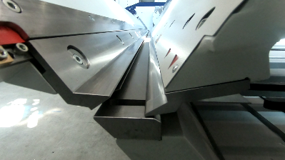  Image source: Schröder Group  Ingenious closing function: The Power-Bend Multi can be used to fold hems in just one operation with the folding beam. | 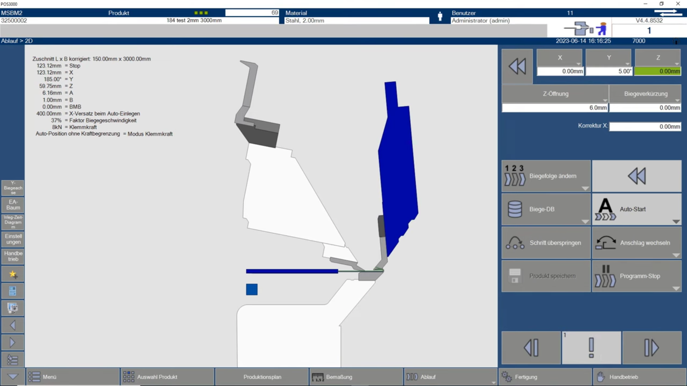  Image source: Schröder Group  The new function in the POS 2000 Professional software control.

Available video material
The following video material can be found on our YouTube channel:
https://www.youtube.com/watch?v=0pb6ZUd6HxY
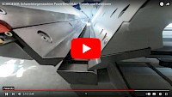
Source: Schröder Group

The new closing function of the PowerBend Multi is shown on YouTube.

About Schröder Group
The Schröder Group consists of Hans Schröder Maschinenbau GmbH, which is located in Wessobrunn-Forst, Germany, SCHRÖDER-FASTI Technologie GmbH, located in Wermelskirchen, Germany and the SMU GmbH, located in Leinburg-Weißenbrunn.
Founded in 1949, Hans Schröder Maschinenbau GmbH unifies traditional and modern approaches in machine building: Successfully managed as a quality and customer-oriented, family-owned company, Hans Schröder Maschinenbau is specialized in the development of modern machine concepts for bending and cutting sheet metal.
The successful integration of the Fasti Company in 2006 and its worldwide presence make the Schröder Group one of today‘s leading providers of machines for bending, cutting, beading, flanging, and circular bending all types of sheet metal. The company‘s precision machines range from proven solutions for craftsmen to innovative, high-performance machines for automatic industrial production processes. 2021 the Schröder Group was expanded by the tool manufacturer SMU GmbH. Overall, the Schröder Group currently employs more than 300 people at various locations at home and abroad.
Further information is available at www.schroedergroup.eu/en.

Press contact:
Schröder Group
Hans Schröder Maschinenbau GmbH
Janina Biró
Feuchten 2
82405 Wessobrunn-Forst
Germany
T: +49 8809 9220-68
E-mail: jj@schroedergroup.eu
Website: www.schroedergroup.eu

HighTech communications GmbH
Brigitte Basilio
Brunhamstraße 21
81249 München
Germany
T: +49 89 500778-20
E-mail: b.basilio@htcm.de
Website: www.htcm.de

