FOR THE MEDIA
PCBs trigger program downloads on the SMT line
Seamless program changeovers – now also across setups
Suwanee (USA), January 30, 2025 – ASMPT, the global market and technology leader in hardware and software solutions for semiconductor and electronics manufacturing, has implemented another step in automating product changeovers on the SMT line. The Automated Program Change function in the WORKS Operations application, which is part of the WORKS Software Suite, has been enhanced with a crucial new feature: In addition to triggering automatic program changeovers with family setups, its latest version now also supports them across setups.
“Automatic Program Change has proven to be a real game changer. Customers report setup time reductions of up to 35 percent and significantly lower nonconformity costs,” says Thomas Marktscheffel, Director Product Management Software Solutions at ASMPT SMT Solutions. In the past, every product change required new assembly programs to be manually downloaded to each machine in a time-consuming and error-prone process. With Automatic Program Change, this now happens automatically as soon as the first PCB of a new batch enters the line. And in the latest version, even setup changeovers are seamlessly integrated because the machines let operators know when stencils or feeder tables need to be replaced. This intelligent function optimizes product changeovers even in complex high-mix/low-volume and provides the foundation for further automation steps like automatic feeder table changeovers.
Industry-standard data transfers
Automated Program Change and its latest enhancement are based on a network with IPC-HERMES-9852 interfaces, which enables seamless data transfers in accordance with the latest industry standard. To make the concept work, the system transmits the necessary information for each new circuit board to the first machine on the line – usually the solder paste printer – either via a barcode reader or digitally via IPC-HERMES-9852 data. If the machine recognizes a batch change, it automatically loads the new assembly program. When the board moves to the next machine, it is accompanied by its IPC-HERMES-9852 data. In this way, each station along the line, irrespective of its manufacturer, adapts its program automatically when needed. The open and standardized interface also ensures that the conveyors automatically adapt to the respective circuit board width – again irrespective of their manufacturer. With family setups, this means that product changeovers are possible with no operator assists whatsoever.
Quick and error-free product changeovers
For electronics manufacturers, the optional Automated Program Change function in WORKS Operations offers several advantages: It enables rapid product changeovers without the line being idle – all that’s required is a barcode reader at the beginning of the line. The automatic changeovers also relieve the operators and avoid scrap resulting from faulty manual downloads.
“With the Automated Program Change across setups, we continue to advance our Intelligent Factory concept at ASMPT,” says Thomas Marktscheffel. “Our goal is to make electronics manufacturing more productive, resilient and efficient through the integrative use of data on the basis of standardized interfaces.”

Illustrations for downloading
The following print-ready artwork is available on the internet for downloading:
https://kk.htcm.de/press-releases/asmpt/

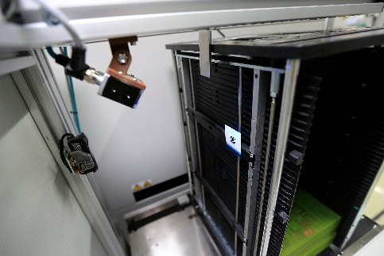 | 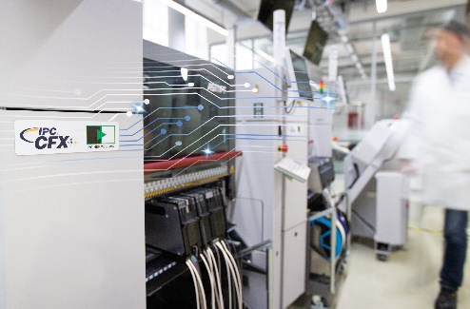
Only the first machine in the line must be equipped with a barcode reader. Once scanned, the data is automatically forwarded from machine to machine.  Image credit: ASMPT | The standardized IPC-HERMES-9852 interface enables automatic program downloads on all machines in the SMT line irrespective of their manufacturers.  Image credit: ASMPT

About ASMPT Limited (“ASMPT”)
ASMPT Limited is a leading global supplier of hardware and software solutions for the manufacture of semiconductors and electronics. Headquartered in Singapore, ASMPT’s offerings encompass the semiconductor assembly & packaging, and SMT (surface mount technology) industries, ranging from wafer deposition to the various solutions that organize, assemble and package delicate electronic components into a vast range of end-user devices, which include electronics, mobile communications, computing, automotive, industrial and LED (displays). ASMPT partners with customers very closely, with continuous investments in R&D helping to provide cost-effective, industry-shaping solutions that achieve higher productivity, greater reliability, and enhanced quality. ASMPT is a founding member of the Semiconductor Climate Consortium.
ASMPT is listed on the Hong Kong Stock Exchange (HKEX stock code: 0522) and is one of the constituent stocks of the Hang Seng TECH Index, the Hang Seng Composite MidCap Index, the Hang Seng Composite Information Technology Industry Index under Hang Seng Composite Industry Indexes, the Hang Seng Corporate Sustainability Benchmark Index, and the Hang Seng HK 35 Index.
To learn more about ASMPT, please visit www.asmpt.com.

The ASMPT SMT Solutions segment
The mission of the SMT Solutions segment within ASMPT is to implement and support the Intelligent Factory at electronics manufacturers worldwide.
ASMPT solutions support the networking, automation, and optimization of central workflows with hardware, software and services that enable electronics manufacturers to transition to the Intelligent Factory in stages and enjoy dramatic improvements in productivity, flexibility, and quality. With its integrated open automation concept, ASMPT opens the door for its customers to economically feasible automation, entirely in accordance with their individual requirements – modular, flexible, and vendor-independent.
The product range includes hardware and software such as SIPLACE placement solutions, DEK printing solutions, inspection and storage solutions, and the WORKS Software Suite. With WORKS, ASMPT offers electronics manufacturers high-quality software for planning, controlling, analyzing and optimizing all processes on the shop floor. Maintaining close relationships with customers and technology partners is a central component of ASMPT’s strategy.
For more information about ASMPT SMT Solutions, visit smt.asmpt.com.

Media contacts:
AMCAS ASMPT Press Office
SMT Solutions
Mark Ogden
Phone: +1 (770) 797 3189
E-mail: ogden.mark@asmpt.com
Website: smt.asmpt.com

Global ASMPT Press Office
ASMPT Ltd.
Susanne Oswald
Rupert-Mayer-Strasse 48
81379 Munich
Germany
Phone: +49 89 20800-26439
E-Mail: susanne.oswald@asmpt.com
Website: asmpt.com

