PRESS RELEASE

Vibration-resistant capacitors from Würth Elektronik
No Shaking Off
Waldenburg (Germany), January 29, 2025 – All SMT variants of the Aluminum Electrolyte and Aluminum Hybrid Polymer capacitors from Würth Elektronik are now available in an extremely vibration-resistant version on request. Thanks to their enlarged solder pads and thicker base plate, the capacitors can withstand acceleration up to 30 g (294 m/s²).
Electronics must continue to function reliably, even when exposed to strong mechanical stresses. This is the case with electronically controlled tools, industrial applications, construction machinery, or drones, for example.
Risk of failure during continuous operation
SMT components are often not the best choice here, because without special adaptations, they may not withstand the prolonged vibration stress. Especially larger components then quickly reach their limits. Under continuous load, they can detach from the circuit board and cause the electronics to fail.
Optimized for tough operating conditions
However, making electronics vibration-resistant does not necessarily require special connection techniques like press-fitting. The vibration-resistant versions of the Würth Elektronik capacitors feature larger solder pads for a more stable connection to the circuit board and an extra-high base for improved support and vibration damping. In order to maintain optimal temperature management, the well-known manufacturer of electronic and electromechanical components has provided the base of these capacitors with special cut-outs.
Quality assurance in twelve-hour endurance test
The capacitors are tested under conditions that go beyond the requirements of IEC 60384-4: The components must remain securely attached to the circuit board for twelve hours (four hours per axis) under vibration in the frequency range between 10 Hz and 2 kHz with an amplitude of 0.75 mm. The final electrical tests then confirm their functionality.
The vibration-resistant capacitors can be processed on standard SMT production lines. They are delivered with the desired specifications on request.

Available images
The following images can be downloaded from the Internet in printable quality: https://kk.htcm.de/press-releases/wuerth/
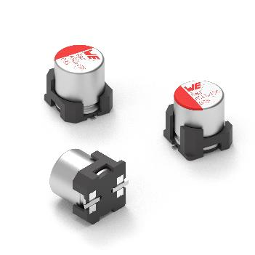  Image source: Würth Elektronik  Now available in a vibration-resistant version: Aluminum Electrolytic and Aluminum Hybrid Polymer capacitors from Würth Elektronik. | 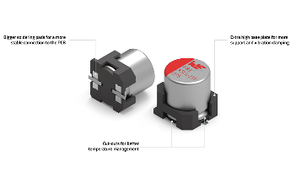Image source: Würth Elektronik  Functionally stable, even in challenging environments: Larger solder pads and a higher base plate make the capacitors vibration-resistant.

About the Würth Elektronik eiSos Group
Würth Elektronik eiSos Group is a manufacturer of electronic and electromechanical components for the electronics industry and a technology company that spearheads pioneering electronic solutions. Würth Elektronik eiSos is one of the largest European manufacturers of passive components and is active in 50 countries. Production sites in Europe, Asia and North America supply a growing number of customers worldwide.
The product range includes EMC components, inductors, transformers, RF components, varistors, capacitors, resistors, quartz crystals, oscillators, power modules, Wireless Power Transfer, LEDs, sensors, radio modules, connectors, power supply elements, switches, push-buttons, connection technology, fuse holders and solutions for wireless data transmission. The portfolio is complemented by customized solutions.
The unrivaled service orientation of the company is characterized by the availability of all catalog components from stock without minimum order quantity, free samples and extensive support through technical sales staff and selection tools.

Würth Elektronik is part of the Würth Group, the global market leader in the development, production, and sale of fastening and assembly materials, and employs 7,900 people. In 2023, the Würth Elektronik Group generated sales of 1.24 Billion Euro.
Würth Elektronik: more than you expect!
Further information at www.we-online.com

Further information:  Würth Elektronik eiSos GmbH & Co. KG  Sarah Hurst  Clarita-Bernhard-Strasse 9  81249 Munich  Germany  Phone: +49 7942 945-5186  E-mail: sarah.hurst@we-online.de  www.we-online.com | Press contact:  HighTech communications GmbH  Brigitte Basilio  Brunhamstrasse 21  81249 Munich  Germany  Phone: +49 89 500778-20  E-mail: b.basilio@htcm.de  www.htcm.de

